For Immediate Release
JUNE 30, 2022

JAX KNOWS “VICTORIA’S SECRET”

Multi-talented singer-songwriter & iHeartRadio Music Award winner
premieres already-viral empowering new single

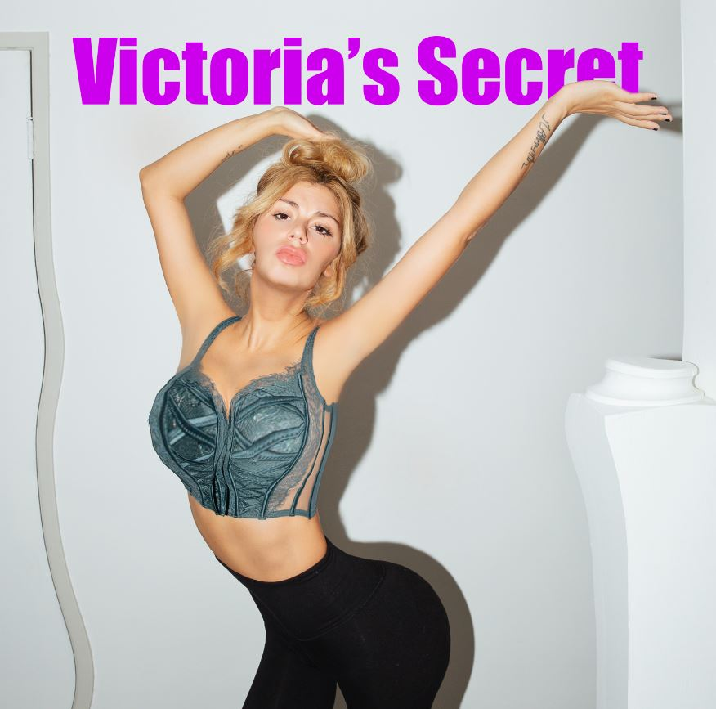
DOWNLOAD HIGH-RES IMAGES

STREAM “VICTORIA’S SECRET”: LINK

Multi-talented singer-songwriter Jax gets real with her new single “Victoria’s Secret” – available now via Atlantic Records. Co-penned/produced by GRAMMY®-winning producer Mark Nilan Jr (Lady Gaga, Zedd) and Dan Henig (ZAYN, Noah Cyrus), the empowering body-positive track has already gone viral on TikTok with over 25 million views (watch here) and a live debut earlier this month at The Governors Ball Music Festival in New York.

“The kid I babysit told me a story about how one of her friends called her “too flat and too fat” in a VS bathing suit she tried on and it got me HEATED. So I went into the studio with my two friends and we recorded a song called ‘Victoria’s Secret.’” — JAX

“Victoria’s Secret” continues what has already been an exciting year for Jax, kicking off with the release of her swooning single “To All The Boys I’ve Loved Before” which was deemed “a viral hit” by Billboard and followed by “u love u” featuring GRAMMY®-nominated producer/singer-songwriter JVKE. 2022 also saw Jax take home the iHeartRadio Music Award for TikTok Songwriter of the Year, thanks to her incredibly creative TikTok songs that have featured cameos from the likes of Leslie Jordan, John Stamos, Natasha Bedingfield and more.

Raised in New Jersey by way of New York, Jax got her start by performing a wide variety of genres and in bands growing up. At the age of 18, she developed cancer above her vocal cords, which returned following a couple months of remission right as she relocated to Los Angeles in pursuit of her music. Left unable to sing herself, Jax turned to songwriting for others and found industry success behind-the-scenes.

As her ability to perform returned, Jax needed to pivot yet again when the COVID-19 pandemic struck. This time she turned to TikTok, posting a hilarious response to the pop gem “Stacy’s Mom” from “Stacy’s Mom’s Perspective” which exploded with nearly 9 million views in just a few months and follow-ups including “Update from Avril Lavigne & Sk8er Boi 18 years later.” She continued to go viral a dozen or more times over, having now amassed over 9.7 million followers on the platform and over 155 million “likes” to date. With a massive online audience under her belt, Jax began sharing her own original music in late 2020 to an overwhelmingly positive response – ultimately leading to her signing with Atlantic Records for her forthcoming debut full-length.

“Victoria’s Secret” marks the latest in a catalog of fan-favorite singles from the Jax – including her heartwarming ballad “Like My Father” which has amassed over 140 million streams and was crowned amongst “the best father-daughter dance songs of all time” by The Knot. Meanwhile, her nostalgia-fueled anthem “90s Kids” received over 1 million weekly streams for 21 consecutive weeks and label-debut single “Ring Pop” yielded high-profile appearances on The Ellen DeGeneres Show, Access Hollywood & more.

CONNECT WITH JAX:
TikTok | YouTube | Instagram | Twitter | Facebook | Press Assets

CONTACT:
Ted Sullivan | ted.sullivan@atlanticrecords.com

