FOR IMMEDIATE RELEASE
MARCH 11, 2022

KALI UNWRAPS TOXIC CHOCOLATE

RISING GA-BASED RAP STAR SHARES EAGERLY AWAITED NEW EP

“STANDARDS” STREAMING NOW FOLLOWING EXCLUSIVE PREMIERE AND FEATURE INTERVIEW
ON APPLE MUSIC’S NEW MUSIC DAILY WITH ZANE LOWE

KALI TO JOIN LATTO ON UPCOMING
MONSTER ENERGY OUTBREAK TOUR PRESENTS: LATTO 777 TOUR
BEGINNING MARCH 19TH IN SANTA CRUZ, CA

TOXIC CHOCOLATE AVAILABLE NOW AT ALL DSPS AND STREAMING SERVICES HERE

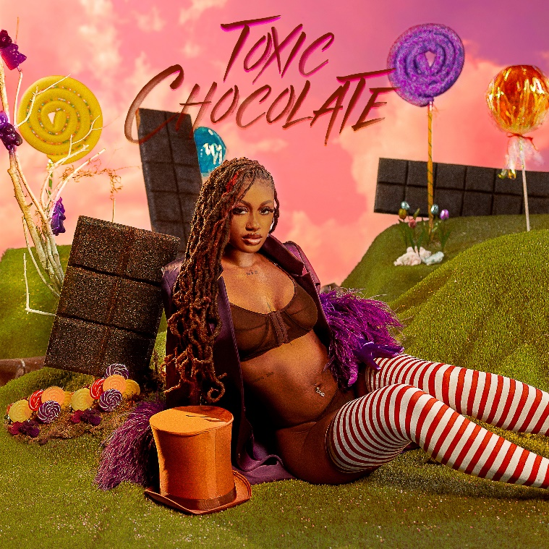

Rising rap sensation Kali has shared her highly anticipated new EP, Toxic Chocolate, available today at all DSPs and streaming services.

Toxic Chocolate – which includes features from Bia – is highlighted by the incendiary singles, “UonU (Feat. Yung Bleu)“ and “Standards,” the latter of which is available for streaming and download HERE following its exclusive premiere – and Kali’s debut interview – earlier this week on Apple Music’s New Music Daily Radio with Zane Lowe.

“Standards” – which features a sample from Boyz II Men’s classic “Doin’ Just Fine” – was preceded last month by the premiere of “UonU (Feat. Yung Bleu),” available now at all DSPs and streaming services HERE; an official music video is streaming now via YouTube HERE.

Recently named among Spotify’s “10 Rappers You Need To Know,” and NYLON’s “17 Under-The-Radar Black Musicians To Know Right Now,” Kali will celebrate Toxic Chocolate on her biggest U.S. tour schedule to date, joining Latto as special guest on the upcoming Monster Energy Outbreak Tour, getting underway March 19th at The Catalyst in Santa Cruz, CA and then travel through an April 23rd tour finale at Atlanta, GA’s historic Tabernacle. Tickets for all dates are on sale now. For complete details and availability, please visit outbreakpresents.com.

Kali – who officially launched Toxic Chocolate with a pair of packed release parties in New York City and her hometown of Atlanta – also joined forces with Voisey for a special open verse challenge. Fans were invited to download the Voisey app and post their best verse using the hashtag #KalixVoisey on Voisey.

The Monster Energy Outbreak Tour Presents: Latto 777 Tour marks the latest collaboration between Kali and Latto following a recent remix of her smash anthem, “MMM MMM.” The “MMM MMM (Feat. ATL Jacob, Latto & MoneyBagg Yo)” remix is available now all DSPs and streaming services HERE.

“MMM MMM“ proved a breakout phenomenon upon its release last summer, with its official sound now boasting more than 1.2M TikTok creates thus far. The track – which reached the top 100 on Shazam’s “Hip-Hop/Rap” chart among other successes – is joined by an equally high-energy official music video fast approaching 7M individual views via YouTube HERE. Along with its epic viral success, “MMM MMM” also drew critical applause, with the influential Brooklyn Vegan declaring “(‘MMM MMM’) manages to be fun and brooding all at once…It suggests that Kali’s got an increasingly bright future.”

Now boasting more than 103M worldwide streams, Kali first lit playlists on fire with 2020’s viral hit single, “Do A Bitch,” featured on her This Why They Mad Now EP. Praised by DJ Booth as “a slow-rolling, shit-talking anthem,” the menacingly catchy single incited a flurry of online activity, quickly racking up over 5M streams in less than a month’s time while spawning a trio of official remixes from such fellow online icons as Enchanting, Saucy Santana, and the one and only Rico Nasty.

Named by BET as one of “5 New Artists Flying Under The Radar”, as well as one of DJ Booth’s “10 Rappers You Should Know Right Now,” Kali kicked 2021 with the premiere of official music videos for “Do a Bitch“ and “Ain’t FWM (Feat. KenTheMan),” both streaming now at YouTube. The GA-based rapper also spent much of last year firing up massive crowds at Rolling Loud festivals in New York, Miami, and California. As if all that weren’t enough, Kali also dropped an exclusive “Who Want Smoke Remix“ as part of No More Heroes’ “Red Light Freestyle” series, streaming now via YouTube HERE.

“You can’t tell me nothing,” Kali says. “I just do what I want. By living like that, I built my confidence up. When I started doing music, I was learning and going through a lot with my family. I realized I had to have my own back more than anybody else. Now, I feel like my sound is ‘Pretty Gangsta B.’ Don’t play with me.”

Toxic Chocolate Tracklist:
- Standards
2) Ms. Lick Back
3) New Day
4) Eat It Up feat. BIA
5) UonU feat. Yung Bleu
6) Toxic Chocolate
7) MMM MMM (The Remix) feat. Moneybagg Yo & Latto

KALI
U.S. TOUR 2022

ALL DATES w/MONSTER ENERGY OUTBREAK TOUR PRESENTS: LATTO 777 TOUR

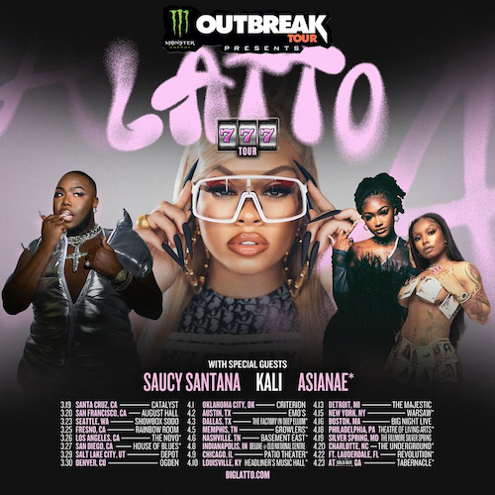

MARCH
19 – Santa Cruz, CA – Catalyst
20 – San Francisco, CA – August Hall
23 – Seattle, WA – ShowBox Sodo
25 – Fresno, CA – Rainbow Room
26 – Los Angeles, CA – The Novo
27 – San Diego, CA – House of Blues
29 – Salt Lake City, UT – Depot
30 – Denver, CO – Ogden

APRIL
1 – Oklahoma City, OK – Criterion
2 – Austin, TX – Emo’s
3 – Dallas, TX – The Factory in Deep Ellum
5 – Memphis, TN - Growlers
6 – Nashville, TN – Basement East
8 – Indianapolis, IN – Deluxe @ Old National Centre
9 – Chicago, IL – Patio Theater
10 – Louisville, KY – Headliner’s Music Hall
13 – Detroit, MI – The Majestic
15 – New York, NY – Warsaw
16 – Boston, MA – Big Night Live
18 – Philadelphia, PA – Theatre of Living Arts
19 – Silver Spring, MD – The Fillmore
20 – Charlotte, NC – The Underground
22 – Ft. Lauderdale, FL - Revolution
23 – Atlanta, GA – Tabernacle

# # #

CONNECT WITH KALI
TIKTOK | TWITTER | INSTAGRAM | FACEBOOK | YOUTUBE

PRESS CONTACT
Ariana White | Ariana.White@AtlanticRecords.com

