FOR IMMEDIATE RELEASE
MARCH 8, 2022

KALI SETS NEW “STANDARDS” ON LATEST RELEASE

LISTEN TO “STANDARDS” HERE

PRE-SAVE TOXIC CHOCOLATE HERE

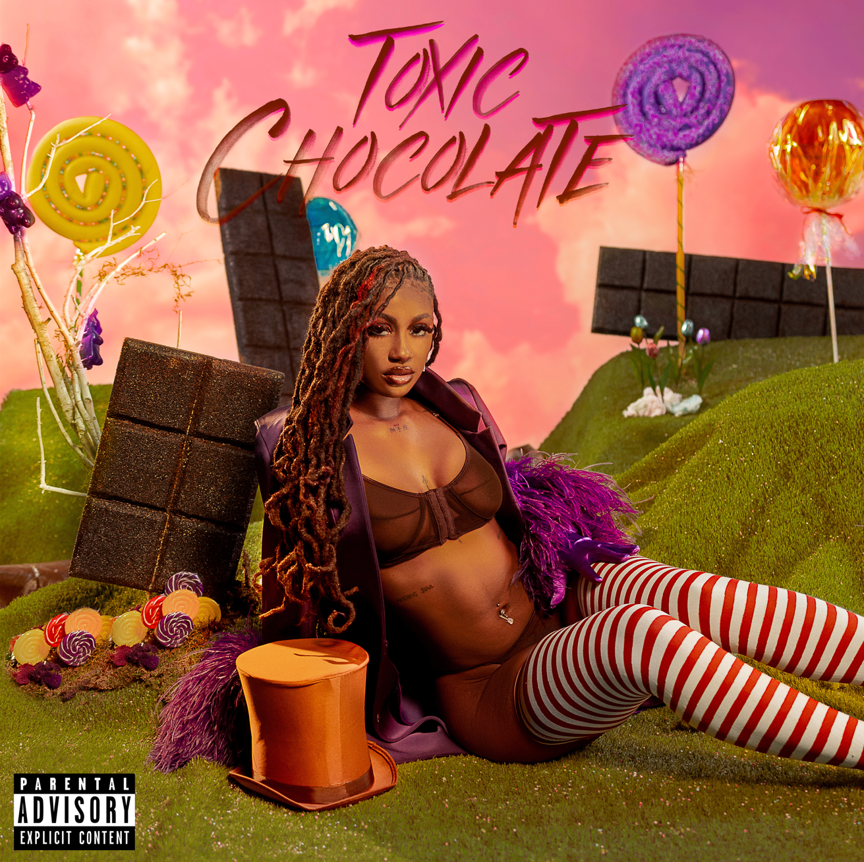

Atlanta’s finest, Kali, is lighting up the day with her latest release “Standards.” A small taste of what is to come on her Toxic Chocolate EP due out this Friday March 11th, “Standards” is an empowering RnB influenced track that samples the prolific “Doin’ Just Fine” by 90’s vocal group Boyz II Men. Play it for the girlfriend who is calling to complain about her man for the third time this week. Play it for yourself when you are four drinks in and about to send that risky text. Whatever you do stream “Standards” now HERE.

ABOUT KALI
Confidence spreads like wildfire. With unapologetic bars, undeniable melodies, and unrestrained spirit, Kali bosses up the moment she wraps her fingers around the microphone. Empowered with style, swagger, and substance, the buzzing rapper quietly set social media ablaze with a sound just as perfect for the streets. In under a year, she has already posted up tens of millions of views and inspired over 400K videos on TikTok with massive plugs by superstars such as Charli D’Amelio, Gabrielle Union, Rico Nasty, Nessa Barrett, and many more.

2022’s Toxic Chocolate EP is the latest chapter in Kali’s story and if what she has shown so far is any indication, it is sure to be a thrilling ride.

KALI
U.S. TOUR 2022

ALL DATES w/MONSTER ENERGY OUTBREAK TOUR PRESENTS: LATTO 777 TOUR

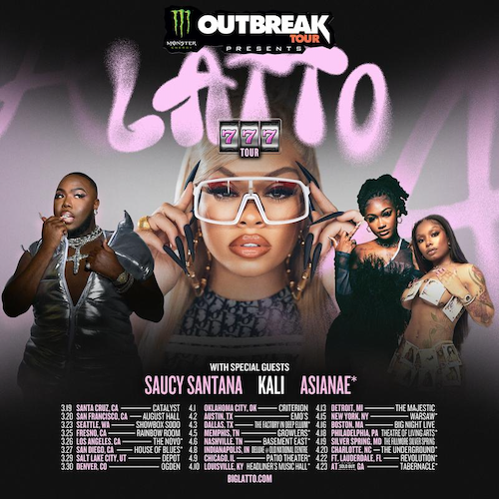

MARCH
19 – Santa Cruz, CA – Catalyst
20 – San Francisco, CA – August Hall
23 – Seattle, WA – ShowBox Sodo
25 – Fresno, CA – Rainbow Room
26 – Los Angeles, CA – The Novo
27 – San Diego, CA – House of Blues
29 – Salt Lake City, UT – Depot
30 – Denver, CO – Ogden

APRIL
1 – Oklahoma City, OK – Criterion
2 – Austin, TX – Emo’s
3 – Dallas, TX – The Factory in Deep Ellum
5 – Memphis, TN - Growlers
6 – Nashville, TN – Basement East
8 – Indianapolis, IN – Deluxe @ Old National Centre
9 – Chicago, IL – Patio Theater
10 – Louisville, KY – Headliner’s Music Hall
13 – Detroit, MI – The Majestic
15 – New York, NY – Warsaw
16 – Boston, MA – Big Night Live
18 – Philadelphia, PA – Theatre of Living Arts
19 – Silver Spring, MD – The Fillmore
20 – Charlotte, NC – The Underground
22 – Ft. Lauderdale, FL - Revolution
23 – Atlanta, GA – Tabernacle

# # #

CONNECT WITH KALI
TIKTOK | TWITTER | INSTAGRAM | FACEBOOK | YOUTUBE

PRESS CONTACT
Ariana White | Ariana.White@AtlanticRecords.com

