FOR IMMEDIATE RELEASE
JUNE 9, 2022

Kelly Clarkson Releases Kellyoke EP

6-track collection available now,
featuring standout covers from The Kelly Clarkson Show

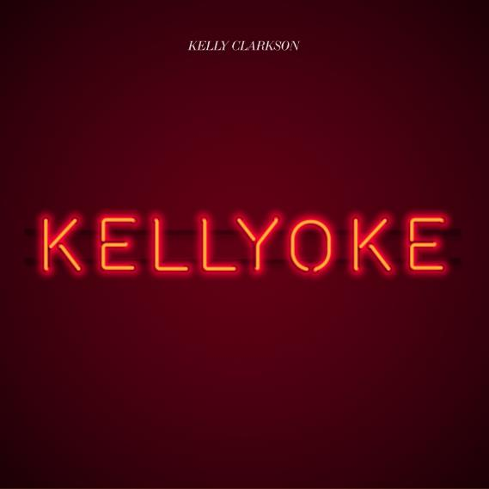
DOWNLOAD HIGH-RES IMAGES + ARTWORK

STREAM “QUEEN OF THE NIGHT”: link
STREAM/BUY KELLYOKE EP: LINK

GRAMMY-winning global superstar Kelly Clarkson has released her blockbuster KELLYOKE EP – available now via Atlantic Records. Preceded by a mighty rendition of Billie Eilish’s “Happier Than Ever” & including a standout cover of Whitney Houston’s “Queen Of The Night,” the 6-track collection features new studio recordings of some of Clarkson’s favorite covers performed on The Kelly Clarkson Show, ranging from modern hits to timeless classics.

“I may not have performed Whitney’s ‘Queen Of The Night’ on my show yet, but little known fact is I covered that song on my very first demo tape… you could say it’s the Kellyoke that started it all!”
– KELLY CLARKSON

Since the premiere of The Kelly Clarkson Show in 2019, Kellyoke has become an institution in its own right with over 500 songs covered to date and counting. The fan-favorite segment sees Clarkson and her band, Y’all, turn audience requests and personal favorites into stunning performances that captivate viewers and the internet alike. A longtime staple of Clarkson’s live show, the series was helmed by her long-time music director Jason Halbert, who along with vocal director Jessi Collins expertly tailor the performances for what has been deemed “one of the best things to happen to daytime television” by Vulture and “wildly popular” by Billboard.

“Music is in the DNA of everything I do, so when ‘The Kelly Clarkson Show’ started we knew it was the perfect way to kick off every episode. Over 500 songs later, and we’re still not running out of amazing artists to pay tribute to. Picking just six was near-impossible, but these songs have been some of my favorites. Thanks for singing along with me y’all!” – KELLY CLARKSON

KELLYOKE EP:
1. “Blue Bayou” (by Linda Ronstadt)
2. “Call Out My Name” (by The Weeknd)
3. “Happier Than Ever” (by Billie Eilish)
4. “Queen Of The Night” (by Whitney Houston)
5. “Trampoline” (by Shaed)
6. “Fake Plastic Trees” (by Radiohead)

ABOUT KELLY CLARKSON:
Kelly Clarkson is among the most popular artists of this era with total worldwide sales of more than 25 million albums and 40 million singles. The Texas-born singer-songwriter first came to fame in 2002 as the winner of the inaugural season of American Idol. Clarkson’s debut single, “A Moment Like This,” followed and quickly went to #1 on Billboard’s Hot 100, ultimately ranking as the year’s best-selling single in the U.S. Further, Clarkson is one of pop’s top singles artists, with 19 singles boasting multi-platinum, platinum and gold certifications around the world, including such global favorites as “Miss Independent” and “Because of You.” Clarkson has released nine studio albums (Thankful, Breakaway, My December, All I Ever Wanted, Stronger, Wrapped In Red, Piece By Piece, Meaning of Life, When Christmas Comes Around…), one greatest hits album, and two children’s books (New York Times Top 10 best seller River Rose and the Magical Lullaby and the follow up River Rose and the Magical Christmas). She is the recipient of an array of awards including three GRAMMY Awards, four American Music Awards, three MTV Video Music Awards, two Academy of Country Music Awards, two American Country Awards, one Country Music Association Award, and two Daytime Emmy Awards. She is also the first artist to top each of Billboard’s pop, adult contemporary, country and dance charts. Clarkson is currently filming season 3 of her own multi-Emmy Award-winning daytime talk show, The Kelly Clarkson Show, which has already been picked up for its 4th season.

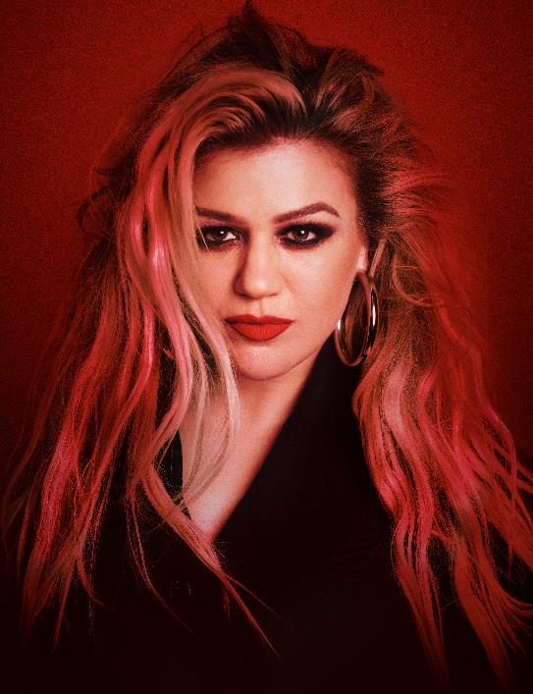
DOWNLOAD HIGH-RES IMAGES (credit: Shane McCauley)

For more information, please visit:
KellyClarkson.com | Facebook | Twitter | Instagram | YouTube | Press Assets

For press inquiries:
Sheila Richman | Sheila.Richman@atlanticrecords.com
Ted Sullivan | Ted.Sullivan@atlanticrecords.com

