FOR IMMEDIATE RELEASE
MARCH 11, 2022

CHICAGO RAP STAR LIL EAZZYY RETURNS WITH NEW SINGLE + VISUAL
“FOREVER BEEN STEPPIN”
STREAM HERE
WATCH HERE

FORTHCOMING MIXTAPE TOO EAZZYY EXECUTIVE PRODUCED BY
GRAMMY-NOMINATED AND MULTI-PLATINUM PRODUCER
CHOP SQUAD DJ TO RELEASE APRIL 22nd
PREORDER HERE

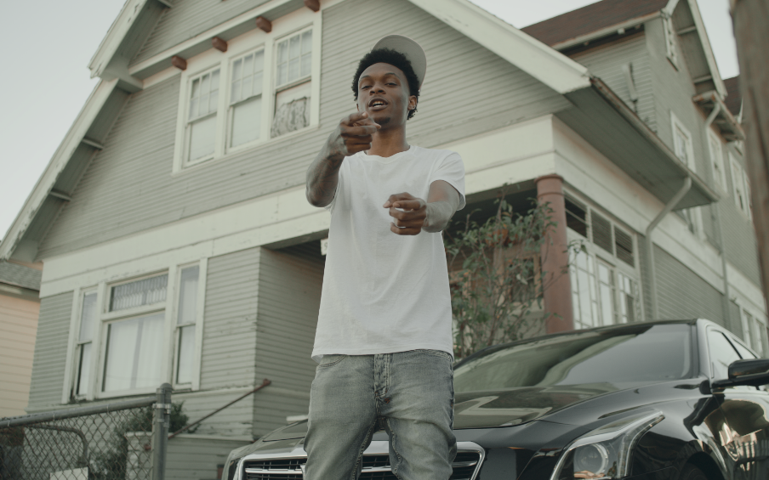
DOWNLOAD THUMBNAIL HERE | DOWNLOAD PRESS IMAGES HERE (press image credit: Jimmy Fontaine)

The new movement of voices for the Chicago streets is in full swing, and Lil Eazzyy is chief among them.
COMPLEX

Eazzyy raps in rolling, rapid, and sometimes melodic cadence that other journalists have compared to Polo G and G Herbo, but Eazzyy raps with such polish and athleticism that similarities fade. You’re only focused on catching every bar.
SPIN

Chicago rap phenomenon, Lil Eazzyy is back with new single, “Forever Been Steppin” in anticipation of his forthcoming mixtape Too Eazzyy. The track is comprised of a 1900s past and present gangster-themed visual directed by SUZY illustrating his immutable lifestyle. SUZY previously directed Eazzyy’s “Spinnin ft Tay Keith.” His upcoming mixtape, Too Eazzyy, set to release April 22nd is executive produced by Grammy-nominated and multi-Platinum producer Chop Squad DJ (Juice WRLD, King Von, Lil Durk, Trippie Redd, Tee Grizzley) and available for pre-order HERE.

In the midst of landing on Rappers to Watch in 2021 lists by Complex, UPROXX, and more, Eazzyy’s 2021 major-label debut, Rookie of the Year, received praise from the likes of HipHopDX, HotNewHipHop, and XXL setting the tone as the future of Chicago’s rap scene. Lead single “Onna Come Up” popped off as a viral phenomenon, eventually surpassed 80 million streams, vaulted to #6 on the Spotify US Viral 50 and #14 on the Global Viral 50 and captured #21 on Rolling Stone’s Breakthrough 25 Chart.
Multiplatinum Chicago luminary G Herbo hopped on the remix, surpassing 134M million streams worldwide and 185 million views globally of its official video, as well as claimed prime spots on influential playlists including Apple’s New Music Daily and The Plug, Spotify’s Rap Caviar and Most Necessary, and Amazon Music’s Hype Music where it graced the cover.

“His latest tape Rookie of the Year continues to drive this point home: that he is the best rapper out right now. The tape features songs that carry a soulful melody and songs like "Trials" that are just straightforward lyrical storytelling. Eazzyy even dabbles in Brooklyn Drill on "Hunnid or Better," and then hits an off-the-dome freestyle.”
POPDUST

Driven by a fiercely competitive spirit, Lil Eazzyy tenaciously tears through production with enough endurance and stamina to stand tall next to the greats coming out of Chicago. Coming out of the gate swinging as a high school senior, he announced himself with “Finesse” in 2019 before posting up millions of streams via “Listen Up,” “Letter To Tracy,” and “Yerk Attack.” These early fan favorites paved the way for his 2019 debut EP, Underrated, which Lyrical Lemonade touted as #8 on their “Top 50 Chicago Projects of 2020” list. Plus, he joined the bill of Cyberwurld Fest headlined by Playboi Carti for his first live virtual performance the same year.

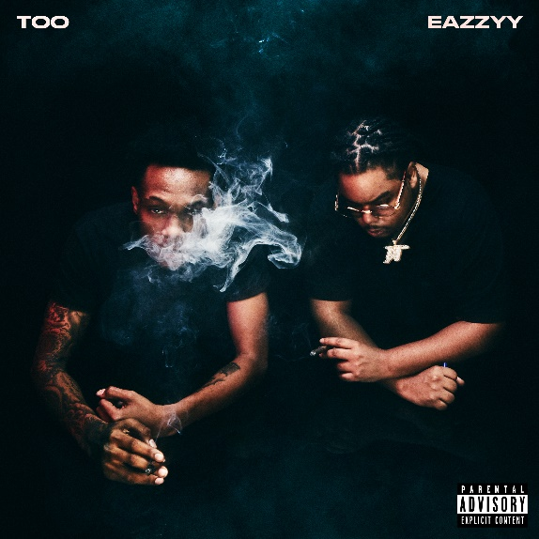
DOWNLOAD HIGH-RES ARTWORK HERE

CONNECT WITH LIL EAZZYY
TWITTER | INSTAGRAM | SPOTIFY | YOUTUBE | SOUNDCLOUD

LIL EAZZYY PRESS CONTACT
BRITTANY BELL | BRITTANY.BELL@ATLANTICRECORDS.COM

