FOR IMMEDIATE RELEASE
MAY 9, 2022

LIL EAZZYY TAGS NLE CHOPPA ON NEW SINGLE
“BRING SOME MO”
STREAM HERE

EAZZYY JOINS NLE CHOPPA ON U.S HEADLINING TOUR

FORTHCOMING MIXTAPE TOO EAZZYY PRODUCED BY
GRAMMY-NOMINATED AND MULTI-PLATINUM PRODUCER CHOP SQUAD DJ
TO RELEASE MAY 13TH
PREORDER HERE

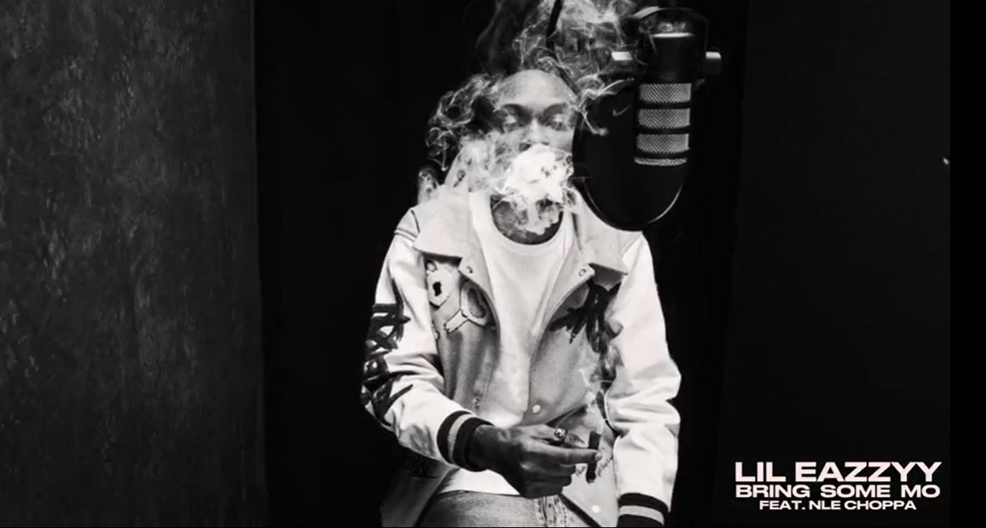
DOWNLOAD THUMBNAIL HERE |DOWNLOAD PRESS IMAGES HERE(press image credit: Jimmy Fontaine)

Chicago Rapstar, Lil Eazzyy does not hold back on new single, “Bring Some Mo ft. NLE Choppa,” produced by Grammy-nominated and multi-Platinum producer Chop Squad DJ. Listen HERE. The track comes days before the Chop Squad DJ-produced project, Too Eazzyy, set to release May 13th. Available for pre-order HERE.

“Bring Some Mo” comes on the heels of Eazzyy heading out on NLE Choppa’s U.S headlining tour, which began May 1st and wraps June 5th. Recently, he sat down with TRSH MAG for their TRSH TALK interview series and live performance of “Forever Been Steppin”. Driven by a fiercely competitive spirit, Lil Eazzyy tenaciously tears through production with enough endurance and stamina to stand tall next to the greats coming out of Chicago.

Previously Eazzyy released his second single off the forthcoming EP, “Nothing Left”. The SUZY-directed companion visual illustrates Eazzyy’s got to have it all mentality. Gearing up for his sophomore debut, he kicked off 2022 with his first single off the EP “Forever Been Steppin, declaring his immutable lifestyle.

His 2021 major-label debut, Rookie of the Year, landed him on Rappers to Watch in 2021 lists by Complex and UPROXX, and received praise from the likes of HipHopDX, HotNewHipHop, and XXL. Lead single “Onna Come Up” popped off as a viral phenomenon, surpassing 80 million streams, vaulting to #6 on the Spotify US Viral 50 and #14 on the Global Viral 50 and captured #21 on Rolling Stone’s Breakthrough 25 Chart. Multi-platinum Chicago luminary, G Herbo, hopped on the remix, surpassing 134M million streams worldwide and 185 million views globally of its official video, as well as claimed prime spots on influential playlists including Apple’s New Music Daily and The Plug, Spotify’s Rap Caviar and Most Necessary, and Amazon Music’s Hype Music where it graced the cover. Initially announcing himself with “Finesse” in 2019 before posting up millions of streams via “Listen Up,” “Letter To Tracy,” and “Yerk Attack; he became a fan favorite early on. It paved the way for his 2019 debut EP, Underrated, which Lyrical Lemonade touted as #8 on their “Top 50 Chicago Projects of 2020” list.

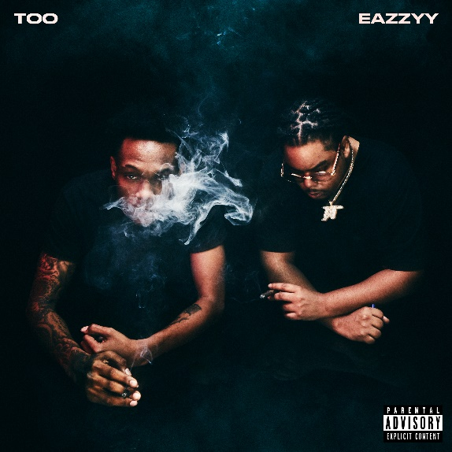
DOWNLOAD HIGH-RES ARTWORK HERE

CONNECT WITH LIL EAZZYY
TWITTER | INSTAGRAM | SPOTIFY | YOUTUBE | SOUNDCLOUD

LIL EAZZYY PRESS CONTACT
BRITTANY BELL | BRITTANY.BELL@ATLANTICRECORDS.COM

