FOR IMMEDIATE RELEASE
MAY 19, 2022

MATT MAESON RETURNS WITH “BLOOD RUNS RED”

CHART-TOPPING SINGER-SONGWRITER UNVEILS SINGLE ALONGSIDE OFFICIAL MUSIC VIDEO

FEATURED ON ILLENIUM’S 2022 BILLBOARD MUSIC AWARD-WINNING ALBUM FALLEN EMBERS

US LIVE SCHEDULE INCLUDES INTIMATE ACOUSTIC SHOWS AND TOP-BILLED PERFORMANCE
AT DOVER, DE’S FIREFLY MUSIC FESTIVAL

“BLOOD RUNS RED” AVAILABLE NOW VIA NEON GOLD/ATLANTIC
AT ALL DSPS AND STREAMING SERVICES

LISTEN TO “BLOOD RUNS RED” | WATCH OFFICIAL MUSIC VIDEO

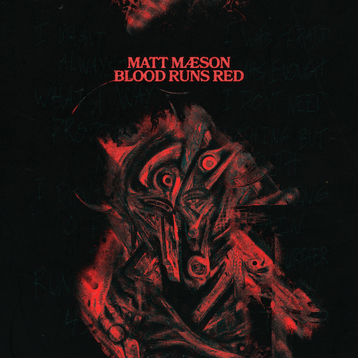
(Download Hi-Res Image // Painting by Jay Young
Graphic Design & Layout by Rozwell)

Chart-topping, RIAA platinum certified singer-songwriter Matt Maeson is back with emotive, reflective new single “Blood Runs Red,” available now via Neon Gold/Atlantic at all DSPs and streaming services. Maeson pairs his new track with official music video – directed by longtime collaborator Jesse DeFlorio– premiering today on YouTube HERE. The video depicts Maeson’s personal demons and the strength to become grounded.

“Blood Runs Red is a song about being a successful artist and the narcissistic tendencies that come along with it. I toured for 3 years straight and received copious amounts of validation but when that ends and you go home, you’re left with yourself and who you’ve become while everyone else around you has remained the same.”

-Matt Maeson

Currently boasting over 1B worldwide streams and more than 122M video views, marquee alternative artist, Matt Maeson will return to the road for a number of upcoming live Intimate Solo Acoustic shows and a much-anticipated performance at Dover, DE’s Firefly Music Festival (September 22-25). For updates, please visit www.mattmaeson.com.

MATT MAESON ACOUSTIC SHOWS
LIVE 2022

MAY
29 – Memphis, TN – Growlers

JUNE
3 – Charleston, SC – Music Farm
4 – Asheville, NC – The Grey Eagle

JULY
7 - Tallahassee, FL - 926 Bar
9- Jacksonville, FL - Ponte Vedra
11 -Tampa, FL - Crowbar
12 - Orlando, FL - The Abbey
14 - Gainesville, FL - High Dive
16 - Ft Lauderdale, FL - Revolution Live

SEPTEMBER
22-25 – Dover, DE – Firefly Music Festival *

* FESTIVAL PERFORMANCE

# # #

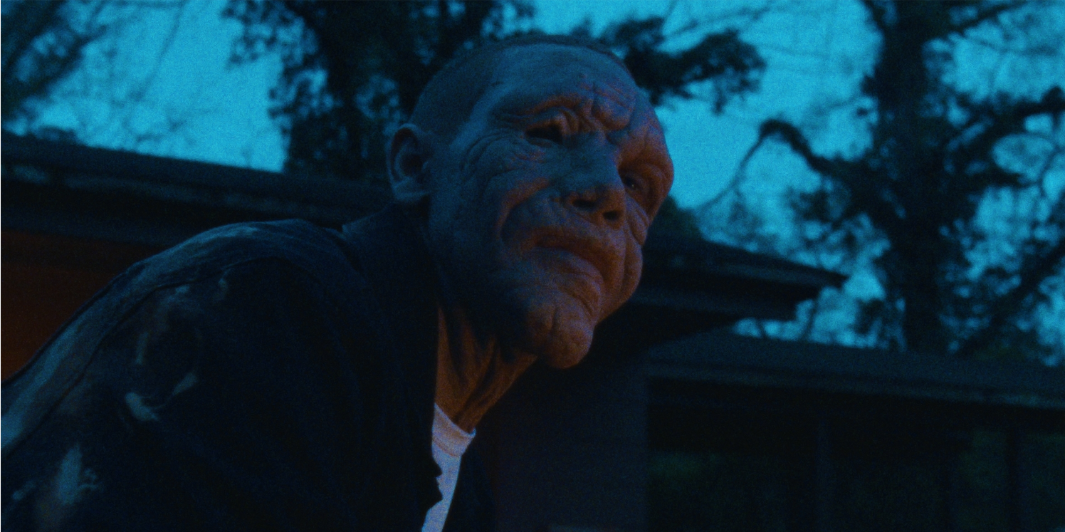

2019 saw Maeson arrive at the forefront of American Alternative music with his critically acclaimed breakthrough debut album, Bank On The Funeral, highlighted by the RIAA platinum certified single, “Cringe,” which spent four consecutive weeks atop Billboard’s “Alternative Songs” chart after a steady 25-week climb. Maeson then made history with the gold certified “Hallucinogenics (Feat. Lana Del Rey),” which spent three weeks at #1 on the Alternative chart while also proving his first multi-format hit by topping Triple A airplay charts nationwide. The triumphant success of “Hallucinogenics” affirmed Maeson as the first ever male solo artist to earn two #1 Alternative hits from a full-length debut album and only the fifth male artist to accomplish that achievement following iconic superstars Beck, Elvis Costello, Peter Gabriel, and Morrissey. Moreover, Maeson joined Cage the Elephant and Bush as one of only three artists in history have had two number #1 Alternative hits on their debut album.

Hailed by American Songwriter for “(creating) a sound unlike much else out there,” Matt Maeson has been on a remarkable journey all his life. The Chesapeake Bay, VA-native grew up on tour, traveling and performing with his parents’ prison ministry at maximum-security penitentiaries across America. His experiences – which include winning over crowds of naked women and Hells Angels at the world-famous Sturgis Motorcycle Rally in South Dakota – inspired him to begin writing songs, spare and powerful confessionals infused with additional strength via his raw, soulful vocal approach. Maeson posted his first songs online in late 2015 and the following summer, embarked on his first US headline tour, presented by Communion, the influential artists’ collective co-founded by Mumford and Sons’ Ben Lovett.

Bank On The Funeral – available now at all DSPs and streaming services HERE – earned wide-ranging critical applause upon its April 2019 release. “Maeson has been impressing the world with his dynamically emotional lyrics and equally powerful melodies with every song he releases,” raved Ones To Watch, “and Bank On The Funeral is no different. His authoritative voice commands the attention of anyone in earshot. Maeson strays on the lines between folk and alternative-pop, showcasing his diverse inspirations ranging from Johnny Cash to Kurt Cobain.” “On first glance, there’s nothing fancy about Virginia-born singer-songwriter Matt Maeson: just a guy and his guitar,” agreed TIME. “But his raw performance is bound to get right under your skin as its intensity builds.”

Last year saw Maeson share the standalone single, “Nelsonwood Lane,” joined by an official music video directed by DeFlorio and streaming now at YouTube HERE. In addition, Maeson also unveiled USERx, an extraordinary musical partnership with his longtime collaborator, producer/designer Rozwell. Pronounced simply as “USER,” USERx made their beautifully warped debut with 2021’s self-titled USERx EP, available now HERE. The EP – which sees the two hometown friends sharing lead vocal duties, with Maeson on guitar and Rozwell programming and producing – includes such remarkable tracks as “My Body Left My Soul (Feat. Pusha-T),” “Waterman,” “Above (Feat. Masego & West Banks),” and “Headsick (Feat. Manchester Orchestra)

Now based in Nashville, TN, Maeson has spent much the past half decade on the road, including his own headline tours, support runs alongside artists like Jaymes Young, Bishop Briggs, and Vallis Alps, and show-stopping sets at such top festivals as Bonnaroo, Lollapalooza, Forecastle, and more.

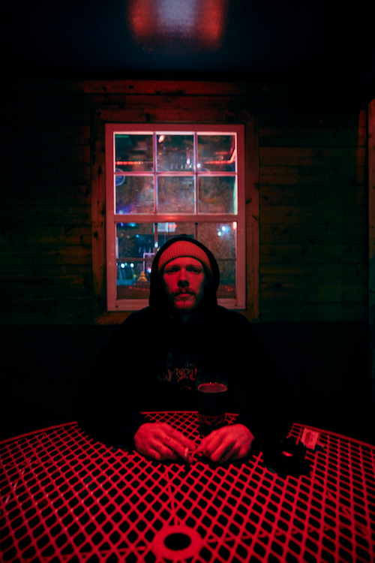
(Download Hi-Res Image // Photo Credit: Jimmy Fontaine)

PRESS CONTACT
COREY BREWER |COREY.BREWER@ATLANTICRECORDS.COM

CONNECT WITH MATT MAESON
MATTMAESON.COM | FACEBOOK | TWITTER | INSTAGRAM | YOUTUBE

###

