FOR IMMEDIATE RELEASE
JUNE 2, 2022

QUANDO RONDO RELEASES LATEST SINGLE AND VISUAL “WAR BABY”

MULTI-PLATINUM RAPPER SETS THE AIRWAVES ON FIRE WITH FOLLOW UP TO “24”

LISTEN TO “WAR BABY” HERE | WATCH OFFICIAL MUSIC VIDEO HERE

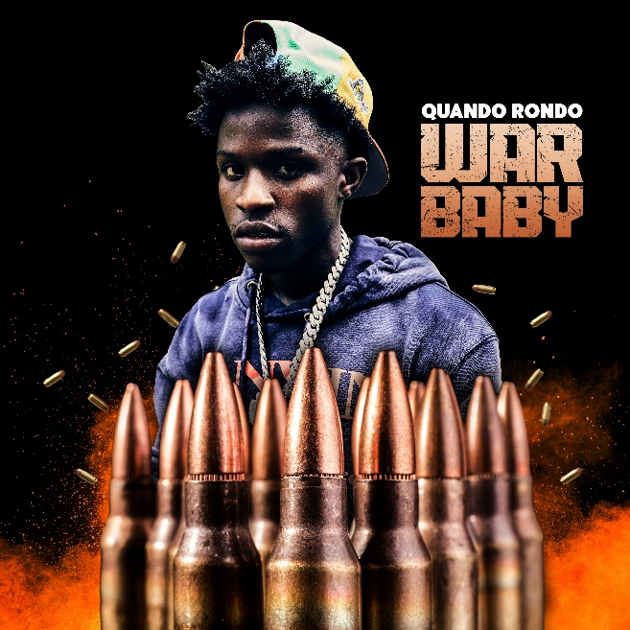

Multi-platinum rapper Quando Rondo is continuing his landmark year with today’s release of his latest single, “War Baby,” available now at all DSPs HERE. The track is accompanied by a visual available for streaming via YouTube HERE. The single is also a follow up to his previous single “24” available for streaming via YouTube HERE.

“War Baby” continues the rising star’s high-volume year, following such recently released tracks as “24” “10.27,” “Six-0 Business,” “Jakiyah” and his recent guest verse on YoungBoy Never Broke Again’s “Gangsta (Ft. Quando Rondo)” – the only feature on YoungBoy’s chart-topping 2022 mixtape, COLORS. What’s more, YoungBoy shouts out Quando on two of the mixtape’s standout tracks, “Bring It On” and “No Switch.”

Quando officially kicked off his busy 2022 with the recently released single, “Dead Wrong,” available for streaming and download HERE; an official music video is streaming HERE. The creative hot streak commenced with last year’s release of the critically acclaimed album, Still Taking Risks, and was swiftly followed by guest verses on the explosive Never Broke Again: The Compilation Vol. 1. A stunning series of singles also dropped, including “Blueprint,” “The Realest,” “Time Spent,” “What I’m On (Ft. Jo Dirt),” and “Shine,” all available now with official music videos streaming via YouTube.

# # #

CONNECT WITH QUANDO RONDO
OFFICIAL | INSTAGRAM | TWITTER | FACEBOOK | YOUTUBE

FOR ALL PRESS INQUIRIES, PLEASE CONTACT:
ARIANA.WHITE@ATLANTICRECORDS.COM

