FOR IMMEDIATE RELEASE
FEBRUARY 18, 2022

RAICHE RETURNS WITH “COMPLICATED”

RISING R&B STAR UNVEILS NEW SINGLE

“COMPLICATED” AVAILABLE NOW AT ALL DSPS AND STREAMING SERVICES

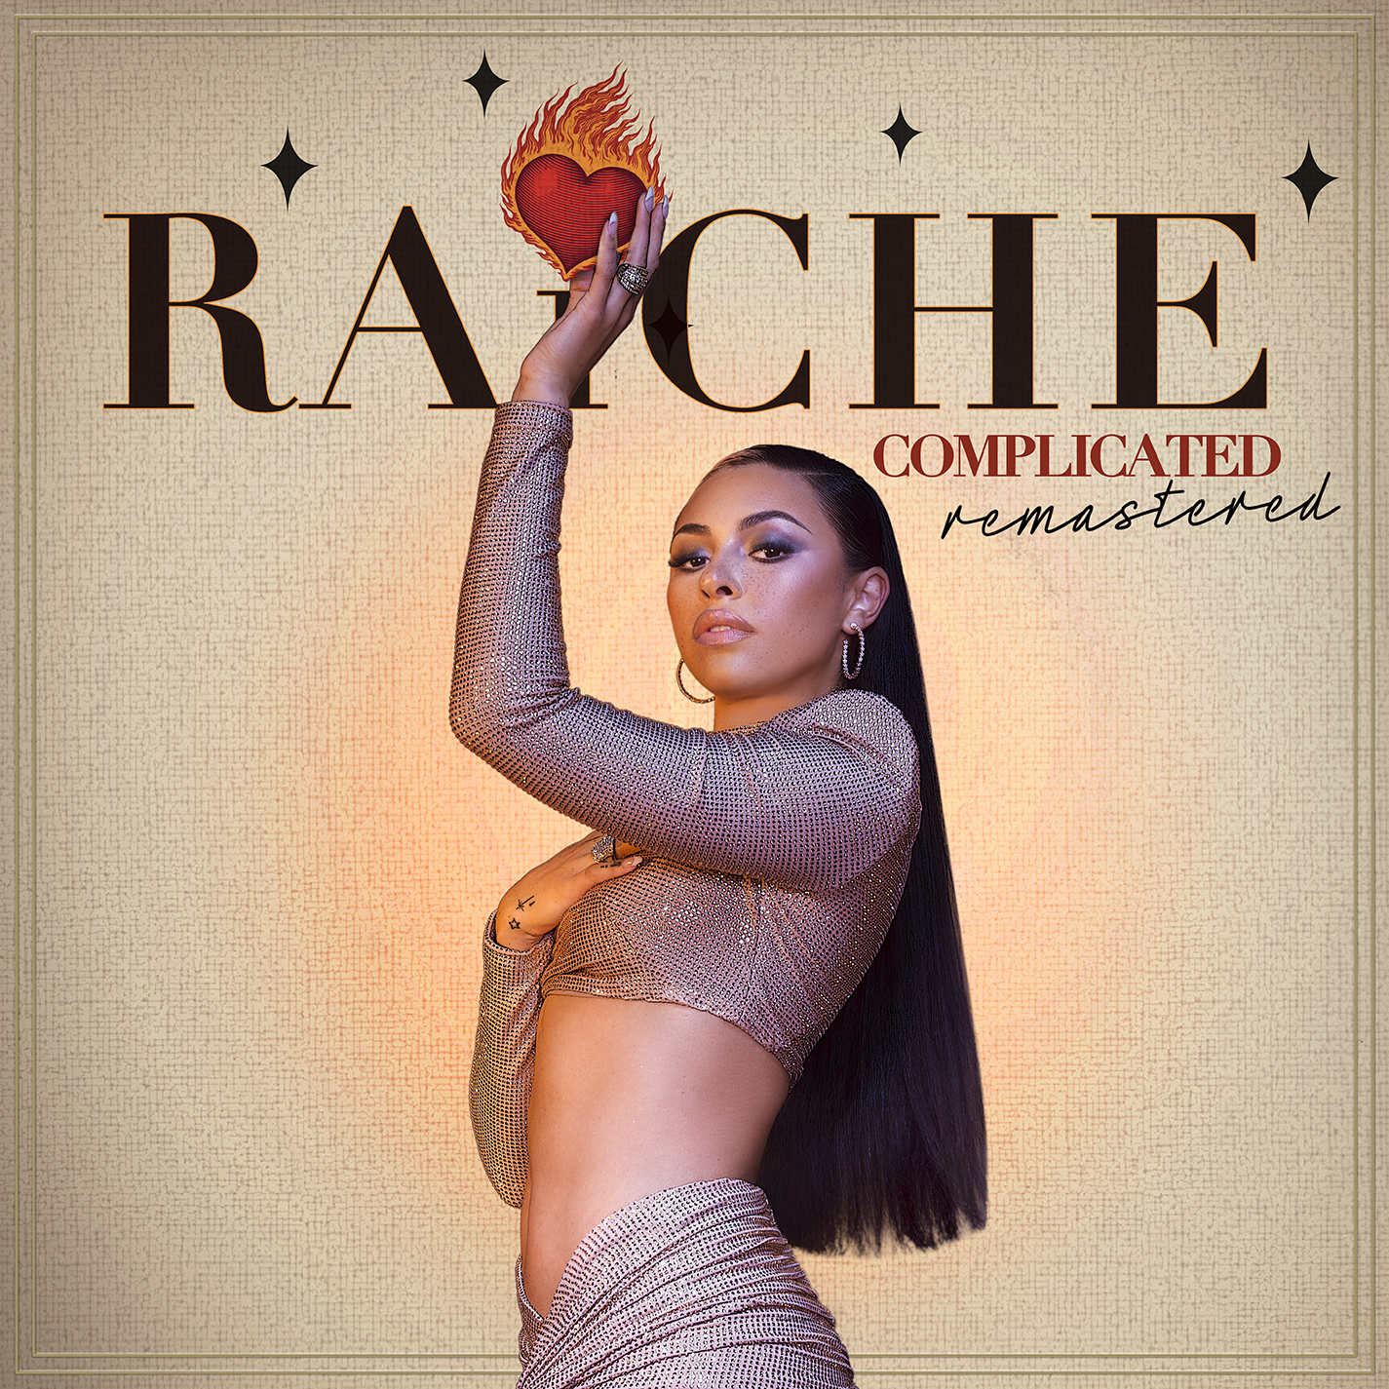

R&B vocalist Raiche has announced today’s release of her single, “Complicated,” available now via GDE/Island Prolific/Atlantic Records at all DSPs and streaming services.

Last year saw Raiche return with the sultry “Burn Your Clothes,” available now at all DSPs and streaming services; an official music video is streaming now HERE. The first single from Raiche’s new project, LOVELAND, due later this year, “Burn Your Clothes” follows her smash 2020 release, “Pick A Side,” which reached #2 at R&B radio outlets nationwide while earning more than 5M worldwide streams. The track is joined by an official music video (streaming HERE) as well as a melodic remix featuring 2x GRAMMY® Award-nominated R&B icon Ty Dolla $ign, available now at all DSPs and streaming services HERE. Raiche further celebrated “Pick A Side” with a spectacular live performance on NBCUniveral’s nationally syndicated Kelly Clarkson Show, streaming HERE.

Named one of Billboard’s “15 Hip-Hop & R&B Artists to Watch in 2021” as well as an ESSENCE “Rising Star,” YouTube “Artist on the Rise,” and iHeartRadio “On The Verge Artist,” Raiche has quickly proven to be a creative sensation and breath of fresh air in contemporary R&B. The gifted young artist fuses soulful roots with modern pop to concoct a genuinely distinctive new sound all her own, lit up with confidence, consistency and positivity. Born and raised in Pittsfield, MA, just two hours outside of Boston, Raiche devoted her energies towards music from an early age, uploading cover videos to YouTube that almost immediately earned her online applause. Her musical dreams almost came to a halt following high school graduation but some encouraging words from her beloved Nana eventually led her to Boston, where she met DJ Knock Out. The local legend soon introduced Raiche to her GDE production team as well as to superstar songwriter Prince Charlez (Rihanna, Beyoncé, Usher), who promptly signed the talented vocalist to his recently launched Island Prolific imprint at Atlantic Records.

Now boasting over 19.1M worldwide streams across her growing body of work, Raiche made her national debut with 2018’s “Money Pies,” streaming HERE; a colorful official video – directed by the all-female Verluxe collective – can be viewed HERE. Raiche’s acclaimed debut EP, DRIVE, followed the next year, highlighted by “Complicated” and the powerful title track, “Drive,” featured in Netflix’s Self Made: Inspired by the Life of Madam C.J. Walker.

CONNECT WITH RAICHE
MYNAMEISRAICHE.COM | FACEBOOK | TWITTER | YOUTUBE | INSTAGRAM | SPOTIFY | SOUNDCLOUD
FOR PRESS INQUIRIES CONTACT:
SYDNEY.MARGETSON@ATLANTICRECORDS.COM

