FOR IMMEDIATE RELEASE
JUNE 7, 2022

SEDDY HENDRINX RELEASES NEW SINGLE AND VIDEO “LIGHTS”

ACCLAIMED JACKSONVILLE, FL RAPPER RETURNS WITH FIRST OFFERING
FROM HIS UPCOMING EP, WELL SED

DOWNLOAD/STREAM
WATCH/SHARE

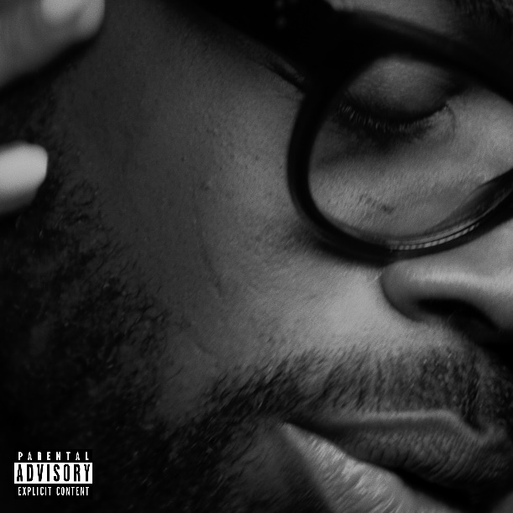

Today, Jacksonville, FL rapper and singer Seddy Hendrinx released his latest single “Lights” streaming now on all DSPs HERE. The single is accompanied by a visual directed by Blu and sees Seddy spending time with a love interest as he perfects his signature melodic trap sound as he serenades her throughout. The simple yet intimate visual, shot in black and white, gives a seductive feel while still giving a fun vibe to start the summer off.

“Lights” also comes after Seddy’s recent appearance and freestyle on the Power 105.1 sponsored On the Radar by Gabe P. Seddy also held his first ever #WELLSED pop up earlier this year at Atlanta, GA’s Full Circle ATL celebrating his recently launched merch brand. A recap of the sold-out event – which also included a special first listen to Well Sed – is available here.

Melodic trap’s rising star Seddy Hendrinx continues to keep his eyes set on longevity with a string of recent releases like “Dotted Line,” “Reason,” “How I Feel,” and “Damn Damn” garnering close to 300k+ views in total. Seddy also released a series of increasingly eclectic tracks throughout last year, including “Lost,” “Trying (Ft. K Camp),” and “Breathe (Ft. Major Nine),” all streaming now alongside a growing selection of vlogs and studio sessions at his official YouTube channel HERE.

Hailed by Complex as “a versatile artist who excels at creating emotionally-rich and cathartic music” and their “Rappers to Watch in 2021,” Seddy Hendrinx exercises raw emotion in each verse and every hook. Joining forces with Florida Boy Entertainment, Generation Now, and Atlantic Records, Seddy made mainstream waves on 2019’s “LOWKEY,” setting the stage for Roots 2 and a lot more “street soulful, real deal pain music.” With his eyes set on longevity, Seddy kept at it, including a featured track on 2020’s 1800 Seconds Vol. 2, a compilation album curated by platinum superstar Future showcasing the hottest rising stars from around the country. B.H.D. (Black Hearted Demon) followed, earning acclaim from Flaunt as “his most impressive project yet.”

###

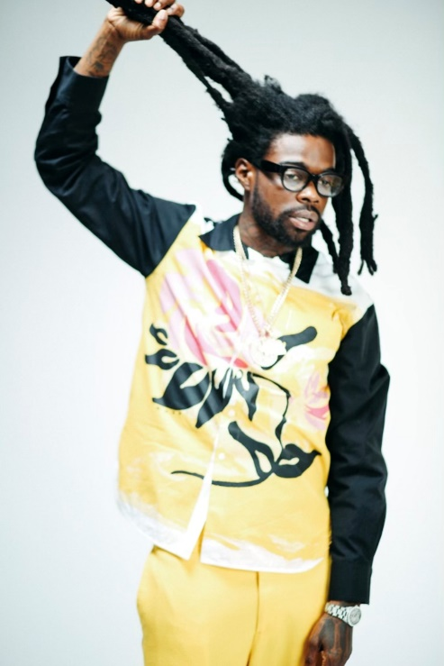

CONNECT WITH SEDDY HENDRINX
FACEBOOK | TWITTER | INSTAGRAM | SOUNDCLOUD | YOUTUBE

PRESS CONTACT
SELAM.BELAY@ATLANTICRECORDS.COM

