FOR IMMEDIATE RELEASE
MARCH XX, 2022

SEDDY HENDRINX IS BACK WITH WELL SED

ACCLAIMED JACKSONVILLE, FL RAPPER RETURNS WITH NEW EP

HIGHLIGHTS INCLUDE TITLE TRACK ALONGSIDE FEATURES FROM
T-PAIN AND FIVIO FOREIGN

WELL SED AVAILABLE NOW VIA FLORIDA BOY ENTERTAINMENT/
GENERATION NOW/ATLANTIC RECORDS

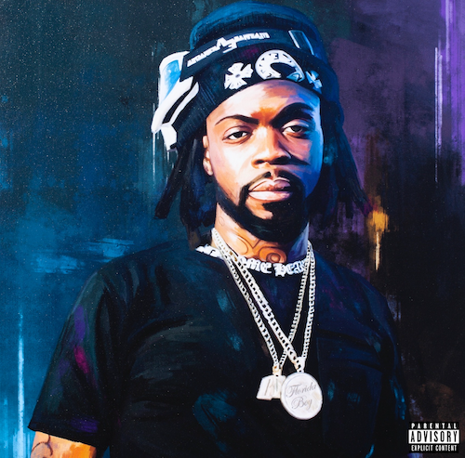

“A creative force to be reckoned with…Seddy’s music is emotionally potent and personal, and he has carved his own lane through creating uniquely cathartic bangers.”
– EARMILK

“Seddy creates the perfect blend of hip-hop and R&B, injecting emotion and feeling into his songs.”
– FLAUNT

Jacksonville, FL rapper and singer Seddy Hendrinx has unveiled his eagerly awaited new mixtape. Well Sed is available now via Florida Boy Entertainment/Generation Now/Atlantic Records.

Well Sed sees Seddy continuing to blend melodic trap and R&B with his natural talent and effortless charisma, highlighted by the striking title track as well as features from GRAMMY® Award-winning superstar T-Pain and rising NYC rapper Fivio Foreign.

Earlier this month, Seddy held his first ever #WELLSED pop up at Atlanta, GA’s Full Circle ATL celebrating his recently launched merch brand. An exclusive recap of the sold-out event – which also included a special first listen to Well Sed – is streaming HERE.

Hailed by Complex as “a versatile artist who excels at creating emotionally-rich and cathartic music,” Seddy Hendrinx exercises raw emotion in each verse and every hook. Despite professing fandom for Tupac, Lauryn Hill, André 3000, DMX, Future, and Erykah Badu, rap never seemed like an option until he witnessed the murder of his best friend Johnell in 2016. Gunned down at a party, Johnell’s last words struck a chord with Seddy: “Ball out for me.”

Upholding his promise to do so, Seddy tried his hand at an unofficial remix of Bryson Tiller’s “Remember” and quickly caught fire on Soundcloud. The Roots mixtape dropped in 2017, followed by that same year’s Just Cause EP and 2018’s Death B4 Dishonor: Loyalty Over Everything. Joining forces with Florida Boy Entertainment, Generation Now, and Atlantic Records, Seddy made mainstream waves on 2019’s “LOWKEY,” setting the stage for Roots 2 and a lot more “street soulful, real deal pain music.”

With his eyes set on longevity, Seddy kept at it, including a featured track on 2020’s 1800 Seconds Vol. 2, a compilation album curated by platinum superstar Future showcasing the hottest rising stars from around the country. B.H.D. (Black Hearted Demon) followed, earning acclaim from Flaunt as “his most impressive project yet.” Seddy returned later that same year with Sayless, features guest appearances by G Herbo, Jetsonmade, Jack Harlow, Gunna, and 24HRS. His stacked 2020 concluded with the release of “45 (Feat. A Boogie Wit Da Hoodie),” joined by an official music video now with close to 1.5M views via YouTube.

Named among Complex’s “Rappers to Watch in 2021,” Seddy released a series of increasingly eclectic tracks throughout last year, including “Lost,” “Trying (Ft. K Camp),” and “Breathe (Ft. Major Nine),” all streaming now alongside a growing selection of vlogs and studio sessions at his official YouTube channel HERE. 2022 has already seen an array of new track releases, setting up what looks to be Seddy Hendrinx’s most productive and creative season thus far.

“I want to wake everybody up to respect real music again,” Seddy says. “I want to get the game back to rapping. No matter what you like, you can play this.”

# # #

SEDDY HENDRINX
Well Sed
(Florida Boy Entertainment/Generation Now/Atlantic Records)

TRACKLIST
Well Sed
Groovy (Ft. Fivio Foreign)
Can’t Go
Crash Dummies
Body 2 Body (Ft. T-Pain)
Lights
Monday Thru Sunday
Passion
Heartbeat
Again

# # #

CONNECT WITH SEDDY HENDRINX
FACEBOOK | TWITTER | INSTAGRAM | SOUNDCLOUD | YOUTUBE

PRESS CONTACT
SELAM.BELAY@ATLANTICRECORDS.COM

