FOR IMMEDIATE RELEASE
MARCH 30, 2022

SILK SONIC TO OPEN THE 64TH ANNUAL GRAMMY AWARDS®
WITH LIVE PERFORMANCE ON CBS APRIL 3RD AT 8PM (ET)

DUO RELEASES THREE VERSION EXCLUSIVE VINYL SET
TO CELEBRATE GRAMMY WEEKEND
AVAILABLE VIA WEB STORE + IN-STORE
PURCHASE HERE

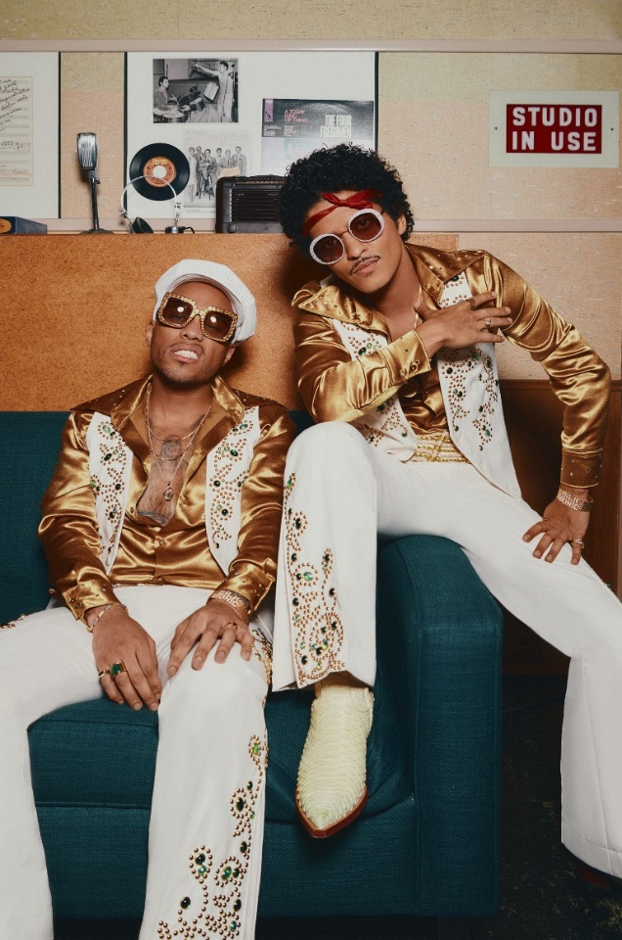
Download Asset(s) Here
Photo Credit: John Esparza

LOS ANGELES, LA – MARCH 30, 2022: The Recording Academy® has officially added Silk Sonic to their list of additional performers for the 64th Annual GRAMMY Awards®. The duo will open the show with a performance on the GRAMMY Awards® telecast live from MGM Grand Garden Arena in Las Vegas. Silk Sonic is up for four GRAMMY awards, Record Of The Year ("Leave The Door Open"), Song Of The Year ("Leave The Door Open"), Best R&B Performance ("Leave The Door Open"), and Best R&B Song ("Leave The Door Open"). Hosted by Trevor Noah, the 64th Annual GRAMMY Awards will be broadcast live on Sun, April 3, 2022, at 8 p.m. ET/5 p.m. PT on the CBS Television Network and will be available to stream live and on demand on Paramount+.

Adding to the excitement, surrounding the duo’s success, Silk Sonic released a three-version exclusive vinyl set. The online set is available in the Silk Sonic webstore with a velvety sleeve and additional track, “Love’s Train.” The in-store version can be purchased HERE with an exclusive translucent yellow version at Walmart or an alternate cover version at Target.

Silk Sonic recently accepted the Best Duo/Group of the Year award at the 2022 iHeart Radio Music Awards simultaneously winning Outstanding Album, Outstanding Duo, Group or Collaboration at the 2022 NAACP Image Awards.

ABOUT SILK SONIC:
Silk Sonic introduced “Leave The Door Open” in March 2021 alongside an official music video directed by Mars and Florent Déchard, which won Best R&B Video and Best Editing at the 2021 MTV Music Video Awards. The track was followed by a hugely popular social media campaign, #LetSilkSonicThrive, which earned them a debut live performance at the GRAMMY® Awards (plus a powerful tribute to Little Richard) followed quickly by iconic live sets at the iHeartRadio Music Awards and the BET Awards. “Leave The Door Open” became Silk Sonic’s first #1 single on the Billboard Hot 100, spending two non-consecutive weeks at #1 and 18 consecutive weeks in the top 10. In the meantime, their infectious jingle co-written and performed for SelvaRey Rum amassed widescale praise over the summer. The duo then coasted into their sophomore release of “Skate,” which saw them glide into a second top 10 hit on Billboards Hot R&B/Hip-Hop Songs as it debuted at #4 and began as the genre’s best-selling song of the week. “Smokin Out The Window” arrived last week with Billboard noting how “Anderson .Paak and Bruno Mars take it all the way back to the 1970s Soul Train era in the retro video. [It]finds them going through their choreo on an old school TV set while rocking wide lapel tuxedo jackets.” An Evening With Silk Sonic is out now.

CONNECT WITH SILK SONIC
WEBSITE | FACEBOOK | TWITTER | INSTAGRAM | YOUTUBE | TIKTOK | SPOTIFY | APPLE MUSIC

CONNECT WITH BRUNO MARS
WEBSITE | FACEBOOK | TWITTER | INSTAGRAM | YOUTUBE

CONNECT WITH ANDERSON .PAAK
WEBSITE | FACEBOOK | TWITTER | INSTAGRAM | YOUTUBE

CONTACT FOR SILK SONIC/BRUNO MARS:
SHEILA.RICHMAN@ATLANTICRECORDS.COM
BRITTANY.BELL@ATLANTICRECORDS.COM

CONTACT FOR ANDERSON .PAAK:
KRISTEN.FOSTER@FULLCOV.COM
ERICA.GERARD@FULLCOV.COM

CONTACT FOR ATLANTIC RECORDS:
BRITTANY.BELL@ATLANTICRECORDS.COM

###

