FOR IMMEDIATE RELEASE
OCTOBER 11, 2019
SEDDY HENDRINX INTRODUCES ROOTS II MIXTAPE

INCLUDES FEATURES FROM LIL POPPA & OMB PEEZY

ACCOMPANIED BY NEW VISUAL, “DEAD HOMIES”
SEES CAMEOS FROM JACK HARLOW, KILLUMANTII AND OMB PEEZY

DOWNLOAD/STREAM ROOTS II: https://Seddy.lnk.to/RootsII
WATCH/SHARE “DEAD HOMIES”: https://youtu.be/2KrKeYA0Cg0

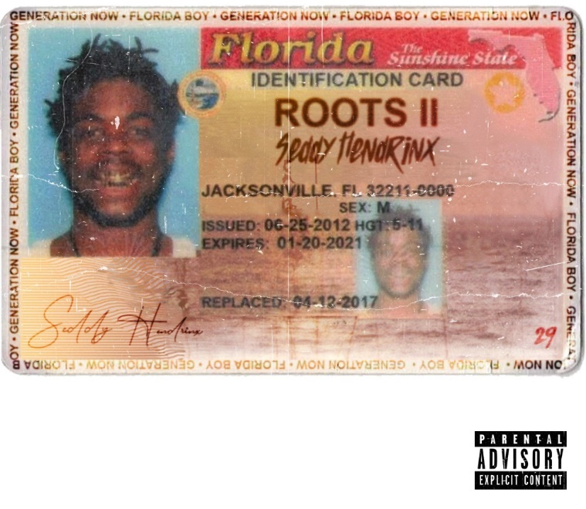
Jacksonville, FL rapper SEDDY HENDRINX has introduced his latest mixtape, ROOTS II. Guest features include Lil Poppa and OMB Peezy. The mixtape is accompanied by a new companion visual for one of the mixtape’s tracks, “Dead Homies” which sees appearances from Jack Harlow, Killumantii and OMB Peezy.

DOWNLOAD/STREAM ROOTS II: https://Seddy.lnk.to/RootsII
WATCH/SHARE “DEAD HOMIES”: https://youtu.be/2KrKeYA0Cg0

Seddy first broke onto the scene with an unofficial remix to Bryson Tiller’s “Remember” and it quickly caught fire on Soundcloud. Soon after he dropped THE ROOTS mixtape in 2017 followed by the JUST CAUSE EP and 2018’s DEATH B4 DISHONOR; LOYALTY OVER EVERYTHING. He returned earlier this year with the earworm “LOWKEY” which has accumulated nearly half a million views on YouTube. This track ultimately set the stage for ROOTS II and a lot more “street soulful real deal pain music” says Seddy.

ROOTS II
SEDDY HENDRINX
(Florida Boy Entertainment/Generation Now)

- Feel
- IDK
- Exclusive Drip
- Dead Homies
- Earnings
- Pain
- Lessons ft. Lil Poppa
- Lowkey
- Klosure
- Ain’t Goin
- Dickies & Vlones ft. OMB Peezy
- Elmo
- 904

DOWNLOAD OFFICIAL PRESS IMAGE HERE
PHOTO CREDIT: SPUDDS MCKENZIE

KEEP UP WITH SEDDY HENDRINX
INSTAGRAM| SOUNDCLOUD | YOUTUBE

PRESS CONTACT
SELAM BELAY // SELAM.BELAY@ATLANTICRECORDS.COM

