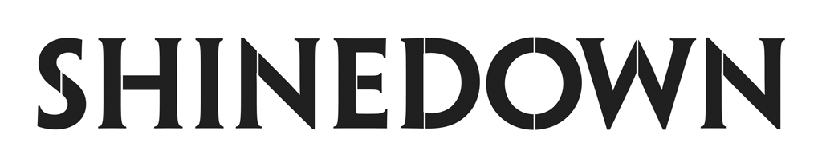

**Releases Soaring Anthem About Our Human Connections**

**“Daylight” Single Out Now**

[**PRESS HERE**](http://shinedown.lnk.to/Daylight) **To Listen**

***You saved my life // Not once but twice***

***You keep me free from falling***

***You saved my life // Make it all alright***

***When I don’t feel like talking***

***You make sure I always see the daylight***

***Planet Zero* Album Out July 1 on Atlantic Records**

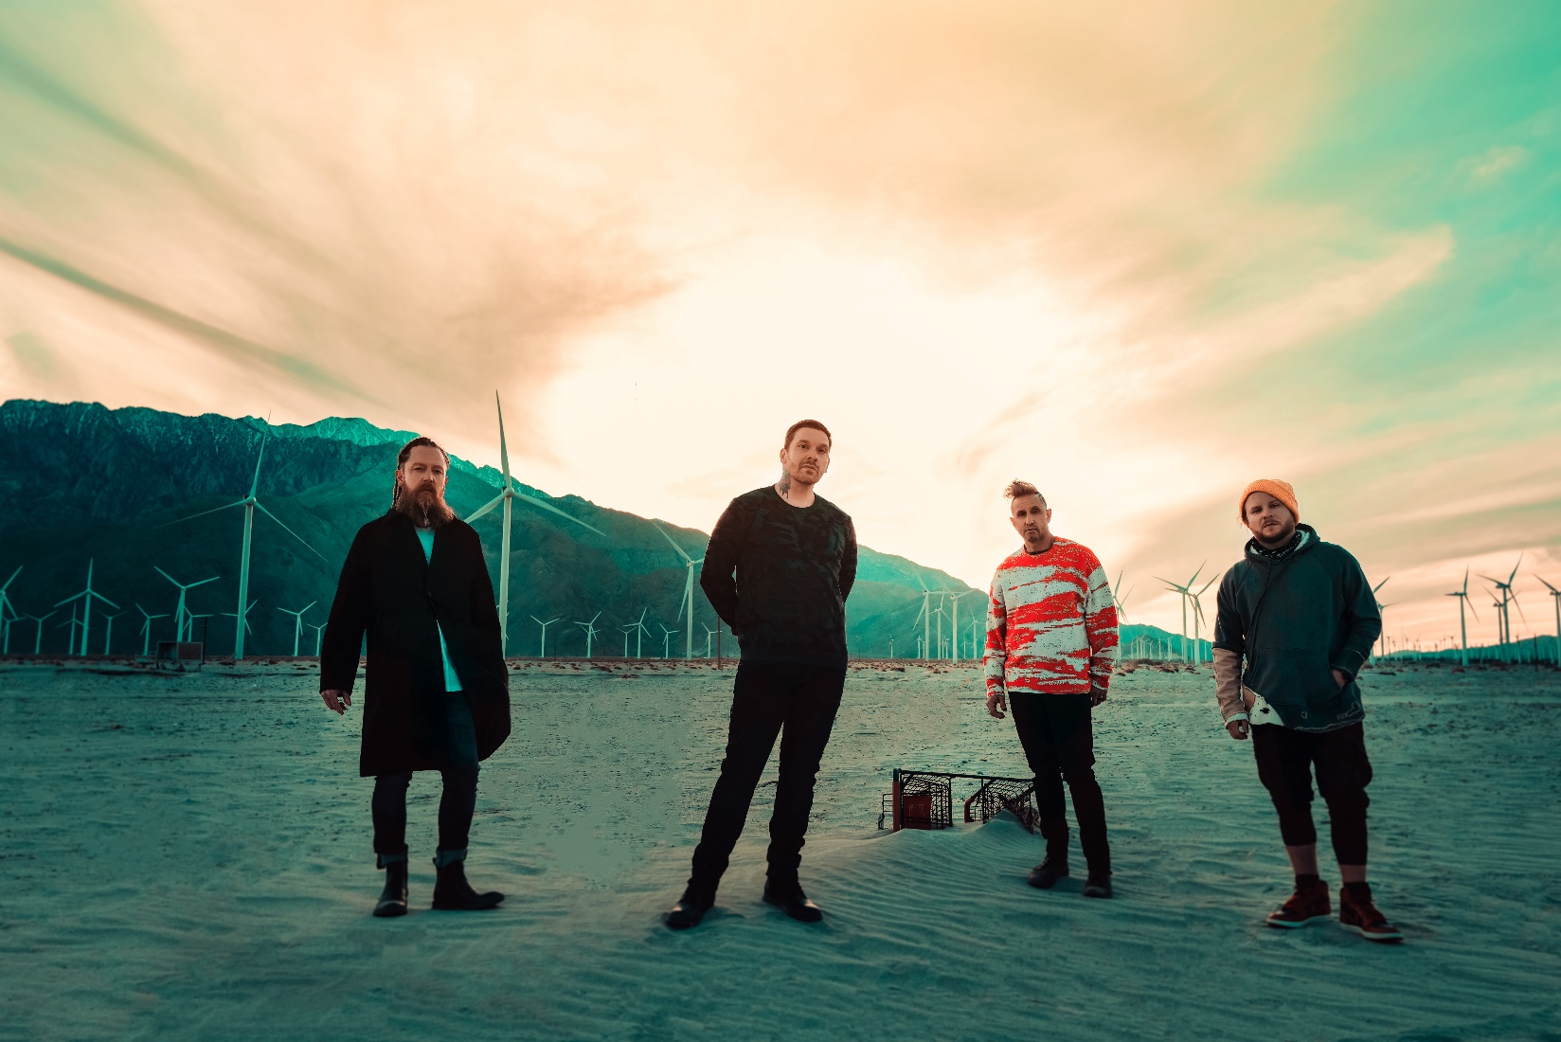(Photo Credit: Sanjay Parikh; download the photo [HERE](https://app.box.com/s/zdmyjkil2q581759sx649gweeau8ruua))

“'Daylight' is the most powerful of pop-rock songs created to remind us that we are truly all in this together." - ***PEOPLE***

*New York, NY – [June 1, 2022] –* **Multi-platinum band** **Shinedown** have released their **soaring and poignant anthem “Daylight.”** Offering an assurance that **you are never alone,** the single’s meaningful **portrait of a vital human connection** reflects the **importance of our relationships** and the **people in our lives whose support and empathy help get us through to the next day.**

[**PRESS HERE**](http://shinedown.lnk.to/Daylight) **to listen to** **"Daylight” from Shinedown’s forthcoming album *Planet Zero* out July 1st on Atlantic Records.** Check outthe **first look and interview** with front man **Brent Smith** via[***PEOPLE***](https://people.com/music/shinedown-rockers-back-at-it-with-daylight/).

“This is about the human condition. We’ve got to live, and we’ve got to live with one another. And that should be something that is celebrated and not tolerated. That's what ‘Daylight’ really represents. It's our humanity. It’s an understanding that we're all on this planet together, and we've got to figure out ways to take care of one another. A lot of times, it may just be asking someone 'are you okay?’ because you could potentially save someone's life just by asking. We can’t lose our empathy and courage towards each other, or our willingness to pick someone up if you see them on their knees, because there's gonna be a moment in time when you need someone to pick you up,” says **Brent.**

**“Daylight”** is the latest addition to **a catalog that has earned Shinedown recognition for their timely and relevant messages behind their chart-topping hits that resonate with not only their global audience and the rock community, but the greater public and our culture at large.** With more than **6.5 billion global streams**, the record for the **most mainstream rock #1 hits ever**, **platinum or gold certification for all their albums,** and **major media praise, Shinedown** has cemented their status as one of the most vital and forward-thinking powerhouses in music.

***Planet Zero***, which already spawned the band’s **record-breaking 18th #1 hit** with [**"Planet Zero,"**](https://www.youtube.com/watch?v=IipnUpoW-58) **is available for pre-order** [**HERE**](http://shinedown.lnk.to/planetzero)**.**

***Planet Zero*’s previously released lead single** [**"Planet Zero"**](https://shinedown.lnk.to/planetzerosingle) **and album track** [**"The Saints of Violence and Innuendo"**](https://shinedown.lnk.to/TheSaintsOfViolenceAndInnuendoPR)introduced an album that is an incisive yet optimistic look at the fractures and frays of a society that has undergone many challenges in the last few years, seeing **Shinedown take on the forces that are keeping us divided at a time when we need to be coming together.** The high-concept, viscerally charged album, **produced by Shinedown’s Eric Bass,** takes a hard look at the **divisiveness among those of differing ideologies**, **cancel culture ran rampant,** **the toxicity of social media**, **the need for honesty in our public discourse**, and the **corrosive effects of these things on mental health and humanity**. A dystopian saga that warns of **dangerous dehumanizing consequences, *Planet Zero* is a reminder that** **if we shut each other down, we risk losing empathy, respect for one another, and our ability to communicate and unify in a way that leads to actual progress and understanding**.The album also shares **hope, perseverance, triumph, and reminders that we all need one another, like on “Daylight.”** After all, it is the band’s impassioned **striving for unity** that has long been at the heart of their creative output.

The **Planet Zero World Tour (produced by Live Nation) begins in Bonner Springs, KS on September 3rd with special guests Jelly Roll and John Harvie,**kicking off a **U.S. run of fall shows** that will see the record-breaking, chart-topping band bring their new music, #1 hits, fan favorites and biggest stage show yet to cities from coast to coast**. Full routing below** which also includes festival performances at **Louder Than Life** on **September 23** in Louisville, KY and **Aftershock** on **October 9** in Sacramento, CA. Beginning **June 3**, **Shinedown** will embark on a **UK/Europe run of festival performances** and **select shows with** **Iron Maiden** followed by **Canadian dates with special guests Pop Evil and Ayron Jones in July and August.** For tickets and all show details, please visit [**www.shinedown.com**](http://www.shinedown.com).

**PRAISE FOR *PLANET ZERO***

“We're lucky to have *Planet Zero*as a warning flare. The album is Shinedown’s most strident statement yet. From cancel culture to Twitter addiction to divisive politics, Shinedown take shots at the forces that undermine our shared humanity.” - ***GRAMMY.com***

“a blatant warning—lose connection and lose humanity.” – ***Parade***

“...a high-concept treatise on societal affairs during the past 22 months, including the travails of living through a pandemic, the pitfalls of social media, mental health issues, political divisiveness, partisan media and cancel culture.” - ***Billboard***

“... ravages sound waves and inspires thoughts. It’s a great blend of art and attitude.”–

***American Songwriter***

“Shinedown’s songs are always socially relevant and ‘Planet Zero’ is no exception…they are back with more powerful messaging about humanity…”  - ***Spectrum News***

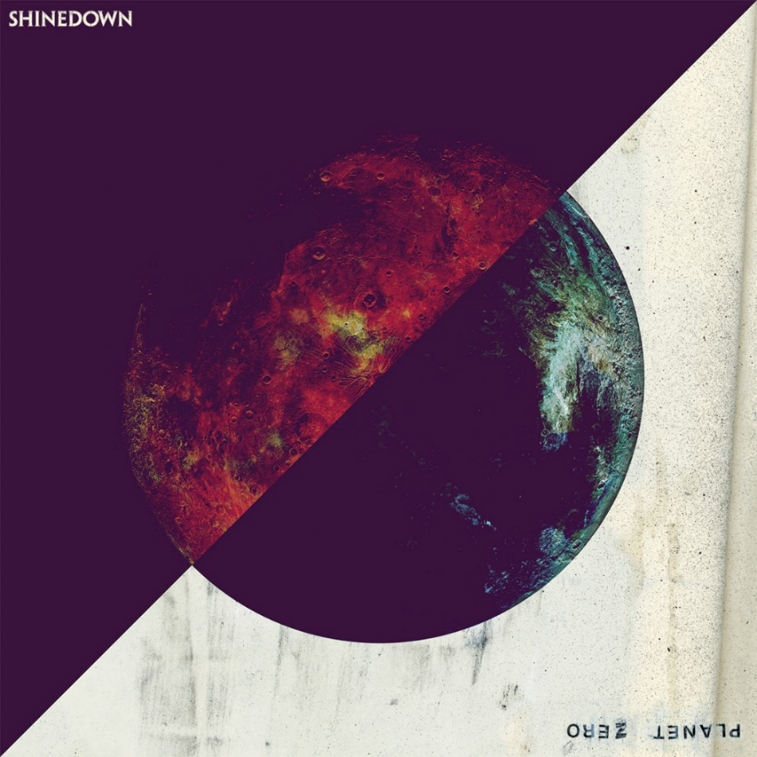

(Planet Zero Cover Art)

**SHINEDOWN TOUR DATES 2022**

June 3 – Nuremberg, Germany @ Rock im Park

June 5 – Nuremberg, Germany @ Rock am Ring

June 7 – Budapest, Hungary @ Groupama Aréna +

June 9 – Hamburg, Germany @ edel-optics.de Arena

June 11 – Donington, UK @ Download Festival

June 13 – Belfast, UK @ Ormeau Park +

June 16 – Utrecht, Netherlands @ Tivoli Vredenburg

June 17 – Clisson, France @ Hellfest

June 18 – Dessel, Belgium @ Graspop Metal Meeting

July 8 – Deadwood, SD @ Deadwood Live! Open Air Music Series

July 9 – Deadwood, SD @ Deadwood Live! Open Air Music Series

July 11- Casper, WY @ Ford Wyoming Center^

July 12- Kearney, NE @ Viaero Event Center^

July 14 – Madison, WI @ The Sylvee

July 15- Council Bluffs, IA @ Westfair Amphitheatre (special guests Jelly Roll, Austin Meade & Salt Creek)

July 16 – Cadott, WI @ Rock Fest

July 19 – Quebec, QC @ Centre Videotron *^

July 20 – Montreal, QC @ L’Olympia *^

July 22 – Toronto, ON @ History *

July 23 – Windsor, ON @ The Colosseum at Caesars Windsor *^

July 26 – Winnipeg, MB @ Burton Cummings Theatre *^

July 27 – Moose Jaw, SK @ Mosaic Place *^

July 29 – Saskatoon, SK @ TCU Place *^

July 30 – Calgary, AB @ Grey Eagle Resort & Casino *^

July 31 – Edmonton, AB @ Convention Centre *^

August 2 – Penticton, BC @ South Okanagan Event Centre *^

August 3 – Abbotsford, BC @ Abbotsford Centre *^

August 28- Knoxville, TN @ Thompson Bolin Arena #

September 3 – Bonner Springs, KS @ Azura Amphitheater ~

September 5 – St. Louis, MO @ Hollywood Casino Amphitheatre ~

September 6- Cedar Rapids, IA @ Alliant Energy Powerhouse ~

September 9 – Pittsburgh, PA @ The Pavilion at Star Lake ~

September 10 – Holmdel, NJ @ PNC Bank Arts Center ~

September 11 – Camden, NJ @ Waterfront Music Pavilion ~

September 13 – Mansfield, MA @ Xfinity Center ~

September 14 – Saratoga Springs, NY @ Saratoga Performing Arts Center ~

September 16 – Gilford, NH @ Bank of New Hampshire Pavilion ~

September 17 – Syracuse, NY @ St. Joseph's Health Amphitheater at Lakeview ~

September 18 – Virginia Beach, VA @ Veterans United Home Loan Amphitheater at Virginia Beach ~

September 20 – Darien, NY @ Darien Lake Amphitheater ~

September 21 – Detroit, MI @ Pine Knob Music Theater ~

September 23 – Louisville, KY @ Louder Than Life  *(not a Live Nation date)*

September 24- Grayslake, IL @ WIIL Rock Fest - Lake County Fairgrounds

September 26 – Charlotte, NC @ PNC Music Pavilion ~

September 28- Biloxi, MS @ Mississippi Coast Coliseum & Convention Center ~

September 30 – Irving, TX @ The Pavilion at Toyota Music Factory ~

October 1 – Houston, TX @ The Cynthia Woods Mitchell Pavilion ~

October 2 – Cedar Park, TX @ H-E-B Center at Cedar Park ~ *(not a Live Nation date)*

October 5 – Albuquerque, NM @ Isleta Amphitheater ~

October 7 – Phoenix, AZ @ Ak-Chin Pavilion ~

October 8 – Anaheim, CA @ Honda Center ~

October 9 – Sacramento, CA @ Aftershock *(not a Live Nation date)*

**November 10** - Cologne, Germany @ Palladium @

**November 12** - Berlin, Germany @ Columbiahalle @

**November 15** - Offenbach, Germany @ Stadthalle Offenbach @

**November 19** - Munich, Germany @ Zenith, Die Kulturhalle @

**KEY:**

* with Pop Evil

^ with Ayron Jones  
**#** Dorothy and Diamante  
+ with Iron Maiden

~ with Jelly Roll and John Harvie

**ABOUT SHINEDOWN**

Multi-platinum, record-breaking band **Shinedown** **– Brent Smith**[vocals],**Zach Myers**[guitar],**Eric Bass**[bass, production],**and Barry Kerch**[drums]**–**were named**#1 on Billboard’s Greatest Of All Time Mainstream Rock Artists Chart,**after notching the**most ever #1s (17) in the 40-year history of the Mainstream Rock Songs Chart with a string of consecutive #1 hit singles** **“**[**Atlas Falls**](https://www.youtube.com/watch?v=YiVkAvm-BVE)**,” “**[**ATTENTION ATTENTION**](https://www.youtube.com/watch?v=AKkWblVAiJY)**,” “**[**GET UP**](https://www.youtube.com/watch?v=RcohgARJTWQ)**,” “**[**MONSTERS**](https://www.youtube.com/watch?v=J6sIK2KnhH8)**,” “**[**DEVIL**](https://www.youtube.com/watch?v=_AsPY1bQx70)**,” and now “**[**Planet Zero**](https://youtu.be/IipnUpoW-58)**.”** With  **over 6.5 billion global streams, 18 #1 Active Rock hits, 10 million albums sold worldwide, 14 platinum and gold singles, platinum or gold certification for all their albums, all 28 career singles reaching the Top 5 on Billboard’s Mainstream Rock Songs Chart,**and **countless sold-out arena tours, Shinedown**have also becomean essential cultural force as evidenced by their **major media acclaim** and participation in the **prestigious 92Y Talks series.**  The band’s last studio album, 2018’s acclaimed [***ATTENTION ATTENTION***](https://lnk.to/AttentionAttention) ,debuted in the **Top 5 on the Billboard 200** andsimultaneously hit **#1 on Billboard's Alternative, Top Rock and Hard Rock Albums Charts.**  **Shinedown also recently made their ATTENTION ATTENTION** [**feature film**](https://shinedown.lnk.to/ATTENTIONATTENTIONFilm) **available worldwide.** A stunning visual counterpart to their 2018 acclaimed album of the same name, the film, directed by **Bill Yukich**(Beyoncé, Metallica, Wiz Khalifa), brings to life the album’s narrative about a mental health journey and the resolve of the human spirit, weaving together 14 songs into a provocative and thought-provoking cinematic story that illuminates yet another dimension of Shinedown’s limitless creativity.

**FOLLOW SHINEDOWN**

[Facebook](http://r20.rs6.net/tn.jsp?f=001AxgtQbchxD7wqTUe5xBWTMWRnQwYwTs_jfTWHlX9umAb_gqiFLSHSsYgGNgLABZAPQwtJ9YF9VyJKWS3TU6-YsRD9kLarNmppzsCDJhwtNh8mhMxeCFX9ac9JfqZRVGyhmJBtTFjCz3eaQC-u7bB9mXc8xsqG5ju&c=nz7_6P1khIjWKAQ_IICC-nfRttQ4zx_srwi9r1mYe_z1VnjXOrfDmw==&ch=djyIpZoxy4uJgI86bLdj80hu2Pe0bSS_P9kDo5dV7TMaweiNZ42UhA==) | [Instagram](http://r20.rs6.net/tn.jsp?f=001AxgtQbchxD7wqTUe5xBWTMWRnQwYwTs_jfTWHlX9umAb_gqiFLSHSsYgGNgLABZAfb_rpyRT7kjYFmIzqtAFc3pJXndqDkc901SITR1XDTUFuD5JG0wLvaBKYtf4Pd0b2qv5gqFiDW96zBNc8K6ZfwAAa5GJe21FqKY1M8s19W0h0BhVHFZd5w==&c=nz7_6P1khIjWKAQ_IICC-nfRttQ4zx_srwi9r1mYe_z1VnjXOrfDmw==&ch=djyIpZoxy4uJgI86bLdj80hu2Pe0bSS_P9kDo5dV7TMaweiNZ42UhA==) | [Twitter](http://r20.rs6.net/tn.jsp?f=001AxgtQbchxD7wqTUe5xBWTMWRnQwYwTs_jfTWHlX9umAb_gqiFLSHSsYgGNgLABZA0jBEf5p9Uo8fmHOFPQtMK4A-aK3m3w01_nVqNDvhC4iMMjz05CEQoa3N3_vOxowqSn-ybjUymCjLfm_DqzYnrvJnx2Dd-VijClloxFloh8yHgt0oBNbmseBIChG2EYjURzqCc16QfGR8ExywAnBs6UHAkFzndVjb81krN4SHPsm6rlvTAMbqfw==&c=nz7_6P1khIjWKAQ_IICC-nfRttQ4zx_srwi9r1mYe_z1VnjXOrfDmw==&ch=djyIpZoxy4uJgI86bLdj80hu2Pe0bSS_P9kDo5dV7TMaweiNZ42UhA==) | [Website](http://r20.rs6.net/tn.jsp?f=001AxgtQbchxD7wqTUe5xBWTMWRnQwYwTs_jfTWHlX9umAb_gqiFLSHSquoZPgbSuIAZtBiLZRS2Qb2x1RFZsLwOnnXPWyPMvqtC1n50maan6uiUTbliJY3qmd7l8BxzJnHwQThVcAR9JIWqsI0BmluwA==&c=nz7_6P1khIjWKAQ_IICC-nfRttQ4zx_srwi9r1mYe_z1VnjXOrfDmw==&ch=djyIpZoxy4uJgI86bLdj80hu2Pe0bSS_P9kDo5dV7TMaweiNZ42UhA==) | [Atlantic Records](http://r20.rs6.net/tn.jsp?f=001AxgtQbchxD7wqTUe5xBWTMWRnQwYwTs_jfTWHlX9umAb_gqiFLSHSquoZPgbSuIAKLZXWuTM-OlCnHRtQsshQs476V46_9km_0J_mj8XY4ywszMJNfu-ylC9wBsUEr6ZNiYdVaIWuqjhK6lC7jyFmgk7NVer3nCT2FJgw7K1pQY=&c=nz7_6P1khIjWKAQ_IICC-nfRttQ4zx_srwi9r1mYe_z1VnjXOrfDmw==&ch=djyIpZoxy4uJgI86bLdj80hu2Pe0bSS_P9kDo5dV7TMaweiNZ42UhA==)

**For more information on Shinedown, please contact:**

**Press Here**

Linda Carbone / [linda@presshereproductions.com](mailto:linda@presshereproductions.com)   
Carla Senft / [carla@pressherepublicity.com](mailto:carla@pressherepublicity.com)

Bari Lieberman / [bari@pressherepublicity.com](mailto:bari@pressherepublicity.com)

**Atlantic Records**

Glenn Fukushima / [glenn.fukushima@atlanticrecords.com](mailto:glenn.fukushima@atlanticrecords.com)