FOR IMMEDIATE RELEASE
MAY 10, 2022

MULTI-GRAMMY NOMINATED PLATINUM-SELLING
R&B SUPERSTAR TANK SET TO RELEASE HIS HIGHLY ANTICIPATED 10TH & FINAL ALBUM “R&B MONEY” ON AUGUST 19

FEATURES CHRIS BROWN, ROTIMI, J VALENTINE, VEDO, D&D, TVERSE, FEATHER & ALEX ISLEY

RELEASES NEW SINGLE “SLOW” FEATURING J. VALENTINE TODAY!

THE “R&B MONEY” PODCAST” DEBUTS #1 MUSIC PODCAST ON iHEARTMEDIA’S BLACK EFFECT PODCAST NETWORK

CLICK HERE TO PRE-ORDER THE “R&B MONEY” ALBUM NOW!

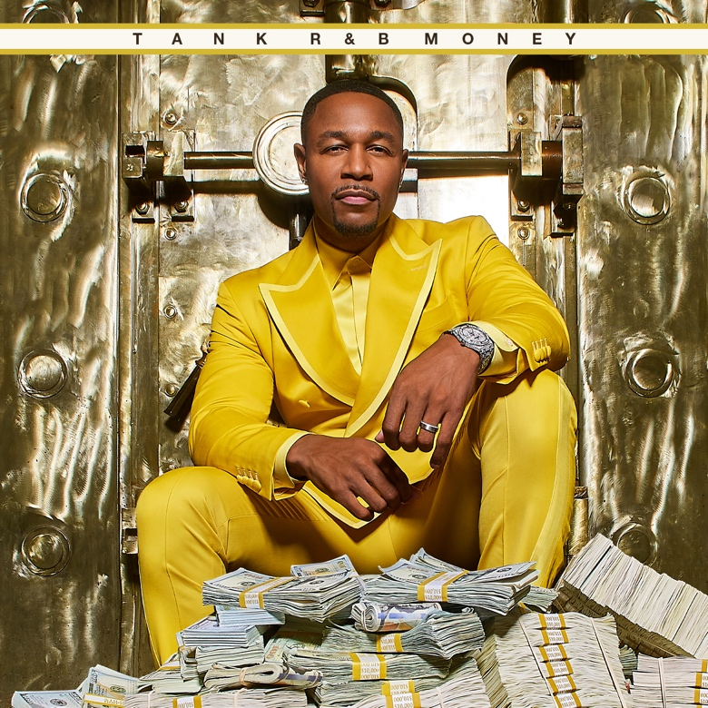

You can’t put a time limit on perfection, and multi-Grammy nominated platinum-selling singer/songwriter/producer Tank is ready to share his highly anticipated 10th and final studio album R&B Money on August 19 via his label R&B Money/Atlantic Records. Today Tank drops his new single “Slow,” featuring his longtime friend and collaborator J. Valentine as a gift to his fans for their dedication and patience. “Slow” also marks the return of J. Valentine to the music scene as he is gearing up to release his new project later this year. This single is a stimulating ballad that will pierce into your imagination as Tank and J. Valentine tap into the very essence of R&B as they take fans on a ride of sensual sounds and musical bravado in the only way these two can. Young Chang directed the accompanying video with the visuals taking this song to the next level. R&B Money features Chris Brown, Rotimi, Vedo, D&D, TVERSE, Alex Isley, and R&B Money artist Feather. R&B Money features chart-topping #1 hits “Can’t Let it Show” and “I Deserve.”

“R&B Money is a labor of love to my fans and to the genre of R&B. This is who I am! I wouldn’t be here if it weren’t for artists like Marvin Gaye, Teddy Pendergrass, Keith Sweat, Al Green, and my fans who inspire me every day to make music,” says Tank. “I wanted this album to pay homage to my influences and my evolution as an artist, and I think that’s what this final album represents.”

CLICK HERE TO LISTEN TO “SLOW”
CLICK HERE TO WATCH “SLOW”

In addition to releasing his new album, Tank and J. Valentine celebrated the launch of their “R&B Money” podcast via iHeartMedia and Charlamagne tha God's Black Effect Podcast Network with Jamie Foxx as their first guest (click here). Debuting as the #1 Music Podcast, the show will celebrate the genre of R&B, representing the culture like no other. It will highlight everything from Marvin Gaye to Pink Sweat$. R&B Money has produced an exciting space for artists & executives in the game to reminisce with exceptionally compelling storytelling while building a place of discovery for the fans.

Throughout his 20+ year career, Tank has garnered over six #1 hits and has written and produced for names like Aaliyah, Chris Brown, Jamie Foxx, Alicia Keys, Beyonce, Kelly Rowland, and more. From his first hit single, “Maybe I Deserve,” Tank has been able to touch listeners that have garnered him a cult following with releases like “Slowly,” “Please Don’t Go,” and “I Can’t Make You Love Me.”

In 2021, Tank celebrated the long-overdue streaming debut of his landmark first three solo albums, 2001’s RIAA gold-certified, #1 debut, FORCE OF NATURE, 2002’s ONE MAN, and 2007’s chart-topping, GRAMMY® Award-nominated SEX, LOVE & PAIN. Rolling Stone acknowledged the historic streaming premiere with an exclusive interview with Tank, writing, “For the first time, fans will also be able to travel through his catalog in reverse, rewinding from 2021 to 2000.”

“R&B MONEY” TRACKLIST

- R&B MONEY
- When You Dance
- Home
- No Limit feat. Alex Isley
- Slow feat. J Valentine
- Morning feat. Vedo
- Can't Let It Show
- See Through Love feat. Chris Brown
- Spoil Her Alert
- I Deserve
- Too Late
- Make Sure feat. Feather
- Let's Take A Ride feat. Rotimi and TVERSE
- It's Nothing
- Awesome feat. D&D
- Regular
- Summer Killa

As fans await the release of R&B Money, Tank will be performing spot dates, concerts, and festivals. See below for dates.

JUNE
11 – Columbia, SC – Township Auditorium
18 – Miami, FL – Club Quarantine with D-Nice
19 – Jacksonville, FL – Club Quarantine with D-Nice
30 – New Orleans, LA – ESSENCE Festival of Culture

JULY
21-23 – Cincinnati, OH – Cincinnati Music Festival
30 – Raleigh, NC – Women’s Empowerment

SEPTEMBER
2-4 – Las Vegas – Club Quarantine with D-Nice

###

FOLLOW TANK:
IG: @therealtank
TW: @therealtank
FB: @therealtank

FOR PRESS INQUIRIES
SYDNEY.MARGETSON@ATLANTICRECORDS.COM
TASHA@STRONGARMMEDIA.COM

