FOR IMMEDIATE RELEASE
JULY 8th, 2020

MULTI-PLATINUM RAPPER O.T. GENASIS RETURNS WITH NEW SINGLE AND VIDEO “WHAT IS YOUR NAME”

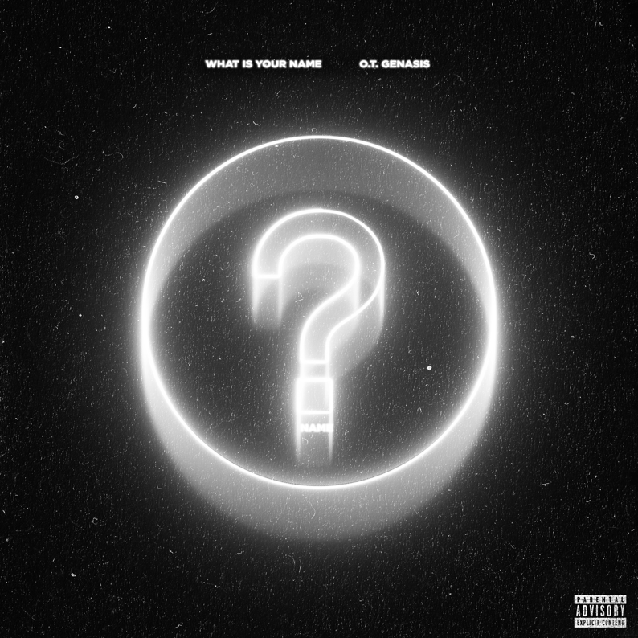

Multi-platinum recording artist O.T. GENASIS is back with the brand-new single “What Is Your Name.” The catchy new record is available now on all DSPs and streaming services HERE. The accompanying visual for the track is available to watch now HERE.

The release follows O.T. Genasis’ most recent collaboration which featured Chris Brown and legendary hitmaker Charlie Wilson. The strong single was a reminder of the rapper’s hit-making ability, showcased in earlier hits such as the notorious single “Bae”; the 2018 banger which has accumulated over 9M views on YouTube HERE. His 2017 hit single, “Everybody Mad,” became a viral sensation soon after its release and is regarded as one of the artist’s biggest hits. The track cemented O.T’s behemoth status in pop culture when it was featured during Beyoncé’s historic Coachella performances in 2018 and also on her most recent “On the Run II” Tour with Jay-Z.

Born in Los Angeles but raised in Long Beach, CA, O.T. Genasis made his breakthrough with 2014’s RIAA platinum certified hit single, “CoCo,” reaching #5 on Billboard’s “Top R&B/Hip-Hop Songs” chart and also reaching #20 on the overall “Hot 100.” O.T. Genasis’ 2016 mixtape “COKE N BUTTER,” saw guest spots from T.I., 2 Chainz, Remy Ma, YG, and Quavo, among others. The project featured standouts such as “Push It (Feat. Quavo & Remy Ma),” an RIAA-certified gold track and “Thick (Feat. 2 Chainz).” The success of “COKE N BUTTER” mirrored the rapper’s earlier mixtape, “RHYTHM & BRICKS,” which included the double-platinum record “Cut It (Feat. Young Dolph).”

CONNECT WITH O.T. GENASIS
OTGENASIS.COM | FACEBOOK | TWITTER | YOUTUBE | INSTAGRAM

FOR ALL PRESS INQUIRIES, PLEASE CONTACT
SYDNEY.MARGETSON@ATLANTICRECORDS.COM

