DRILL PIONEER 22Gz RELEASES VISUAL FOR “UP N STUCK REMIX
(FEAT. KODAK BLACK)”

THE BLIXKY TAPE 2 (DELUXE) AVAILABLE NOW VIA SNIPER GANG/ATLANTIC

LISTEN TO “THE BLIXKY TAPE 2 (DELUXE)”

WATCH “UP N STUCK (FEAT. KODAK BACK)”
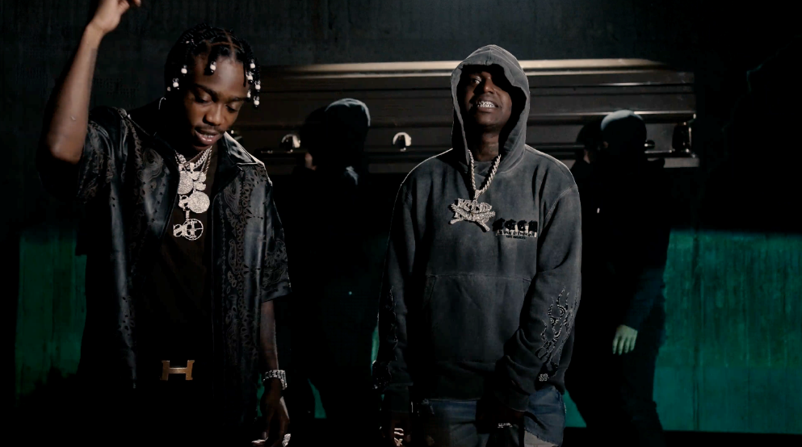
RIAA gold certified Brooklyn Drill pioneer 22Gz released the visual for “Up N Stuck Remix (Feat. Kodak Black) streaming on via YouTube HERE. 22Gz says of the new collaboration: “I wanted to bring Kodak into the world of drill and he killed it.” The original is featured on The Blixky Tape 2 (Deluxe) and streaming HERE. “Up N Stuck Remix (Feat. Kodak Black) also comes on the heels of last month’s release of “Spin” in an immersive Brooklyn-inspired experience in Decentraland and is currently streaming via YouTube HERE.
# # #
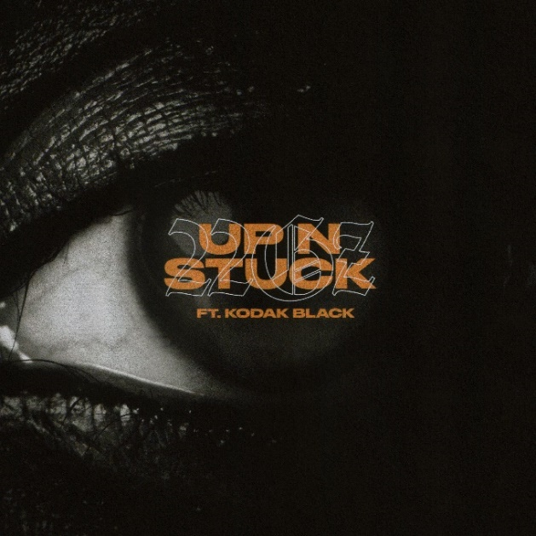
CONNECT WITH 22Gz
INSTAGRAM | YOUTUBE | TWITTER | FACEBOOK
WWW.22GZOFFICIAL.COM

FOR PRESS INQUIRIES PLEASE CONTACT
ARIANA.WHITE@ATLANTICRECORDS.COM

