FOR IMMEDIATE RELEASE

JULY 18, 2022

BANKROL HAYDEN AND LIL SKIES TURN UP THE HEAT WITH
“DEEP END (FEAT. LIL SKIES)”

RADIANT ANTHEM MARKS LATEST TRACK FROM EAGERLY AWAITED NEW PROJECT
DUE LATER THIS YEAR

HAYDEN IS SET TO LIGHT UP DOVER, DE’S FIREFLY MUSIC FESTIVAL STAGE
SUNDAY, SEPTEMBER 25

LISTEN TO “DEEP END (FEAT. LIL SKIES) | WATCH VISUAL

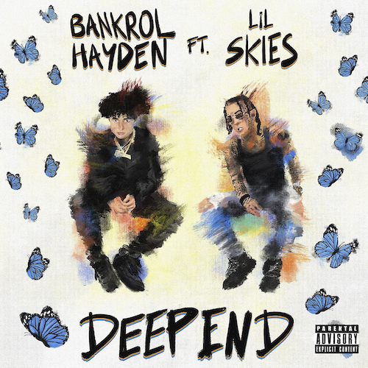
DOWNLOAD HI-RES ARTWORK

Rising hip-hop star Bankrol Hayden and RIAA platinum certified rapper Lil Skies are celebrating the long hot summer with their radiant new anthem, “Deep End (Feat. Lil Skies),” listen HERE. The sweltering track was produced by GRAMMY® Award-nominee Roy Lenzo (Lil Nas X, Jack Harlow, Roddy Ricch) & Einer Bankz, while the liberating visual directed by JakeTheShooter has Hayden detached from love and ready for the weekend. Watch HERE.

“Deep End (Feat. Lil Skies)” marks the latest in a run of new music heralding Hayden’s eagerly awaited new project due later this summer. Previously, he released the guitar-smashing rock ‘n’ roll rave up, “Van Hayden,” Produced by GRAMMY® Award-nominee Roy Lenzo (Lil Nas X, Jack Harlow, Roddy Ricch) and Adriano (Gunna, Lil Skies, Ali Gatie), the track is joined by an explosive official visual directed by JakeTheShooter (Sueco, Nessa Barrett) and currently boasting close to 2M views. Watch HERE.

“Van Hayden” followed a series of additional new tracks, including “F*ck Love” the RIAA gold-certified “Costa Rica,” “Cabo,” “No Drama“ and last year’s smash hit, “Come Through (Ft. Lil Tecca),” the latter of which boasts over 100M worldwide streams after making top playlists such as Spotify’s “Rap Caviar” and “Most Necessary,” Apple Music’s “#OnRepeat” and “The Plug,” Amazon’s “Fresh Hip-Hop,” and more.

Featured among YouTube’s “Artist on the Rise: Trending” series, Bankrol Hayden has also proven an electrifying live performer, lighting up such recent festivals as Gulf Shores, AL’s Hangout Music Festival and Grand Prairie, TX’s So What?! Music Festival. Next up is a much anticipated performance at Dover, DE’s upcoming Firefly Music Festival, set for Sunday, September 25.

With over 125M YouTube views to date, Bankrol Hayden is a true phenomenon, earning fans around the globe with his positive brand of soulful, pop-forward hip-hop. The talented young artist first broke out in 2017 with a series of popular YouTube videos and SoundCloud favorites. Viral smashes as “B.A.N.K.R.O.L.,” “29,” and the RIAA gold certified “Brothers (Feat. Luh Kel)“ followed, the latter of which scored 30M Spotify streams and 6.5M YouTube plays in under six months. Bankrol Hayden made his Atlantic Records debut in 2020 with the hugely popular “Costa Rica,” quickly earning RIAA gold certification before following up with his powerful debut mixtape, Pain Is Temporary, highlighted by such emotionally charged tracks as “Whatchu On Today (Ft. Polo G),” “Drop A Tear (Ft. Lil Baby),” and “Rich Bitch,” all joined by official music videos streaming now at YouTube.

“Tupac used to write as either an observer, participant, or themselves,” Bankrol Hayden says. “That inspires me. I stay true to myself and put my life into this, but you’ll get different perspectives.”
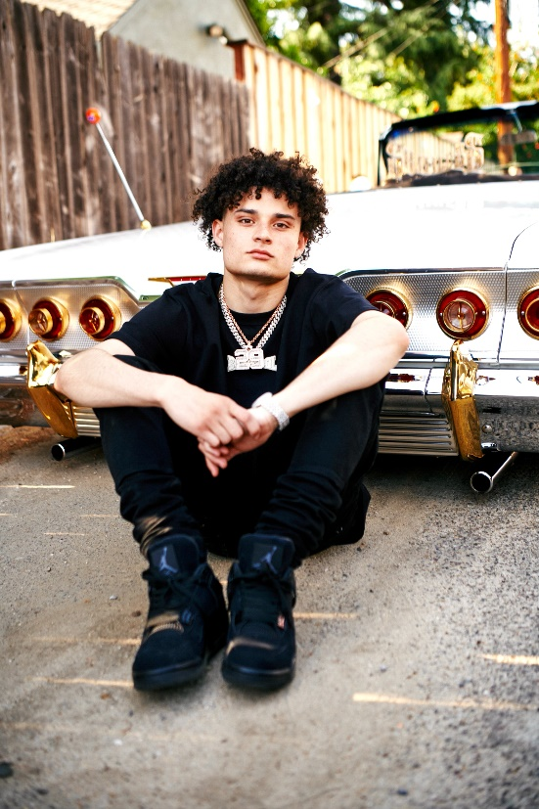
DOWNLOAD ASSET(S) | PHOTO CREDIT: DANIEL PRAKOPCYK

CONNECT WITH BANKROL HAYDEN
OFFICIAL | FACEBOOK | INSTAGRAM | TIKTOK | TWITTER | YOUTUBE

PRESS CONTACT
FAIRLEY MCCASKILL | FAIRLEY.MCCASKILL@ATLANTICRECORDS.COM
# # #

