FOR IMMEDIATE RELEASE
JULY 8, 2022

CORDAE IS BACK WITH FROM A BIRDS EYE VIEW (LIVE) VISUAL ALBUM PREMIERING TODAY EXCLUSIVELY ON FACEBOOK

2X GRAMMY® NOMINATED RAPPER UNVEILS LIVE EDITION OF HIS FROM A BIRDS EYE VIEW ALBUM

HIGHLIGHTS INCLUDE LIVE VERSIONS OF “SINISTER,” “CHRONICLES,” & “COACH CARTER”

“THE HI-LEVEL MINDSET” TED TALK PREMIERED EARLIER LAST MONTH HERE

EPIC WORLD TOUR FEATURES HEADLINE DATES AND FESTIVAL PERFORMANCES
INCLUDING LOLLAPALOOZA, OSHEAGA, FIREFLY MUSIC FESTIVAL,
AND MORE

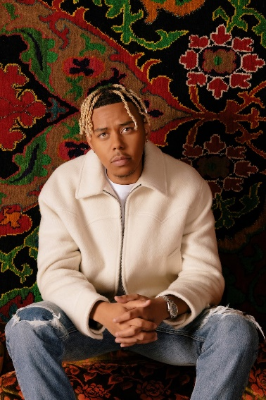

2x GRAMMY® Award-nominated rapper Cordae is proud to announce the live, visual only release of his sophomore album exclusively via Facebook. The original From A Birds Eye View is available now via ART@WAR/Atlantic Records.

The 10-track live album release provides acoustic versions of each track featured on the original From A Birds Eye View. The live version of the album was shot and recorded at Larrabee Studios in North Hollywood, CA with accompanying visuals premiering today exclusively via Facebook.

“I’ve always wanted to do a live album for this body of work. I made this album to be performed live.” - CORDAE

The live album comes just after the premier of his “The Hi-Level Mindset” TED TALK. The TED TALK was an informative conversation mixed with humor about the journey of a high school kid who would grow to achieve his dream of becoming a music star by learning the power of discipline, “The Hi Level Mindset” sees Cordae making the case for doing everything that you put your hands on at the highest level possible, having an extreme work ethic and seriousness in everything you do, no matter how insignificant it may seem. For more information, please visit www.ted.com/speakers/cordae.
Deeply inspired by a life-changing trip to Africa, enduring the loss of a friend gone too soon, and evolving as an artist and a man, From A Birds Eye View sees Cordae telling these stories and more through technicolor imagery, nimble rhymes, and fast evolving wisdom. Among its many highlights, the album includes the acclaimed single, “Sinister (Feat. Lil Wayne),” available everywhere for streaming and download HERE; an official music video is streaming via YouTube HERE.

From A Birds Eye View was first unveiled last fall with the powerhouse single, “Super,” available now at all DSPs and streaming services HERE. Produced by longtime collaborator Kid Culture (Justin Bieber, Ed Sheeran) and co-produced by Jenius, the track is joined by an official music video streaming now at YouTube HERE. The album also includes the bonus track “Gifted (Feat. Roddy Ricch)” a sonic marriage between two of modern hip-hop's greatest players. "Gifted" features a vocal appearance by Ant Clemons and the official music video directed by Cole Bennett is available to watch HERE..

# # #

Cordae knows exactly what he wants to say. He chooses his words and phrases carefully. He speaks from a place of truth. That’s why the 2x GRAMMY® Award-nominated gold-selling Maryland-raised rapper has quietly become one of the modern generation’s most trusted narrators. A remarkable life has given him a lot to say. He went from trailer parks and public housing with his mom to stratospheric success. After a series of buzzing singles, he reached critical mass with his milestone 2019 debut album, The Lost Boy, available now at all DSPs and streaming services HERE. Now boasting more than 430M worldwide streams and counting, the full-length project bowed among the top 15 on the Billboard 200 and includes the RIAA gold-certified singles, “Have Mercy,” “RNP (Feat Anderson .Paak),” “Broke As F**k,” and “Kung Fu.”

Beyond unanimous praise from Billboard, Complex, High Snobiety, the New York Times, Pitchfork, and Stereogum, Cordae garnered a pair of GRAMMY® Award nominations in the categories of “Best Rap Album” for The Lost Boy and “Best Rap Song” for the RIAA gold certified lead single, “Bad Idea (Feat. Chance the Rapper).” The rare artist whose presence can be felt on-screen in a Super Bowl commercial alongside legendary Academy® Award-winning director Martin Scorsese and among XXL’s coveted “Freshman Class,” Cordae linked up with Roddy Ricch for “Gifted” as well as joining forces with Eminem for “Killer.” Absorbing wisdom from a life-changing trip to Africa, enduring the loss of a friend gone too soon, and evolving as an artist and a man, he tells this story in widescreen technicolor on his 2022 second full-length offering, From A Birds Eye View [ART@WAR/Atlantic Records].

# # #

CORDAE
FROM A BIRDS EYE VIEW (LIVE)
TRACKLIST
1. Jean-Michel
2. Super
3. Momma’s Hood
4. Want From Me
5. Today
6. Coach Carter
7. Sinister
8. Chronicles
9. Champagne Glasses
10. Westlake High

CONNECT WITH CORDAE
INSTAGRAM | YOUTUBE | TWITTER | FACEBOOK

FOR PRESS INQUIRIES
SYDNEY.MARGETSON@ATLANTICRECORDS.COM

