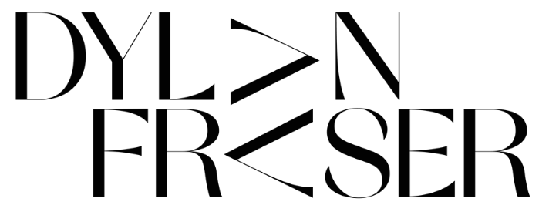

DROPS HYPE-BUILDING TRACK ‘VAMPIRE’ FEATURING ALASKA REID
FOLLOWING ITS ‘FIRST PLAY’ ON CLARA AMFO’S BBC RADIO 1 SHOW

LISTEN TO 'VAMPIRE' HERE
WATCH THE OFFICIAL VIDEO

NEW EP ‘2030 REVOLUTION’ SET FOR RELEASE ON AUGUST 17
EP TRACKLISTING UNVEILED TODAY

“There really isn’t a box you could put him in, which is precisely why he’s so compelling… a true original.” – The Sunday Times

“…his decade-spanning influences converge into songs that always sound expansive…” – NME

“The audacity of this UK newcomer to deliver a sound that's as fully formed and self-assured as this... Get into him now so you can brag to all your friends about knowing him first when he inevitably breaks big.” – E!

“Like his hero Thom Yorke, Fraser's voice exhibits both fragility and ferocity. It's a versatile instrument made for both ballads and dark electronica.” – PopDust

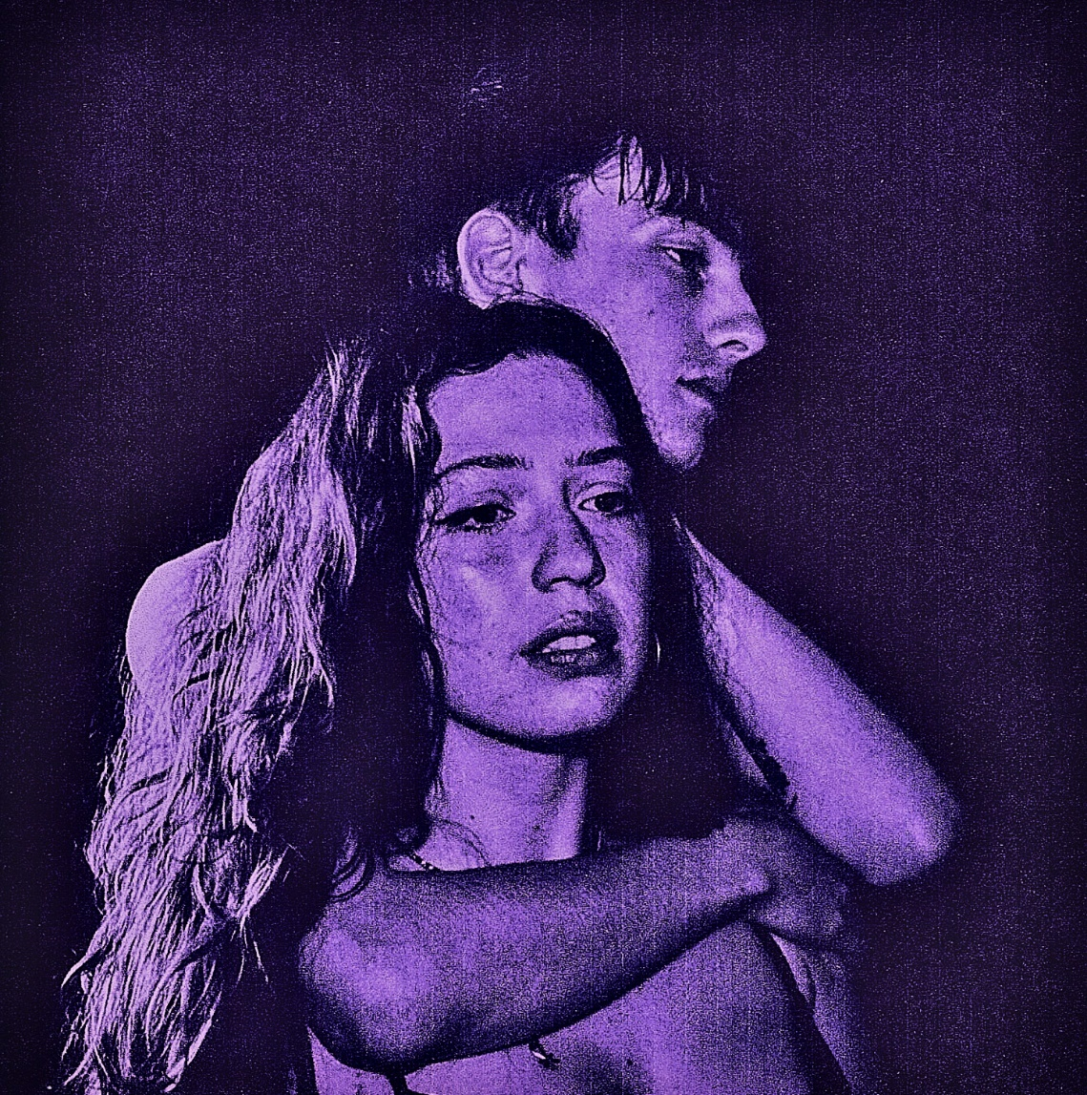

Photo + Artwork Credit: @PIERRESNAPS | DOWNLOAD HERE
Rising alt/pop Scottish artist Dylan Fraser has dropped ‘Vampire’ feat. Alaska Reid today – the third track to be released off his upcoming EP, 2030 Revolution, set for release on August 17. The track arrives alongside the official video, which was directed by Trash Factory. It joins previously-released tracks ‘It Took A Lot To Get To This’ and ‘Apartment Complex On The Eastside,’ the latter of which was co-written by Samia.

“Vampire” was born out of one of many fruitful writing sessions with indie pop songstress Alaska Reid. The duo first connected when Dylan reached out to Alaska following the release of her 2020 debut, Big Bunny, then later met her in person at a Charli XCX show, where the two solidified their creative bond. Produced by Jonah Summerfield, ‘Vampire’ is a synth-soaked excursion into the darker sides of relationships, uncovering how we tend to take things out on those closest to us.

“This song is about feeling like you’re a bad person to someone you love. When you love someone, you show them every side of yourself, even the bad parts. Sometimes, I think you tend to lash out at people you love the most but it’s only because you feel comfortable enough to let your frustration or upset out around them, but it can leave you feeling like you’re a bad person; a liability, over the top. Who knows, maybe even a vampire, a monster….” says Dylan Fraser.

Over the course of the summer, Dylan – who recently collaborated in the studio with PC Music’s A.G. Cook and Rodaidh McDonald – has been making his name on the live circuit, playing numerous UK festivals, including Barn on the Farm, where Dylan shared the stage with Holly Humberstone, JP Saxe, Maisie Peters, and more for a one-off performance. Earlier this month, Dylan also appeared on Jack Saunders’ BBC Radio 1 show, where he reimagined Kate Bush’s ‘Running Up That Hill (A Deal With God)’ and played his own recent release, ‘It Took A Lot To Get To This’ (listen here).

Dylan Fraser’s upcoming four-track EP, 2030 Revolution, due out August 17, finds the young Scot documenting the fractal features of finding purpose, offering a fresh lens on the uncertainties we all face throughout modern life.

###

EP Tracklisting:

- Apartment Complex On The Eastside
- It Took A Lot To Get To This
- Vampire
- 2030 Revolution

###

About Dylan Fraser

Functioning around introspection, destination and self-validation, Dylan’s early catalogues finds the Scottish-born artist unpacking his journey from his small town of Bathgate to his newfound reality as an artist with the world at his feet, trying to make sense of the people and situations he’s faced along the way.

First picking-up a guitar at just 12-years-old (a hand-me-down from his mom, who, subsequently, taught him his first four chords,) Dylan set his sights on a music career from early childhood. Holed away in his bedroom, he would reimagine his favorite songs by his decade-spanning influences - everyone from Radiohead to Lorde to Kanye West - dreaming of city lights whist plotting a path out of his satellite town.

One of the most exciting alt/pop artists on the UK scene, Dylan has accumulated over 16 million streams to date, supported Inhaler and Holly Humberstone on their UK tours, released two well-received EPs, The Storm and The World Isn’t Big When You Know How It Works, and landed early support from music heavyweights Sir Elton John and Sam Smith, press critics, and radio’s Clara Amfo, Jack Saunders and Zane Lowe.

“I’m not a betting man, but it’s not a bet when it’s a sure thing, and this artist is a sure thing.” – Zane Lowe

