FOR IMMEDIATE RELEASE

JULY 20, 2022

**FKA TWIGS RELEASES POWERFUL VISUAL FOR ‘KILLER’**

WATCH [HERE](https://www.youtube.com/watch?v=6Fm4A79TgIw)

Today, Grammy-nominated vocalist, songwriter, lyricist, and producer FKA twigs releases a powerful new visual for single ‘KILLER’ (watch [here](https://www.youtube.com/watch?v=6Fm4A79TgIw)). The video, directed by Yoann Lemoine, features actor Arón Piper (Elite) and was shot on Praia de Almagreira beach in Portugal. The stunning visual is an intimate insight into the turmoil of heartbreak, as showcased lyrically in ‘KILLER’.

Speaking on directing the visual, Lemoine says: *"Twigs approached me with a beautiful treatment for KILLER that she had written about her personal story. It felt empowering and vulnerable at the same time. I said yes instantly when she asked me to direct it. It was the perfect opportunity to portray her in a way that we have not seen before, raw and intimate. The video is about the poison and the fuel that personal trauma is in art. How our experience forces us to create and how sometimes it is only inhibition and violence.*

*I just wanted to let her talent as a performer and dancer shine through without turbulence or filter, and to let the beautiful work of choreographer Juliano Nuñes shine through her. Twigs is the hardest working artist I have ever met, and it made the process so easy. Her connection with Aron Piper is very special and cinematic, he brought the perfect tension to the film, I’m very excited I could work with both of them."*

‘KILLER’, released last month, received high praise from the likes of Rolling Stone, Pitchfork, The Independent and more. Last week, Colors studio released an incredible live version of ‘KILLER’. Watch [here](https://colorsxstudios.com/shows/fka-twigs-killer-a-colors-show). Alongside releasing more music this year, FKA twigs will be starring alongside Bill Skarsgård in modern reimagining of THE CROW, based on the original graphic novel by James O’Barr, directed by Rupert Sanders.

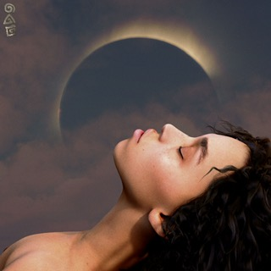

[Hi-Res Artwork](https://www.dropbox.com/s/wvx0usm79phpq9t/FINAL%20KILLER%20ART%20COVER.jpg?dl=0)

[Press Pictures](https://www.dropbox.com/scl/fo/8fl2qp6ruuf148k5mevm9/h?dl=0&rlkey=3i94v929xu5kyu9hipkl1eucy)

###

**CONNECT WITH FKA TWIGS:**

[TWITTER](https://twitter.com/FKAtwigs) | [FACEBOOK](https://www.facebook.com/fkatwigs) | [INSTAGRAM](https://www.instagram.com/fkatwigs/) | [OFFICIAL](https://www.fkatwigsofficial.com/) | [YOUTUBE](https://www.youtube.com/channel/UCXwsBnDQtx1i2qbgcHoQWNA)

**FOR PRESS INQUIRIES, PLEASE CONTACT:**

BENNY TARANTINI | [BENNY@BTPR.BIZ](mailto:Benny@BTPR.biz) | MOYA CROWLEY | [MOYA@BTPR.BIZ](mailto:Moya@BTPR.biz)

ARIANA WHITE | [ARIANA.WHITE@ATLANTICRECORDS.COM](mailto:Ariana.White@atlanticrecords.com)