FOR IMMEDIATE RELEASE
JULY 15, 2022

FAOUZIA ANNOUNCES NORTH AMERICA CITIZENS TOUR

GLOBAL POP SONGSTRESS TO KICK OFF FIRST EVER HEADLINE TOUR THIS FALL

NATIONWIDE RUN INCLUDES STOPS AT NEW YORK CITY’S IRVING PLAZA AND LOS ANGELES’ EL REY THEATRE

TICKETS ON SALE NOW HERE

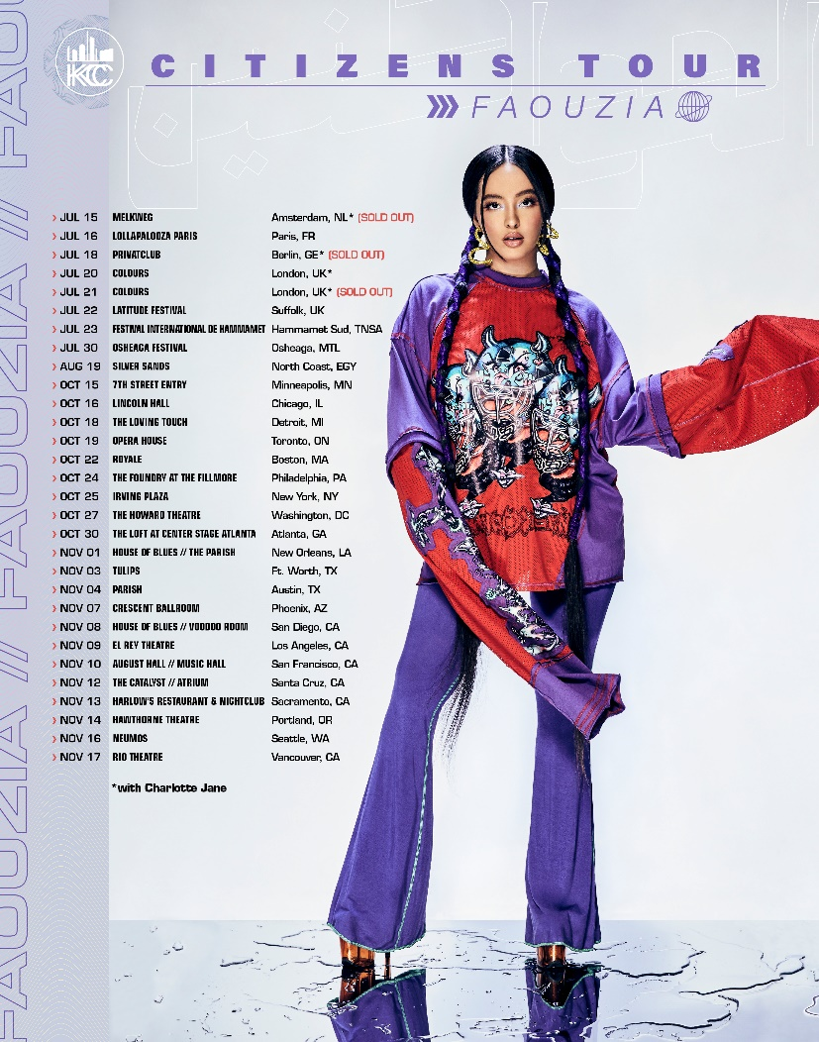
(DOWNLOAD HI-RES PHOTO)
“One of the most powerful new voices you’ll hear this year.”
– BILLBOARD

“What sets the singer-songwriter apart, though, is a stirring inflection that nods to her Arab roots”
– ENTERTAINMENT WEEKLY

“Faouzia is the Next Big Thing”
– BUSTLE

Acclaimed Moroccan-Canadian singer/songwriter/multi-instrumentalist Faouzia has announced her first ever North America headline tour celebrating her debut project, CITIZENS. For tickets and more information, please visit https://www.faouziaofficial.com.
CITIZENS includes global hits “RIP, Love” and “Minefields" with John Legend in addition to five impressive new tracks including Faouzia’s first completely self-produced anthem, “Don’t Tell Me I’m Pretty” and her new single, “Anybody Else.” Tracks from CITIZENS have been used in over 1.8M TikTok creates, amassing over 4 BILLION+ views across the platform.

CITIZENS Tour
North America 2022

October 15 – Minneapolis, MN – 7th Street Entry
October 16 – Chicago, IL – Lincoln Hall
October 18 – Detroit, MI – The Loving Touch
October 19 – Toronto, ON – Opera House
October 22 – Boston, MA – Royale
October 24 – Philadelphia, PA – The Foundry at The Fillmore
October 25 – New York, NY – Irving Plaza
October 27 – Washington, DC – The Howard Theatre
October 30 – Atlanta, GA – The Loft at Center Stage Atlanta
November 1 – New Orleans, LA – House of Blues // The Parish
November 3 – Ft. Worth, TX – Tulips
November 4 – Austin, TX – Parish
November 7 – Phoenix, AZ – Crescent Ballroom
November 8 – San Diego, CA – House of Blues // Voodoo Room
November 9 – Los Angeles, CA – El Rey Theatre
November 10 – San Francisco, CA – August Hall // Music Hall
November 12 – Santa Cruz, CA – The Catalyst // Atrium
November 13 – Sacramento, CA – Harlow’s Restaurant & Nightclub
November 14 – Portland, OR – Hawthorne Theatre
November 16 – Seattle, WA – Neumos
November 17 – Vancouver, BC – Rio Theatre

Named one of Variety’s “Artists to Watch for the 2022 Grammys,” Vogue’s “Style Stars Set to Make 2022 Exciting,” PEOPLE’s “Talented Emerging Artists Making Their Mark on the Musical Landscape,” and Entertainment Weekly’s “Artist to Watch in 2022,” the 21-year-old artist also made an exclusive visit to Genius’s influential Verified series, following earlier appearances including ELLE’s Song Association, Seventeen’s Tik Tok Reacts, Cosmopolitan’s TikTok Reacts and Refinery 29’s Spill It. Faouzia made her television debut in 2019 on The TODAY Show + The Kelly Clarkson Show alongside John Legend for stunning performances of their rising single “Minefields.”
A true global artist, Faouzia has found fans in VOGUE Arabia, GQ Middle East, Gazelle Magazine, and more. Faouzia recently performed “Minefields” with Legend at an exclusive Chanel Event in Dubai. The Canadian-Moroccan artist was also featured in a YouTube Canada campaign “Every Day, Canadians Count on YouTube” and recently nominated for “Breakthrough Artist of the Year” at Canada’s JUNO Awards and “International Breakthrough of the Year” at France’s NRJ Awards.
With over 800M global streams to date, Faouzia has a combined social reach of over 8M followers. Boasting over 1.8M YouTube subscribers, 1.9M Instagram followers and more than 3.1M Tik Tok followers, Faouzia has cemented herself as a surefire artist to watch. With collaborations with John Legend, Kelly Clarkson, David Guetta, and more, the landmark star has been praised in global publications spanning VOGUE, Harper’s Bazaar, PEOPLE, ELLE, Rolling Stone, Genius, Seventeen, Billboard, and UPROXX, to name but a few. Currently hard at work on her eagerly awaited debut album, Faouzia remains focused on turning her unbridled self-expression into a powerful outlet for her audience.

CONNECT WITH FAOUZIA
WEBSITE | TWITTER | FACEBOOK | INSTAGRAM | YOUTUBE | TIK TOK

FOR PRESS INQUIRIES, PLEASE CONTACT:
Jessica Nall / Jessica.Nall@atlanticrecords.com

