FOR IMMEDIATE RELEASE

FEBRUARY 10, 2022

**FRED AGAIN.. AND INDIA JORDAN COLLABORATE ON “ADMIT IT (U DON’T WANT 2)”**

**THE LATEST IN A SERIES OF MONTHLY FRED AGAIN.. CLUB-FOCUSED COLLABORATIONS**

**LISTEN TO “ADMIT IT (U DON’T WANT 2)”** [**HERE**](https://fredagain.lnk.to/Admit-it-india-Jordan)

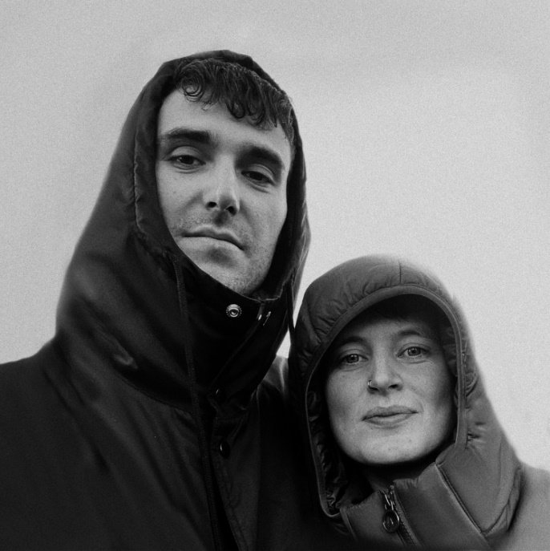

[DOWNLOAD ARTWORK HERE](https://isaac.wmg.com/app/#/s/v9jBiJF0rQ)

Two of dance music’s most exciting artists, Fred again.. and India Jordan join forces for the release of new single “[Admit It (U Don’t Want 2)](https://fredagain.lnk.to/Admit-it-india-Jordan).” With both artists enjoying widespread acclaim across 2020 and 2021 ‘Best Of” lists for their releases and live shows, and multiple awards nominations (including Fred’s “Best Dance Act” nomination at this year’s Brit Awards and both shortlisted for “Best Producer” at the forthcoming NME Awards), “Admit It (U Don’t Want 2)” represents a joyous coming together of musical tribes. With its “admit that it hurts you” lyric echoing round, the collaboration is a prime example of emotional, yearning dance music and sees the pair pushing each other into new musical territory. It’s also the latest in a series of monthly, club-focused Fred again.. collaborations with some of the most talked-about names in electronic music, coming hot on the heels of January’s “Lights Out” collaboration with HAAi and Romy.

**Talking about “Admit It (U Don’t Want 2)”, India Jordan says:**

“The track started as a couple of stems from some old loops I had that I sent to Fred, last year - then I eventually went over to his a couple of times in December and we made the track together, accompanied by some lovely walks down the River Thames and lots of cups o’ tea. It was great to work with him, had lots of fun!”

**While Fred again.. says:**

“It was such an effortless joy working with India on this. We made it in like three sessions and finished it on the rooftop where I live. It was sick that like while we were working on it India could go and road test it when they’d play out and we ended up evolving the tune based on the reaction. We both wanted to make something that just honoured the feeling of hearing ‘u don’t want 2…..admit that it hurts you’ in a rave. That line really resonated with us.”

**About Fred again..:**

It's fair to say that 2021 was an incredible year for Fred again.. The prolific London artist released two acclaimed, deeply personal albums - his debut ‘Actual Life (April 14 - December 17 2020)’ and its companion follow up ‘Actual Life 2 (February 2 - October 15 2021)’ - which were beloved of fans and critics alike and heralded by the likes of DJ Magazine, Evening Standard and NPR as one of the year's best. Meanwhile Fred rounded off the year with a 2022 BRIT Awards nomination in the "Best Dance Act" category.

2021 also saw Fred again.. become one of the year's most talked about live acts as he transformed his Actual Life records into an immersive, communal real-life experience for the first time. With shows selling out across the UK and USA, he was named one of Mixmag's "Top 10 Live Acts Of 2021". 2022 will see Fred continue his upwards trajectory with his biggest headline show yet – a sold out 3000 capacity event at London’s Roundhouse – in addition to festival appearances at the likes of Coachella, Primavera, Melt, Way Out West, Rock En Seine and All Points East.

**About India Jordan:**

One of dance music’s most exciting artists, India Jordan is a true disciple of high-energy, high-emotional dance music. After DJing across the UK for the best part of a decade, the last few years have seen them take the plunge into releasing their own music with an instant impact - their 2020 EP ‘For You’ for the Local Action label was unanimously praised as one of the biggest and best releases of the year, named the #1 single of 2020 by Resident Advisor and flying high in similar lists from Pitchfork, Crack, NME & The Fader, while last year’s ‘Watch Out!’ EP on Ninja Tune saw them star on the cover of both DJ Mag and the NME, and take home awards such as DJ Mag’s Best Breakthrough Producer, Radio 1’s Best Mini-Mix of the Year and Pete Tong’s Breakout Star of the Year. Hot off the heels of an acclaimed BBC Radio 1 residency, 2022 will see India Jordan tour North America for the first time in February/March, before returning for a packed live diary full of festival slots and headline shows across Europe and the UK and a recent nomination for Producer of the Year at the 2022 NME awards.

More on: Fred again.. [OFFICIAL SITE](https://www.fredagain.com/) / [INSTAGRAM](https://www.instagram.com/fredagainagainagainagainagain/?hl=en)

India Jordan [INSTAGRAM](https://www.instagram.com/indiajordan_/?hl=en) / [TWITTER](https://twitter.com/indiajordan8?ref_src=twsrc%5Egoogle%7Ctwcamp%5Eserp%7Ctwgr%5Eauthor) / [BANDCAMP](https://indiajordan.bandcamp.com/) i

For press inquiries, please contact:

Kelly McWilliam // [Kelly.mcwilliam@alanticrecords.com](mailto:Kelly.mcwilliam@alanticrecords.com)