FOR IMMEDIATE RELEASE
NOVEMEBER 19, 2021

FRED AGAIN.. RELEASES NEW ALBUM

‘ACTUAL LIFE 2 (FEBRUARY 2 - OCTOBER 15 2021)’ OUT TODAY
VIA ATLANTIC RECORDS

LISTEN HERE

FRED AGAIN.. EMBARKS ON SOLD OUT TOUR INCLUDING TWO SHOWS AT LOS ANGELES’ ROXY THEATRE AND SHOWS AT NEW YORK’S MUSIC HALL OF WILLIAMSBURG AND BOWERY BALLROOM

READ MIXMAG’S NEW FRED AGAIN.. COVER FEATURE HERE

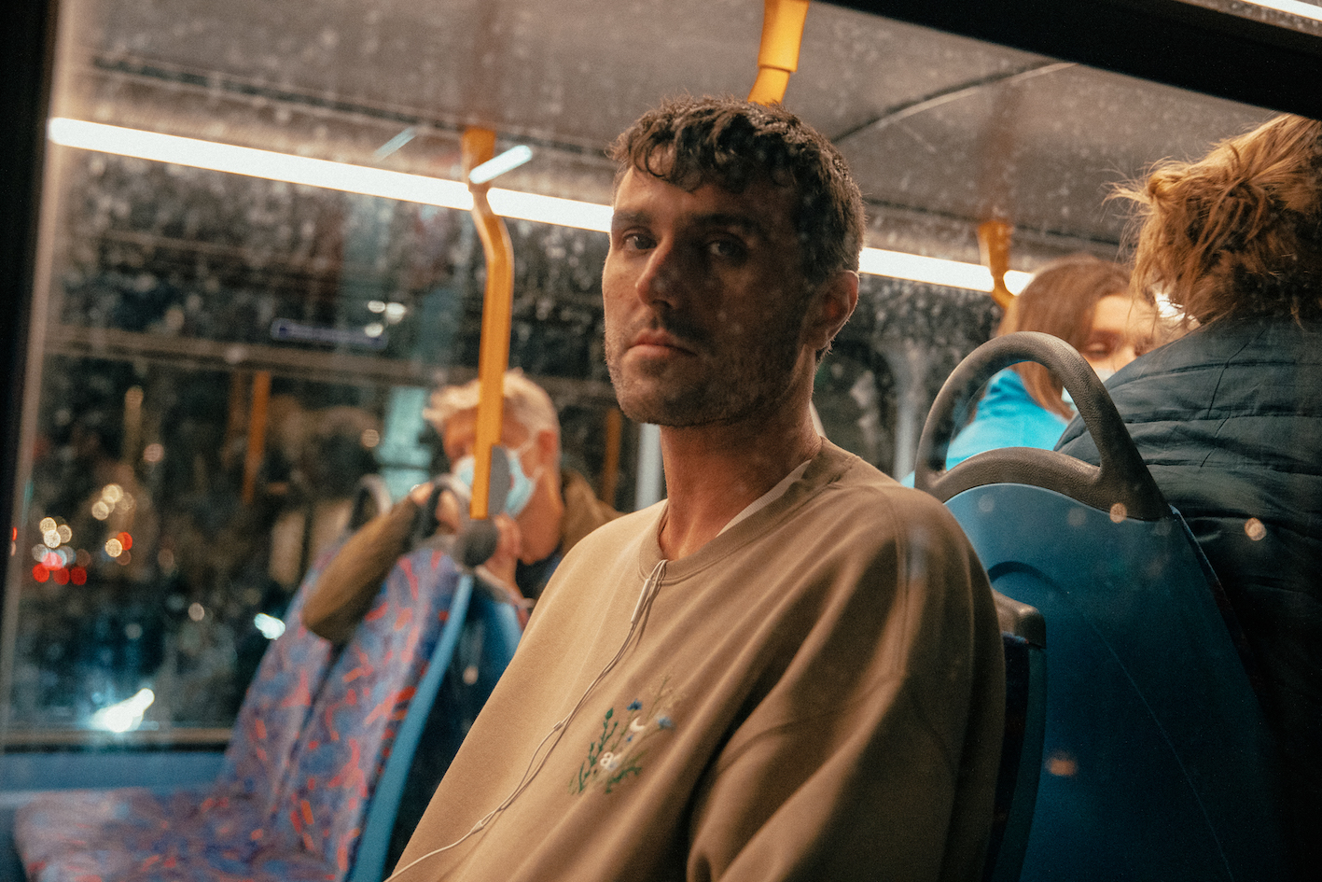
(download high res photo here)

Today – Friday, November 19 – Fred again.. has released his brand new album ‘Actual Life 2 (February 2 - October 15 2021)’, featuring the acclaimed trio of singles “Billie (Your Loving Arms)”, “Hannah (The Sun)” and “Faisal (Envelops Me”). Following on from his acclaimed debut album ‘Actual Life (April 14 - December 17 2020)’ earlier this year, his new release sees him build on the unique diary-esque approach he applies to making music. As the title suggests, the new album offers an insight into an 8 month period, stitching together vocal clips and found sounds to create a deeply autobiographical record that documents an extremely difficult time of his life.

With his new body of work, we’re offered a snapshot of an artist dealing with the many complexities of grief - exploring how confiding in close friends and family have helped him heal wounds, but also acknowledging how that grief is indelibly etched into his subconscious.

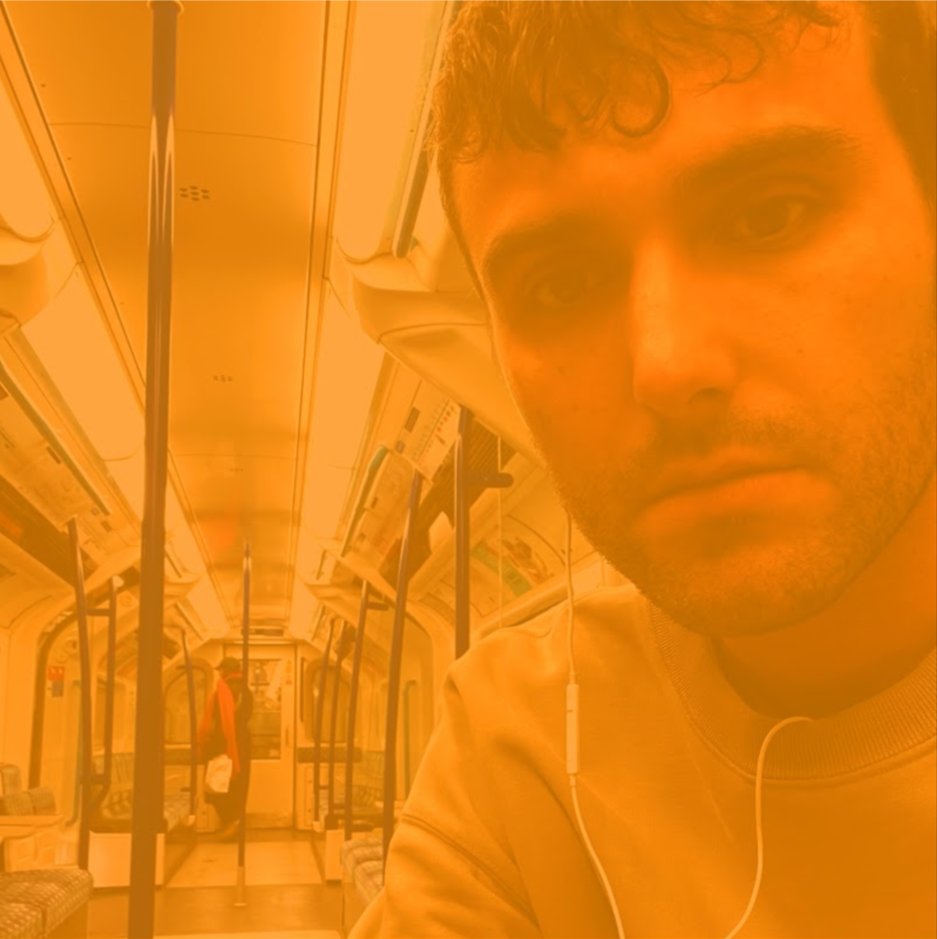
(download high res album artwork here)

Fred again..
Actual Life 2 (February 2 - October 15 2021)
November 19th 2021 / again.. Records

Tracklisting
1. February 2nd 2021
2. Catrin (The City)
3. Roze (Forgive)
4. Gigi (What You Went Through)
5. Kahan (Last Year)
6. Tate (How I Feel)
7. Hannah (The Sun)
8. Carlos (Interlude)
9. Faisal (Envelops Me)
10. Tayla (Every Night)
11. Tanya (Maybe Life)
12. Marco (And Everyone)
13. Billie (Loving Arms)
14. Billie (Interlude)
15. Mollie (Hear Your Name)
16. October 15th 2021

After a summer of festival performance and an incendiary sold out night at London’s Village Underground (which featured a guest appearance from The xx’s Romy), Fred again.. has spent the last month becoming one of the UK's most talked about live acts as he transforms his Actual Life project into a communal, immersive, real life live experience for the very first time. Fans will get the chance to experience this as the year draws to a close with Fred embarking on a run of sold out trans-Atlantic November / December tour dates (see full list below)

Fred again.. Live November 2021:

November 19 King Tuts, Glasgow (SOLD OUT)
November 22 Club Academy, Manchester (SOLD OUT)
November 23 Marble Factory, Bristol (SOLD OUT)
November 24 Islington Assembly Hall, London (SOLD OUT)
December 01 The Roxy Theatre, Los Angeles CA, USA (SOLD OUT)
December 02 The Roxy Theatre, Los Angeles CA, USA (SOLD OUT)
December 05 Music Hall of Williamsburg, Brooklyn NY, USA (SOLD OUT)
December 07 Bowery Ballroom, New York NY, USA (SOLD OUT)

Meanwhile Fred again.. is the latest Mixmag cover star. Check out the insightful interview, which sees Fred talking in-depth abiut the new album here

"Fred again... is on fire this year." - THE FADER

“His debut solo album traverses the personal for an eclectic and electrifying snapshot of his travels and companions” - NME

“It’s the search for authenticity that makes Fred again.. so exciting – and makes us reckon he could be the real deal.” - MIXMAG

"Fred again.. is solidifying himself as the producer of the moment and, quite possibly, the future" - LOUD & QUIET

“Fred again.. is a British artist taking a unique approach to his mesmerizing dance tracks” - PIGEONS & PLANES

“Listening to Fred again..’s music feels like you’ve stumbled onto something very personal. In many ways, his oeuvre is a diary with multiple authors. Fred again.. is the producer behind some of the UK’s biggest tracks in recent years can count Stormzy, Headie One, and Ed Sheeran as collaborators. But it’s how he collaborates with the world outside music that makes his sound especially visceral” - HIGH SNOBIETY

“His songs hover in the territory between the purest euphoria and gut-wrenching melancholy” – GRM DAILY

Fred again.. Instagram / Soundcloud

For press inquiries, please contact:
Kelly McWilliam / Kelly.McWilliam@atlanticrecords.com

