FOR IMMEDIATE RELEASE
JULY 27, 2021

FRED AGAIN.. RELEASES VIDEO FOR
“ANGIE (I’VE BEEN LOST)”

TAKEN FROM HIS DEBUT ALBUM
ACTUAL LIFE (APRIL 14 - DECEMBER 17 2020)

WATCH THE LOOSE DIRECTED VIDEO HERE

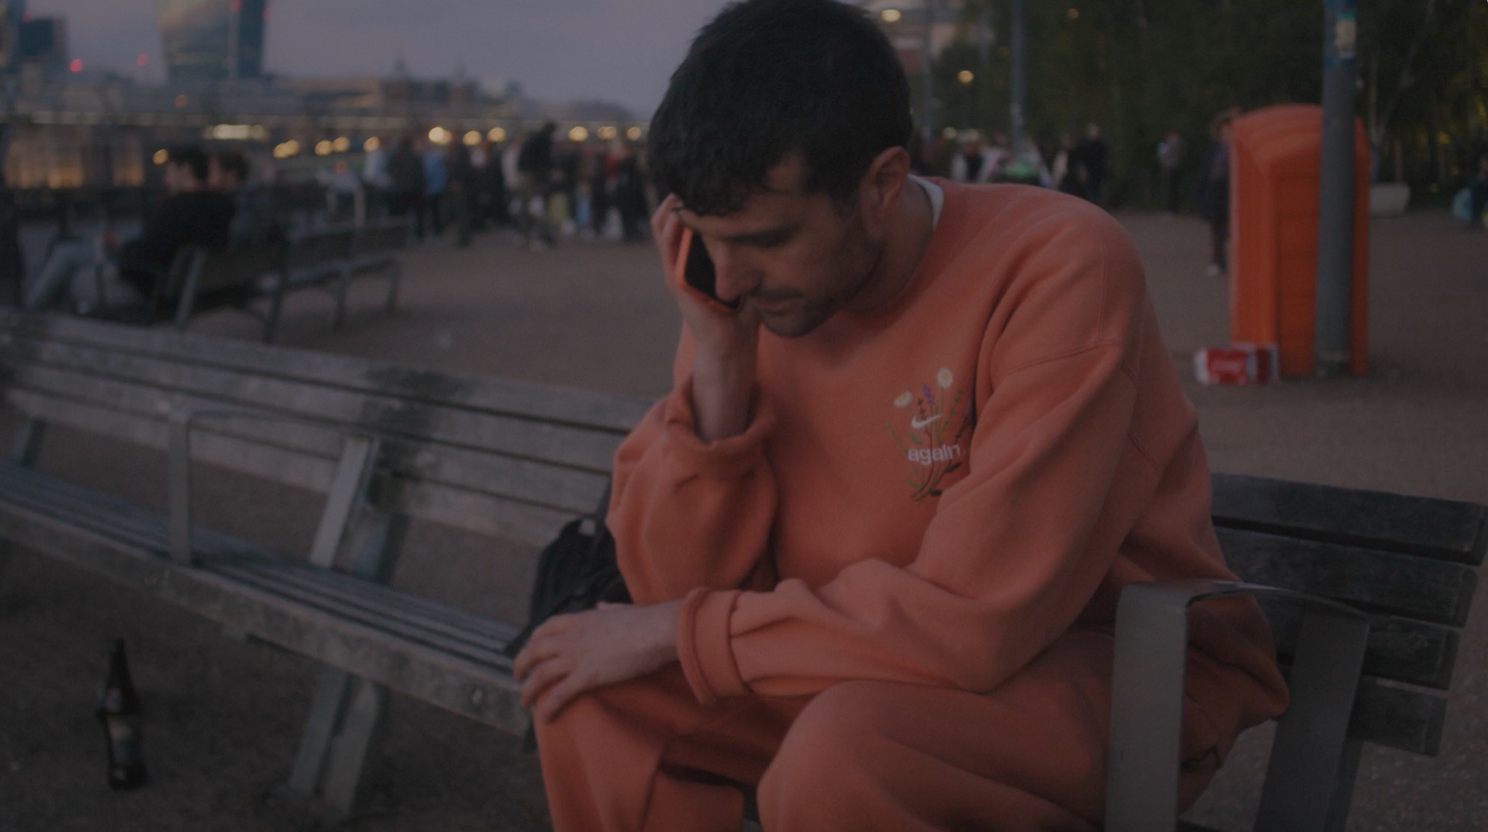

Today, 27th July, Fred again.. releases the video for his latest single “Angie (I’ve Been Lost)”. Taken from his acclaimed debut album “Actual Life (April 14 – December 17 2020)” (released in April via again.. Records), the track sees the multi-faceted London-based artist unpack a key event that impacted the recording of the album. Featuring vocals from Fred again.. himself, and set over a shuffling, strikingly melodic production, we see an artist coming to terms with the duality of having to find joy whilst undergoing personal tragedy.

Talking to The Guardian about the record recently Fred again.. says:

“People tell me I’ve made a joyful record but to me it’s devastating. Perhaps I was subconsciously trying to find some sort of positivity while everything around felt tragic. Most of the really optimistic people I know have become like that after really challenging circumstances”

Watch the video for “Angie (I’ve Been Lost)” HERE

The track provides a distinct counterpoint to Fred’s recent crossover anthem “Marea (We’ve Lost Dancing)”, a track that single handedly encapsulated the seismic impact the last 18 months has had on dance music culture featuring the voice of dance music icon Marea Stamper aka The Blessed Madonna. It’s a further example of the unique approach to music making that defines Actual Life..., a signature sound that sees him building tracks around vocals uncovered from the unlikeliest of sources; from obscure YouTube clips to personal FaceTime conversations, random Instagram accounts and iPhone video footage of half-remembered nights out.

Over the last year, Fred has also added his production skills to tracks as diverse as Ed Sheeran’s current global number one smash “Bad Habits”, Headie One, AJ Tracey and Stormzy’s “Aint It Different”, Jayda G’s GRAMMY-nominated “Both Of Us” and “Lifetime”, the acclaimed debut solo single from The xx’s Romy. In 2020, he also released GANG, his project with Headie One that saw the two friends collaborating alongside features from some of the UK's most exciting and innovative artists including FKA twigs, Jamie xx, Sampha, Slowthai and Berwyn.

“Angie (I’ve Been Lost)” video credits:

Directed by LOOSE
DOP - Donny Johnson
Camera Op - Theo Batterham
Edit - Charlie Hutchins
Grade - Donny Johnson

"Fred again... is on fire this year." - THE FADER

“His debut solo album traverses the personal for an eclectic and electrifying snapshot of his travels and companions” - NME

“It’s the search for authenticity that makes Fred again.. so exciting – and makes us reckon he could be the real deal.” - MIXMAG

"Fred again.. is solidifying himself as the producer of the moment and, quite possibly, the future" - LOUD & QUIET

“Fred again.. is a British artist taking a unique approach to his mesmerizing dance tracks” - PIGEONS & PLANES

“Listening to Fred again..’s music feels like you’ve stumbled onto something very personal. In many ways, his oeuvre is a diary with multiple authors. Fred again.. is the producer behind some of the UK’s biggest tracks in recent years can count Stormzy, Headie One, and Ed Sheeran as collaborators. But it’s how he collaborates with the world outside music that makes his sound especially visceral” - HIGH SNOBIETY

“Fred’s approach to sampling is like no other” - NOTION

“His songs hover in the territory between the purest euphoria and gut-wrenching melancholy” – GRM DAILY

Fred again.. Instagram / Soundcloud

For publicity enquiries:

Kelly McWilliam // Kelly.McWilliam@atlanticrecords.com

