**FRED AGAIN.. RELEASES “BILLIE (LOVING ARMS)” VIDEO**

**HIS LATEST VISUAL IN HIS SERIES OF ‘ACTUAL LIFE’ RELEASES**

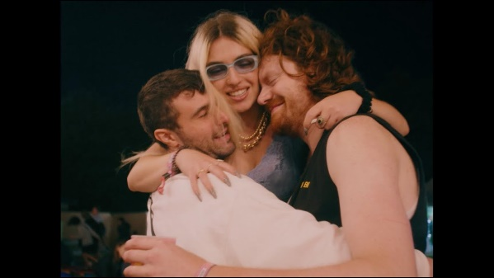

([download high res artwork here](https://nam04.safelinks.protection.outlook.com/?url=https%3A%2F%2Fwww.dropbox.com%2Fs%2Fxthytps79y0yhtu%2FLOVING_ARMS_ARTWORK_FINAL.jpg%3Fdl%3D0&data=04%7C01%7CMegan.Rasmussen%40atlanticrecords.com%7C1e6e56dd9dcf4cdc96d808d9786a3cd3%7C8367939002ec4ba1ad3d69da3fdd637e%7C0%7C0%7C637673219958819078%7CUnknown%7CTWFpbGZsb3d8eyJWIjoiMC4wLjAwMDAiLCJQIjoiV2luMzIiLCJBTiI6Ik1haWwiLCJXVCI6Mn0%3D%7C1000&sdata=iyd5MgJbocdC996rTQvVFzmZYjKyqlnsN1BClPou1aY%3D&reserved=0))

**PRIASE FOR “BILLIE (LOVING ARMS)”**

*“Sonically rich, big-tent-pop ambitious, soulful house music from Fred again..”* **– NEW YORK TIMES**

“10 cool new pop songs to get you through the week” **– BILLBOARD**

*“With each new single, Fred Again… effortlessly calls to mind dance hits that span not just generations but cultures, moods, and life experiences... It's a testament to Fred Again…'s grasp on the emotional element that fuels electronic music, an understanding that allows his music to define the here and now while remaining wholly timeless.”* **– ONES TO WATCH**

“Best New Tracks” – **HYPEBEAST**

“33 new songs out today**” – BROOKLYN VEGAN**

**Fred again..** has released the official video for his recent single **“**[**Billie (Loving Arms)**](https://nam04.safelinks.protection.outlook.com/?url=https%3A%2F%2Ffredagain.lnk.to%2FBillie&data=04%7C01%7CMegan.Rasmussen%40atlanticrecords.com%7C1e6e56dd9dcf4cdc96d808d9786a3cd3%7C8367939002ec4ba1ad3d69da3fdd637e%7C0%7C0%7C637673219958829027%7CUnknown%7CTWFpbGZsb3d8eyJWIjoiMC4wLjAwMDAiLCJQIjoiV2luMzIiLCJBTiI6Ik1haWwiLCJXVCI6Mn0%3D%7C1000&sdata=6NkpqG18sw4WSlN0VM5iI0wCLoy9CrwaKACnl3MHovI%3D&reserved=0)**”.** Directed by **LOOSE**, the poignant diary entry style video documents a day and night in the life of Fred and a group of close friends. Watch it [HERE](https://nam04.safelinks.protection.outlook.com/?url=https%3A%2F%2Fwww.youtube.com%2Fwatch%3Fv%3D_WkzhhO21s8&data=04%7C01%7CMegan.Rasmussen%40atlanticrecords.com%7C1e6e56dd9dcf4cdc96d808d9786a3cd3%7C8367939002ec4ba1ad3d69da3fdd637e%7C0%7C0%7C637673219958838981%7CUnknown%7CTWFpbGZsb3d8eyJWIjoiMC4wLjAwMDAiLCJQIjoiV2luMzIiLCJBTiI6Ik1haWwiLCJXVCI6Mn0%3D%7C1000&sdata=X5GxnCrViIrq7JS%2F56P0BcWIvUMe3cV%2BoihVzrKnxcA%3D&reserved=0).

“Billie (Loving Arms)” marked the first track to be revealed from Fred’s second **‘Actual Life’** album - due later this year - and saw the London based artist and producer building the track around a sample of **Billie Ray Martin’s** great, cult 1994 dancefloor classic “**Your Loving Arms**”. Although the source material comes from a different era to Fred’s previous music, this is an evolution rather than a reinvention. In his trademark **“Actual Life’** style, Fred only heard the original for the first time this year on a night out with friends, his phone footage of the dancefloor epiphany providing the source material for what would become **“Billie (Loving Arms)”.**

**Speaking about the track, Fred says:**

*“For me this song is about allowing people to help you, when you need it most. Like last year I felt like that was made almost impossible for us to do in some ways. I mean just the physical touch of someone throwing themselves around you can really cure us of a whole lot I think.”*

**Fred again..** [**Instagram**](https://nam04.safelinks.protection.outlook.com/?url=https%3A%2F%2Fwww.instagram.com%2Ffredagainagainagainagainagain%2F%3Fhl%3Den&data=04%7C01%7CMegan.Rasmussen%40atlanticrecords.com%7C1e6e56dd9dcf4cdc96d808d9786a3cd3%7C8367939002ec4ba1ad3d69da3fdd637e%7C0%7C0%7C637673219958838981%7CUnknown%7CTWFpbGZsb3d8eyJWIjoiMC4wLjAwMDAiLCJQIjoiV2luMzIiLCJBTiI6Ik1haWwiLCJXVCI6Mn0%3D%7C1000&sdata=tu9vRaOI0dyKG2VqC5Jr4MbpXzfNU0N60cChOAUkB7w%3D&reserved=0) **/** [**Soundcloud**](https://nam04.safelinks.protection.outlook.com/?url=https%3A%2F%2Fsoundcloud.com%2Ffredagain&data=04%7C01%7CMegan.Rasmussen%40atlanticrecords.com%7C1e6e56dd9dcf4cdc96d808d9786a3cd3%7C8367939002ec4ba1ad3d69da3fdd637e%7C0%7C0%7C637673219958848941%7CUnknown%7CTWFpbGZsb3d8eyJWIjoiMC4wLjAwMDAiLCJQIjoiV2luMzIiLCJBTiI6Ik1haWwiLCJXVCI6Mn0%3D%7C1000&sdata=AICS%2BkC19SqW9FIerDrWYYJXQDsCpYMeR82voKp0RlQ%3D&reserved=0)

**For press inquiries, please contact:**

Kelly McWilliam // [Kelly.McWilliam@atlanticrecords.com](mailto:Kelly.McWilliam@atlanticrecords.com)