FOR IMMEDIATE RELEASE
JUNE 25, 2021

FRED AGAIN.. RELEASES
ACTUAL LIFE PIANO EP (APRIL 14 – DECEMBER 17 2020)

OUT NOW / LISTEN HERE

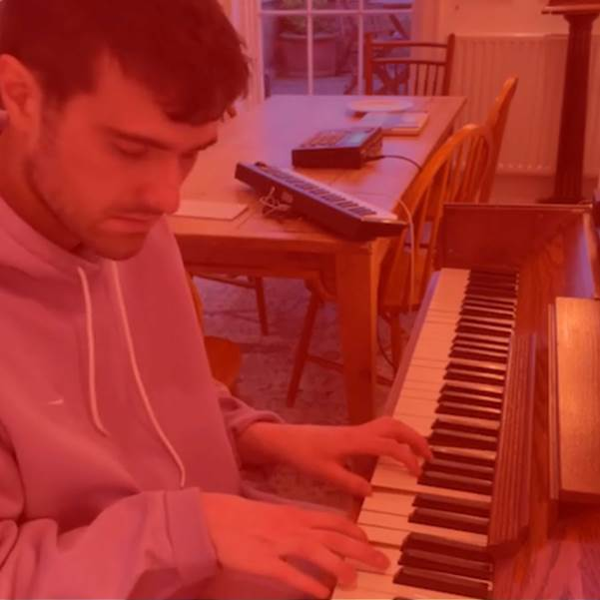

Today – Friday 24th June – Fred again.. releases a brand new EP of stripped back piano versions of tracks from his acclaimed debut album. Titled Actual Life Piano EP (April 14 – December 17 2020), the EP showcases a whole different side of Fred’s sound – a calming, meditative accompaniment to the emotional and at times euphoric electronica of his debut album. In keeping with the way he often records music, the four tracks were all recorded on the move and in public spaces, taking in London’s Gatwick Airport, Waterloo Station and on the Northern Line in addition to Berlin’s Alexanderplatz Station. The results are spellbinding, capturing spontaneous moments of musical intimacy.

Actual Life Piano EP (April 14 – December 17 2020) Track List

1. Kyle (Northern Line)
2. Julia (Gatwick Airport)
3. Yasminah (Alexanderplatz Station, Berlin)
4. 17th December 2020 (Waterloo Station)

"Fred again... is on fire this year." - THE FADER

“His debut solo album traverses the personal for an eclectic and electrifying snapshot of his travels and companions” - NME

“It’s the search for authenticity that makes Fred again.. so exciting – and makes us reckon he could be the real deal.” - MIXMAG

"Fred again.. is solidifying himself as the producer of the moment and, quite possibly, the future" - LOUD & QUIET

“Fred again.. is a British artist taking a unique approach to his mesmerizing dance tracks” - PIGEONS & PLANES

“Listening to Fred again..’s music feels like you’ve stumbled onto something very personal. In many ways, his oeuvre is a diary with multiple authors. Fred again.. is the producer behind some of the UK’s biggest tracks in recent years can count Stormzy, Headie One, and Ed Sheeran as collaborators. But it’s how he collaborates with the world outside music that makes his sound especially visceral” - HIGH SNOBIETY

“Fred’s approach to sampling is like no other” - NOTION

“His songs hover in the territory between the purest euphoria and gut-wrenching melancholy” – GRM DAILY

About Actual Life (April 14 – December 17 2020):

It all started with Carlos – a construction worker Fred met after a show in Atlanta. It was one of those chance encounters that’s difficult to describe if you weren’t there. Fred’s video clips from the evening do some of the job; Carlos’ voice – a joyous Southern drawl proclaiming “I want you to see me, friend! We gon’ make it through” – does the rest.

Now, Carlos runs as a motif throughout Fred’s music. “He basically already was a song,” says Fred, better known as London-based producer Fred again.., “I just had to play chords.”

This began Fred’s process of transforming momentary snippets by setting them to music. He was compiling a diary, of sorts. Over time, the diary grew as Fred, 27, gathered clips from nights out, stored voice notes, and combed through social media – seeking out musical moments in the everyday ephemera of life.

The first few times Fred lifted art from others – the poem that forms the base of woozy club stomper ‘Kyle (I Found You)’, or the haunting monologue about living with depression that leads ‘Sabrina (I Am A Party)’ – he felt terrible. This didn’t feel like a consenting collaboration. But gradually he came to terms with it, helped by the overwhelming support and gratitude he received when he showed his songs to the people whose work he’d interpolated. He doesn’t put out anything without strict approval.

Actual Life offers a glimpse into how Fred sees – or rather, how he hears – the world, and the people who bring it to life around him. He doesn’t write about experiences; he takes experiences and turns them into songs.

He’s wildly gregarious, laughs a lot, optimistic to the last. This all transfers. Over the past five years, he’s brought this inescapable charisma to his work with everyone from FKA twigs to Stefflon Don, BTS, Jayda G, Romy and Burna Boy. It helped draw UK drill rapper Headie One out of his comfort zone, on the pair’s collaborative mixtape GANG, to dazzling effect. He’s also, to state it more plainly, wildly successful: in 2019 he spent 15 weeks (just shy of 30%) of the year at number one in the charts.

Fred says he doesn’t believe in talent. He’s thought about it a lot, he says. Perhaps he’s right. Or perhaps being surrounded day-to-day by so many extraordinarily talented musicians (and more than a decade of mentorship from Brian Eno) has coloured his view. Either way, this belief has blinded him to his unique talent for seeing the music in passing moments – and his ability to capture the emotion of those instances so vividly in notes of his own. He writes pop music in the purest sense: songs that could be about anyone, but will mean something to everyone.

Soon, however, his own spontaneous, spooling solo project, Actual Life, would take on a heavier, deeply personal significance. Fred had been collating sounds and making songs for a while, with no real aim or end goal other than making music and experimenting with this new way of working. Mostly, he was pouring everyday joy and love into these songs. But the spiralling illness of a close friend gave his project a new focus. And, with huge and unexpected tragedy, gave the project an end date too. Loss and pain are a part of life, so they became a part of Actual Life too.

Fred’s lyrics hang in the tension between euphoria and the worry that one day it might end. Even songs written before the deterioration of his friend’s illness took on a new shape through the prism of the pair’s experience together. Rapturous piano chords, rich synths, and driving kick drums exalt a deeper sorrow. One track on the album, titled ‘Me (Quiet Evenings)’, features only Fred’s voice. Set in the suffocating environs of a hospital ICU, the track takes the album’s centre point and provides its rawest, most vulnerable moment.

When Fred talks, he’ll often break out mid-conversation to sing a handful of notes, or tinkle a two-note riff on the piano, to punctuate or emphasise his point. He lets the music add another layer of emotion, or fill in the gaps. Actual Life is Fred’s own journey through joy and grief. But his songs – which revolve around dance, longing, lingering touch – all communicate something more universally felt too. Something that lets the listener know they’re not facing this alone.

Fred again.. Instagram / Soundcloud

For press inquires, please contact:
Kelly McWilliam // Kelly.McWilliam@atlanticrecords.com

