FOR IMMEDIATE RELEASE
JULY 20, 2022

JOSH LEVI ANNOUNCES “THE VICES TOUR”
PURCHASE TICKETS HERE

RISING R&B SENSATION UNVEILS BIGGEST HEADLINE TOUR THUS FAR

EAGERLY AWAITED DATES BEGIN AUGUST 23 IN LOS ANGELES

GENERAL ON-SALE STARTS WEDNESDAY, JULY 20 AT 10:00 AM (LOCAL)

ACCLAIMED SOPHOMORE EP, DISC TWO, AVAILABLE NOW
VIA RAEDIO/ATLANTIC RECORDS HERE

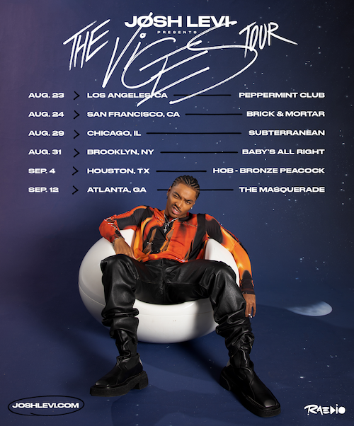

Raedio/Atlantic Records recording artist Josh Levi officially announces his first US headlining tour, “The Vices Tour”, which begins August 23rd in Los Angeles, CA at the Peppermint Club and wraps in Atlanta, GA at The Masquerade on September 12th. Tickets go on sale Wednesday, July 20th at 10:00 am (local). For more details, please visit www.joshlevi.com.

“The Vices Tour” follows the arrival of Levi’s sophomore EP, DISC TWO, out now. Listen HERE. The EP includes recently released single “DON’T THEY REMIX (FEAT. NORMANI),” which exclusively premiered on
Apple Music’s The Zane Lowe Show, as well as luxurious single, “VICES,” a personal favorite of Justin Bieber, who shared the record on his Instagram feed and story.

DISC TWO was first heralded last summer with “NASA,” which premiered alongside a Loris Russier-directed companion visual streaming HERE. Levi celebrated the release of the EP with a stunning live performance of “VICES” on The Terrell Show, as well as an exclusive interview with Rated R&B. The rising star further displayed his intimate approach to modern R&B with a spectacular live performance video of “NASA,” watch HERE.

Named by PEOPLE as one of last year’s “25 Emerging Musical Artists You Should Add to Your Playlist This Fall,” Levi was featured in Disney/Pixar’s blockbuster, Turning Red, starring as the voice of Aaron Z., a member of the teenage heartthrob boyband 4*Town. Previously nominated in the “Best Musical Moment” category for the 2022 MTV Movie & TV Awards, the soundtrack’s feel-good first single, “Nobody Like U,” written by GRAMMY® Award-winning singer-songwriters Billie Eilish and Finneas O’Connell, proved an immediate smash, ascending to the upper half of Billboard’s “Hot 100” and sending Levi’s monthly Spotify listeners to more than 4.5M.

Josh Levi immediately captivates with each inhale of experience and exhale of emotion. The Houston, TX-raised and Los Angeles-based singer, songwriter, and actor developed a fervent fan base through roles on such hit series as Friday Night Lights as well as a series of viral YouTube covers and consistent touring. Hailed by Earmilk as “an all-encompassing showcase of how much of an anomaly he is,” Levi’s 2020 debut EP, DISC ONE – highlighted by such tracks as “IF THE WORLD,”– earned high profile media attention from the likes of Billboard, Wonderland, and V, which declared him “your classic triple threat.” As a result, Levi caught the attention of Issa Rae's label imprint, Raedio, featuring his 2021 single, “What’s The Use,” on the soundtrack to her critically acclaimed HBO Series, Insecure: Season 5. The track proved an instant smash for Levi, named by Billboard at #6 on their “Tunefind Top TV/Movie Syncs of 2021.”

JOSH LEVI
THE VICES TOUR

AUGUST
23 – Los Angeles, CA – Peppermint Club
24 – San Francisco, CA – Brick + Mortar
29 – Chicago, IL – Subterranean
31 – Brooklyn, NY – Baby's All Right

SEPTEMBER
4 – Houston, TX – House Of Blues (Bronze Peacock)
12 – Atlanta, GA – The Masquerade

CONNECT WITH JOSH LEVI
OFFICIAL | FACEBOOK | INSTAGRAM | TIKTOK | TWITTER | YOUTUBE

PRESS CONTACT:
Brittany Bell | Brittany.Bell@atlanticrecords.com

