FOR IMMEDIATE RELEASE
JULY 20, 2022

LIL EAZZYY RETURNS WITH OFFICIAL VISUAL FOR
“HARD WAY FEAT. SHOEBOX BABY”
WATCH “HARD WAY” VISUAL HERE

CHICAGO RAPSTAR PERFORMS “NOTHING LEFT” LIVE ON THE EYE SESSIONS
WATCH FULL SESSION HERE

EAZZYY SET TO GRACE THE 2022 ROLLING LOUD MIAMI FESTIVAL STAGE
THIS FRIDAY

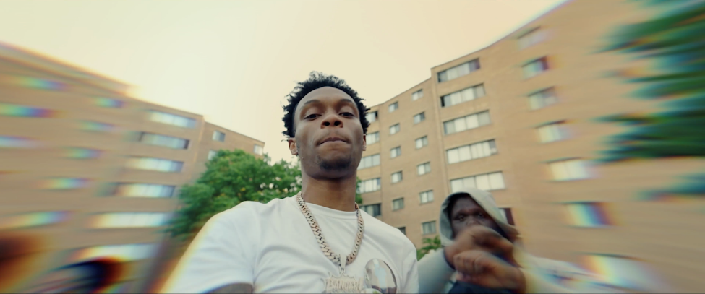
DOWNLOAD THUMBNAIL HERE |DOWNLOAD PRESS IMAGES HERE (press image credit: Jimmy Fontaine)

Lil Eazzyy is back with an official visual for “Hard Way Feat. Shoebox Baby” off his recently released mixtape Too Eazzyy. The pair take it back to the stomping grounds of Chicago with the No More Heroes-directed video. Watch HERE. In addition, Eazzyy shares an effortless yet compelling performance of “Nothing Left” on THE EYE Sessions, once again living up to his name. Watch HERE.

To keep the buzz going, Lil Eazzyy is set to take the 2022 Rolling Loud Miami Festival stage this Friday (7/22) with performances of his previously released singles, “Bring Some Mo feat. NLE Choppa,” “Nothing Left,” and “Forever Been Steppin” off the ten-track project. Stream HERE. Too Eazzyy came a week after Eazzyy embarked on his first U.S headlining tour with NLE Choppa, which kicked off May 1st and wrapped in Los Angeles on June 5th. Eazzyy sat down with TRSH MAG for their TRSH TALK interview series and live performance of “Forever Been Steppin,” positioning himself in line with the greats coming out of Chicago.

Initially announcing himself with “Finesse” in 2019 before posting up millions of streams via “Listen Up,” “Letter To Tracy,” and “Yerk Attack these records paved the way for his 2020 major-label debut, Underrated. Lead single “Onna Come Up” popped off as a viral phenomenon surpassing 147 million streams, vaulting to #6 on the Spotify US Viral 50 and #14 on the Global Viral 50 and captured #21 on Rolling Stone’s Breakthrough 25 Chart. Multi-platinum Chicago luminary, G Herbo, hopped on the “Onna Come Up Remix” featured on Eazzyy’s second project, Rookie of the Year, surpassing 165 million streams worldwide and 11 million views globally of its official video, as well as claiming prime spots on influential playlists’ including Most Necessary, where it graced the cover numerous times.

CONNECT WITH LIL EAZZYY
TWITTER | INSTAGRAM | SPOTIFY | YOUTUBE | SOUNDCLOUD

LIL EAZZYY PRESS CONTACT
BRITTANY BELL | BRITTANY.BELL@ATLANTICRECORDS.COM

