BLACK PUNK SUPERSTAR RICO NASTY RELEASES NEW SINGLE “BLOW ME”
BLUE WATER ROAD TOUR BEGINNING JULY 30TH
UPCOMING MIXTAPE LAS RUINAS ARRIVING 7/22
AVAILABLE FOR PRE-ORDER NOW
STREAM “BLOW ME”
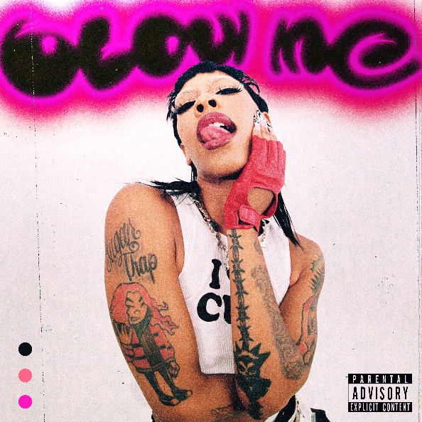
The reigning queen of Black Punk, Rico Nasty, announces new single “Blow Me.” The newly released track comes on the heels of the releases of the singles “Skullflower,” “Black Punk,” “Intrusive,” and “Vaderz (Feat. BKTHERULA). All the singles, including “Blow Me” will be featured on Las Ruinas available for pre-order now.
A busy live schedule will continue in the coming weeks and months as she just wrapped her Black Punk European Tour and gears up for the North American leg of Kehlani’s “Blue Water Road” tour. For complete information, please visit www.riconastymusic.com.
# # #
LAS RUINAS TRACKLIST
- Intrusive
- Vaderz (feat. Bktherula)
- Black Punk
- Messy (feat. TeezoTouchdown & Bktherula)
- Phuckin Lady
- One On 5
- Gotsta Get Paid
- Watch Your Man (feat. Marshmello)
- Blow Me
- Jungle (Rico Nasty Remix)
- Dance Scream
- Skullflower
- Focus On Me
- Always (Skit)
- Easy
- Into The Dark
- Chicken Nugget

# # #
BLUE WATER ROAD TOUR DATES:
JULY
30 – Raleigh, NC – Red Hat Amphitheater

AUGUST
01 – Miami, FL – FPL Solar Amphitheater
03 – Atlanta, GA – Coca-Cola Roxy
05 – Charlotte, NC – Charlotte Metro Credit Union Amphitheatre
07 – Washington, DC – The Anthem
09 – New York, NY – Radio City Music Hall
12 – Boston, MA – Leader Bank Pavilion
13 – Bridgeport, CT – Hartford HealthCare Amphitheater
15 – Philadelphia, PA – Skyline Stage @ The Mann Center
16 – Pittsburgh, PA – UPMC Events Center
17 – Cincinnati, OH – The Andrew J Brady Music Center
19 – Minneapolis, MN – The Armory
22 – Detroit, MI – Fox Theatre
24 – Toronto, ON – Budweiser Stage!
26 – Chicago, IL – Byline Bank Aragon Ballroom
28 – Indianapolis, IN – TCU Amphitheater at White River State Park
30 – Houston, TX – Bayou Music Center

SEPTEMBER
01 – Austin, TX – Moody Amphitheater
03 – Dallas, TX – South Side Ballroom
06 – Denver, CO – Fillmore Auditorium
09 – Las Vegas, NV – The Chelsea @ The Cosmopolitan of Las Vegas
10 – Los Angeles, CA – YouTube Theater
14 – Phoenix, AZ – Arizona Federal Theatre
15 – San Diego, CA – Cal Coast Credit Union Open Air Theatre
17 – Portland, OR – Theater of the Clouds @ Moda Center
18 – Seattle, WA – WAMU Theater
21 – Vancouver, BC – PNE Forum!
30 – Oakland, CA – Oakland Arena

OCTOBER
21 – Honolulu, HI – Waikiki Shell*!
# # #
CONNECT WITH RICO NASTY:
WEBSITE | INSTAGRAM | TWITTER | FACEBOOK | YOUTUBE

FOR PRESS INQUIRIES, PLEASE CONTACT:
Ariana White | Ariana.White@atlanticrecords.com

