FOR IMMEDIATE RELEASE
JULY 13, 2022

SEDDY HENDRINX RELEASES WELL SED EP VIA
GENERATION NOW/ATLANTIC RECORDS

FOLLOW UP TO SINGLE AND VIDEO “LIGHTS”

HE MIGHT NOT SAY MUCH, BUT WHEN HE DOES, ITS WELL SED

WATCH THE MAKING OF WELL SED AVAILABLE TO STREAM NOW

NEW VISUAL FOR “CAN’T GO” PREMIERING TODAY AT 3PM EST

STREAM AND DOWNLOAD WELL SED

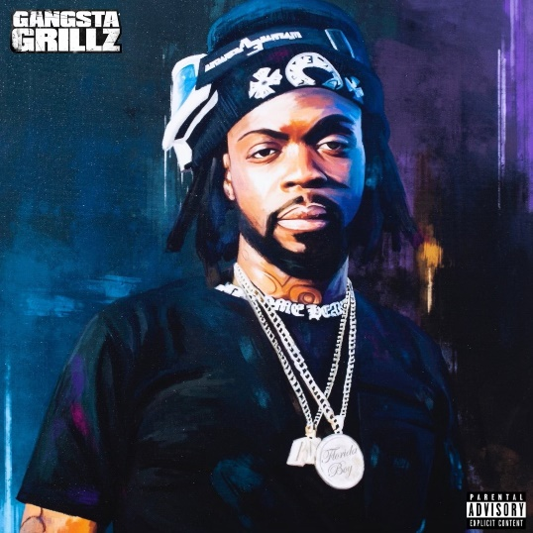
DOWNLOAD HI-RES ART

Today, Jacksonville, FL rapper and singer Seddy Hendrinx released his long awaited Well Sed EP via Generation Now/Atlantic Records. The EP is accompanied by the premiere of the visual for “Can’t Go” releasing today at 3pm EST. Well Sed is executive produced by fellow labelmate, Sonny Digital, with features from Fivio Foreign and T-PAIN. The EP also comes on the heels of the release of the project’s first single and visual, “Lights.” Seddy also released an accompanying EP trailer available HERE.

"Well Sed to me means to represent a lifestyle, a way of living that’s well thought out, well put together and Well Sed. A lot of emotions went into making Well Sed. It was a journey, but at end of the day all worth it." – Seddy Hendrinx

Well Sed comes just after last week’s “Light Up & Listen” event with Seddy Hendrinx and Sonny Digital powered by Generation Now. The event saw both artists playback some of their new hits while engaging with fans, giving away prizes, and fielding listeners’ feedback. The single “Lights,” also comes after Seddy’s recent appearance and freestyle on the Power 105.1 sponsored On the Radar by Gabe P. Seddy also held his first ever #WELLSED pop up earlier this year at Atlanta, GA’s Full Circle ATL celebrating his recently launched merch brand. A recap of the sold-out event – which also included a special first listen to Well Sed – is available here.

WELL SED EP TRACKLIST
- Well Sed
- Groovy Feat. Fivio Foreign
- Can’t Go
- Crash Dummies
- Passion
- Body 2 Body Feat. T-PAIN
- Lights
- Monday Thru Sunday
- Heartbeat
- Again

###

Seddy Hendrinx bobs and weaves between moments of unfiltered emotion, upbeat elation, and undeniable excitement. Through flaunting unmatched unpredictability, the Duval County rapper and singer presents a slick signature style unlike anything else in the game. He asserts himself as a dynamic and diverse disruptor whose uncanny melodic sensibility matches his unbridled intensity. Born and raised in Jacksonville, Florida, music always spoke to Seddy. He immersed himself in records by Tupac, Lauryn Hill, André 3000, DMX, Future, and Erykah Badu. While dying from a gunshot wound, his best friend Johnell urged Seddy to “Ball out for me.” So, Seddy picked up a microphone and did just that. Making waves on Soundcloud, he unleashed music at a prolific pace with projects such as The Roots, Just Cause EP, Death B4 Dishonor: Loyalty Over Everything, Roots II, and B.H.D. (Black Hearted Demon). However, he leveled up on 2020’s Sayless powered by collaborations a la “Plus 10” [feat. Jack Harlow], “Run It Up” [feat. G Herbo], and “45” [feat. A Boogie Wit Da Hoodie]. In addition to plugs from REVOLT, Respect, and more, Earmilk raved, “Hendrinx has quickly become a creative force to be reckoned with, releasing a series of superb albums including Sayless and Roots II.” After racking up tens of millions of streams and views, he perfects this vision on his 2022 mixtape, Well Sed [Generation Now/Atlantic Records].

###

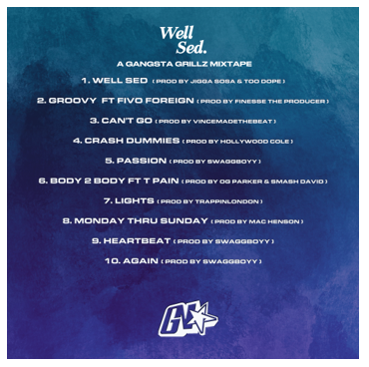

CONNECT WITH SEDDY HENDRINX
FACEBOOK | TWITTER | INSTAGRAM | SOUNDCLOUD | YOUTUBE

PRESS CONTACT
SELAM.BELAY@ATLANTICRECORDS.COM

