FOR IMMEDIATE RELEASE

JULY 19, 2022

**SURF CURSE ANNOUNCE NORTH AMERICAN HEADLINE RUN**

**UPCOMING DATES INCLUDE PRIMAVERA SOUND LOS ANGELES ON SEPTEMBER 17 AND**

**WEBSTER HALL IN NEW YORK ON NOVEMBER 30**

***MAGIC HOUR* ARRIVES VIA ATLANTIC RECORDS ON FRIDAY, SEPTEMBER 16**

**PRE-SAVE/PRE-ORDER NOW** [**HERE**](https://nam04.safelinks.protection.outlook.com/?url=https%3A%2F%2Fsurf-curse.lnk.to%2FMagicHour&data=05%7C01%7CJessica.Nall%40atlanticrecords.com%7C4597ebf60ddd4094906108da65ba8f8c%7C8367939002ec4ba1ad3d69da3fdd637e%7C0%7C0%7C637934150273379096%7CUnknown%7CTWFpbGZsb3d8eyJWIjoiMC4wLjAwMDAiLCJQIjoiV2luMzIiLCJBTiI6Ik1haWwiLCJXVCI6Mn0%3D%7C3000%7C%7C%7C&sdata=FfWouIj0%2BGYqU70Jby1LrtGG2qfIVbGpvqdJ36nl7jE%3D&reserved=0)

[**LISTEN TO “TVI”**](https://nam04.safelinks.protection.outlook.com/?url=https%3A%2F%2Fsurf-curse.lnk.to%2FTVI&data=05%7C01%7CJessica.Nall%40atlanticrecords.com%7C4597ebf60ddd4094906108da65ba8f8c%7C8367939002ec4ba1ad3d69da3fdd637e%7C0%7C0%7C637934150273379096%7CUnknown%7CTWFpbGZsb3d8eyJWIjoiMC4wLjAwMDAiLCJQIjoiV2luMzIiLCJBTiI6Ik1haWwiLCJXVCI6Mn0%3D%7C3000%7C%7C%7C&sdata=q5rT6B1hammFcQ9QI5SPrKHQnxNYmJlg6oTadN7IpZM%3D&reserved=0) **|** [**WATCH OFFICIAL MUSIC VIDEO**](https://nam04.safelinks.protection.outlook.com/?url=https%3A%2F%2Fsurf-curse.lnk.to%2FTVIVideo&data=05%7C01%7CJessica.Nall%40atlanticrecords.com%7C4597ebf60ddd4094906108da65ba8f8c%7C8367939002ec4ba1ad3d69da3fdd637e%7C0%7C0%7C637934150273379096%7CUnknown%7CTWFpbGZsb3d8eyJWIjoiMC4wLjAwMDAiLCJQIjoiV2luMzIiLCJBTiI6Ik1haWwiLCJXVCI6Mn0%3D%7C3000%7C%7C%7C&sdata=fFsvgAPZSdIlYLxVTbdGyf2Fy0eSmM7vLfbrMi8zzeU%3D&reserved=0)

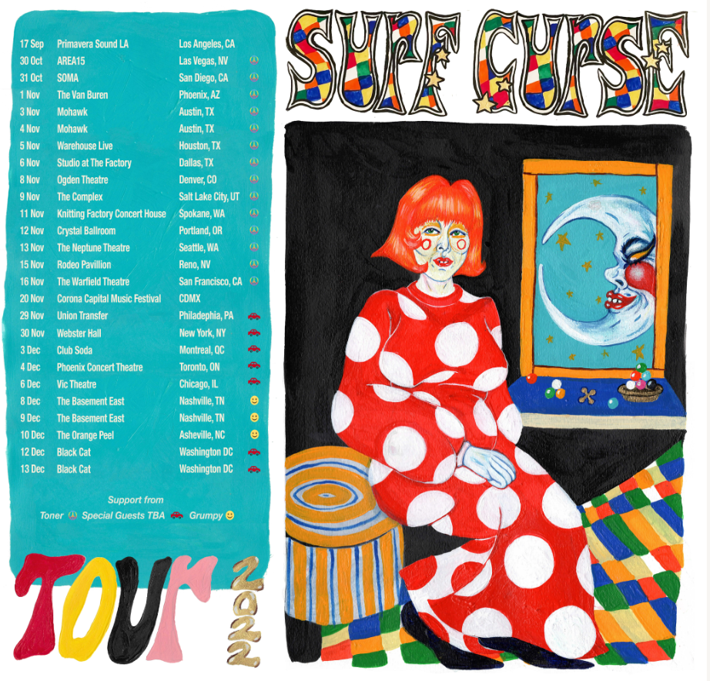

[DOWNLOAD TOUR ADMAT](https://nam04.safelinks.protection.outlook.com/?url=https%3A%2F%2Fwww.dropbox.com%2Fsh%2Fy2ze3tpxbhisrn6%2FAADVCOq1-Pougx1gUWzilVgia%3Fdl%3D0&data=05%7C01%7CJessica.Nall%40atlanticrecords.com%7C69cf741439a545b8837f08da68f0821f%7C8367939002ec4ba1ad3d69da3fdd637e%7C0%7C0%7C637937679419673647%7CUnknown%7CTWFpbGZsb3d8eyJWIjoiMC4wLjAwMDAiLCJQIjoiV2luMzIiLCJBTiI6Ik1haWwiLCJXVCI6Mn0%3D%7C3000%7C%7C%7C&sdata=u1x9yQq9fvT7AOB5HN8KJevaczztClQGvkipFgMnuHo%3D&reserved=0) (Credit: Jennifer Calandra)

Los Angeles, CA-based, RIAA Platinum Certified rock band **Surf Curse** have announced details for their forthcoming North American headline tour, kicking off with two special Halloween shows. The tour includes highly anticipated performances at the new Primavera Sound Los Angeles, set for Saturday, September 17 at Los Angeles State Historic Park and New York’s Webster Hall on November 30th. For complete details and ticket information, please visit [www.surfcurse.com/tour](https://nam04.safelinks.protection.outlook.com/?url=http%3A%2F%2Fwww.surfcurse.com%2Ftour&data=05%7C01%7CJessica.Nall%40atlanticrecords.com%7C4597ebf60ddd4094906108da65ba8f8c%7C8367939002ec4ba1ad3d69da3fdd637e%7C0%7C0%7C637934150273535318%7CUnknown%7CTWFpbGZsb3d8eyJWIjoiMC4wLjAwMDAiLCJQIjoiV2luMzIiLCJBTiI6Ik1haWwiLCJXVCI6Mn0%3D%7C3000%7C%7C%7C&sdata=DFtAXHc1WPw6t9WRRl18OsU%2BsM%2FU6vSz5EzxNZvs2%2F8%3D&reserved=0) and for early access, pre-save the album [HERE](https://nam04.safelinks.protection.outlook.com/?url=https%3A%2F%2Fsurf-curse.lnk.to%2FMagicHour&data=05%7C01%7CJessica.Nall%40atlanticrecords.com%7C4597ebf60ddd4094906108da65ba8f8c%7C8367939002ec4ba1ad3d69da3fdd637e%7C0%7C0%7C637934150273535318%7CUnknown%7CTWFpbGZsb3d8eyJWIjoiMC4wLjAwMDAiLCJQIjoiV2luMzIiLCJBTiI6Ik1haWwiLCJXVCI6Mn0%3D%7C3000%7C%7C%7C&sdata=pqry1trQZ1og6DKqJrOJkqd9LWxZWwGuNbV1B4qLNvI%3D&reserved=0).

**Surf Curse** recently shared the highly energized new single, “[**TVI**](https://nam04.safelinks.protection.outlook.com/?url=https%3A%2F%2Fsurf-curse.lnk.to%2FTVI&data=05%7C01%7CJessica.Nall%40atlanticrecords.com%7C4597ebf60ddd4094906108da65ba8f8c%7C8367939002ec4ba1ad3d69da3fdd637e%7C0%7C0%7C637934150273379096%7CUnknown%7CTWFpbGZsb3d8eyJWIjoiMC4wLjAwMDAiLCJQIjoiV2luMzIiLCJBTiI6Ik1haWwiLCJXVCI6Mn0%3D%7C3000%7C%7C%7C&sdata=q5rT6B1hammFcQ9QI5SPrKHQnxNYmJlg6oTadN7IpZM%3D&reserved=0)**,**” available now via Atlantic Records at all DSPs and streaming services. An official music video, directed by Nick Rattigan and Jacob Rubeck and shot on VHS by Max Knight, follows the band on a *Scooby Doo-*style adventure through a haunted castle in the hills of L.A. – watch at YouTube [HERE](https://nam04.safelinks.protection.outlook.com/?url=https%3A%2F%2Fsurf-curse.lnk.to%2FTVIVideo&data=05%7C01%7CJessica.Nall%40atlanticrecords.com%7C4597ebf60ddd4094906108da65ba8f8c%7C8367939002ec4ba1ad3d69da3fdd637e%7C0%7C0%7C637934150273535318%7CUnknown%7CTWFpbGZsb3d8eyJWIjoiMC4wLjAwMDAiLCJQIjoiV2luMzIiLCJBTiI6Ik1haWwiLCJXVCI6Mn0%3D%7C3000%7C%7C%7C&sdata=hzxb80x3wKC0t0DhxywW%2BrWeRTjJVFnFe4ZpzbPB30o%3D&reserved=0). “TVI” marks the latest single from **Surf Curse’s** eagerly awaited Atlantic Records debut album, [***MAGIC HOUR***](https://nam04.safelinks.protection.outlook.com/?url=https%3A%2F%2Fsurf-curse.lnk.to%2FMagicHour&data=05%7C01%7CJessica.Nall%40atlanticrecords.com%7C4597ebf60ddd4094906108da65ba8f8c%7C8367939002ec4ba1ad3d69da3fdd637e%7C0%7C0%7C637934150273535318%7CUnknown%7CTWFpbGZsb3d8eyJWIjoiMC4wLjAwMDAiLCJQIjoiV2luMzIiLCJBTiI6Ik1haWwiLCJXVCI6Mn0%3D%7C3000%7C%7C%7C&sdata=pqry1trQZ1og6DKqJrOJkqd9LWxZWwGuNbV1B4qLNvI%3D&reserved=0), due everywhere on Friday, September 16. Vinyl / CD / Cassette pre-orders launching soon and digital pre-save/pre-order is available now [HERE](https://nam04.safelinks.protection.outlook.com/?url=https%3A%2F%2Fsurf-curse.lnk.to%2FMagicHour&data=05%7C01%7CJessica.Nall%40atlanticrecords.com%7C4597ebf60ddd4094906108da65ba8f8c%7C8367939002ec4ba1ad3d69da3fdd637e%7C0%7C0%7C637934150273535318%7CUnknown%7CTWFpbGZsb3d8eyJWIjoiMC4wLjAwMDAiLCJQIjoiV2luMzIiLCJBTiI6Ik1haWwiLCJXVCI6Mn0%3D%7C3000%7C%7C%7C&sdata=pqry1trQZ1og6DKqJrOJkqd9LWxZWwGuNbV1B4qLNvI%3D&reserved=0).

***MAGIC HOUR***was recorded at Electric Lady, an iconic studio founded by Jimi Hendrix and located in New York City. The album, produced by Chris Coady, includes the power pop anthem, “[Sugar](https://nam04.safelinks.protection.outlook.com/?url=https%3A%2F%2Flnk.to%2FGetSugarID&data=05%7C01%7CJessica.Nall%40atlanticrecords.com%7C4597ebf60ddd4094906108da65ba8f8c%7C8367939002ec4ba1ad3d69da3fdd637e%7C0%7C0%7C637934150273535318%7CUnknown%7CTWFpbGZsb3d8eyJWIjoiMC4wLjAwMDAiLCJQIjoiV2luMzIiLCJBTiI6Ik1haWwiLCJXVCI6Mn0%3D%7C3000%7C%7C%7C&sdata=DuCVa7aM91NADsGOEjRGeALo5CivfO5Ou%2FnoCBLJLfI%3D&reserved=0),” available now for streaming and download. An official music video – directed by Surf Curse co-founders Nick Rattigan and Jacob Rubeck – has already earned close to 2M views at YouTube [HERE](https://nam04.safelinks.protection.outlook.com/?url=https%3A%2F%2Fwww.youtube.com%2Fwatch%3Fv%3D9KxdfojRh3Q&data=05%7C01%7CJessica.Nall%40atlanticrecords.com%7C4597ebf60ddd4094906108da65ba8f8c%7C8367939002ec4ba1ad3d69da3fdd637e%7C0%7C0%7C637934150273535318%7CUnknown%7CTWFpbGZsb3d8eyJWIjoiMC4wLjAwMDAiLCJQIjoiV2luMzIiLCJBTiI6Ik1haWwiLCJXVCI6Mn0%3D%7C3000%7C%7C%7C&sdata=%2F0BhZtzDKeHYtXMtLHCc0tHlJmjmt3JonEXK3nM2VRM%3D&reserved=0).

Founded in Reno, NV by Nick Rattigan (lead vocals, drums) and Jacob Rubeck (guitar), **Surf Curse** have been crafting a multifaceted sound informed by indie, punk, pop, psych rock, and more for nearly a decade. 2020 saw the band’s breakthrough with the surprise TikTok success of “[Freaks](https://nam04.safelinks.protection.outlook.com/?url=https%3A%2F%2Flnk.to%2FFreaksVideo&data=05%7C01%7CJessica.Nall%40atlanticrecords.com%7C4597ebf60ddd4094906108da65ba8f8c%7C8367939002ec4ba1ad3d69da3fdd637e%7C0%7C0%7C637934150273535318%7CUnknown%7CTWFpbGZsb3d8eyJWIjoiMC4wLjAwMDAiLCJQIjoiV2luMzIiLCJBTiI6Ik1haWwiLCJXVCI6Mn0%3D%7C3000%7C%7C%7C&sdata=qSe6e6UTSlR5yrtSXzAHQ8hWY0tBGObi3lDaXhNCfbA%3D&reserved=0),” which saw the track earn over 500M worldwide streams and RIAA Platinum certification more than eight years after the release.

***MAGIC HOUR***, the band’s fourth LP, sees **Surf Curse** testing the boundaries of their seasoned indie rock approach, exploring a wider range of sonic styles and colors than ever before. The album marks not only the DIY veterans’ Atlantic Records debut, it serves as official  introduction to two new members of the band in Noah Kohll and Henry Dillon. The newly expanded lineup allowed for Surf Curse to push their already ambitious songcraft even further than ever before on tracks like the blistering album-opener “Arrow” and the somber blues rock of “No Tomorrows.”

“*MAGIC HOUR is our excitement about rock music and being in a band,*” says guitarist, **Jacob Rubeck**, “*This album is the excitement of starting something that we all can feel good about with each other, but also progressing as creative people and throwing in that magic. We're feeling that magic, what's brewing in the air and what's existing in what we're doing together.*”

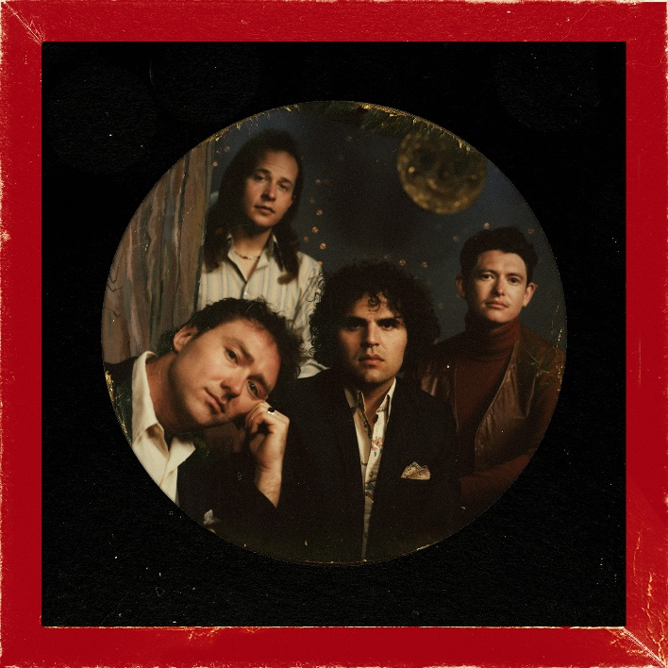

[DOWNLOAD ALBUM ARTWORK](https://warnermusicgroup.app.box.com/file/981495087485)| [DOWNLOAD SINGLE ARTWORK](https://warnermusicgroup.app.box.com/file/981496064835?s=qiz3o8stl7w04usph468k965au2o4fri)

# # #

**SURF CURSE**

**WORLD TOUR 2022**

**SEPTEMBER**

17 - Los Angeles, CA - Primavera Sound Los Angeles *

28 - London, United Kingdom - Electric Ballroom

**OCTOBER**

1 - Manchester, United Kingdom - New Century

2 - Glasgow, United Kingdom - SWG3 Studio Warehouse

4 - Dublin, Ireland - The Academy

6 - Birmingham, United Kingdom - The Castle & Falcon

7 - Brighton, United Kingdom - Chalk

8 - Bristol, United Kingdom - SWX

10 - Amsterdam, Netherlands - Paradiso

12 - Paris, France - Le Trabendo

13 - Bordeaux, France - Rock School Barbey

14 - Barcelona, Spain - Razzmatazz

15 - Madrid, Spain - Independence Club

17 - Zürich, Switzerland - Mascotte

19 - Berlin, Germany - Kesselhaus

20 - Cologne, Germany - Gebäude 9

30 – Las Vegas, NV – Area 51  
31 – San Diego, CA – SOMA

**NOVEMBER**

1 – Phoenix, AZ – Van Buren  
3 – Austin, TX – Mohawk  
4 – Austin, TX – Mohawk  
5 – Houston, TX – Warehouse Live  
6 – Dallas, TX – The Factory Studio  
8 – Denver, CO – Ogden Theater  
9 – Salt Lake City, UT – Rockwell at the Complex  
11 – Spokane, WA – Knitting Factory  
12 – Portland, OR – Crystal Ballroom  
13 – Seattle, WA – Neptune Theatre  
15 – Reno, NV – Rodeo Pavilion  
16 – San Francisco, CA – Warfield

20 - Mexico City, Mexico - Corona Capital *

29 – Philadelphia, PA – Union Transfer  
30 – New York, NY – Webster Hall

**DECEMBER**

​3 – Montreal, QC – Club Soda  
4 – Toronto, ON – Phoenix  
6 – Chicago, IL – Vic Theater  
8 – Nashville, TN – Basement East  
9 – Nashville, TN – Basement East  
10 – Asheville, NC – The Orange Peel  
12 – Washington, DC – Black Cat  
13 – Washington, DC – Black Cat

* FESTIVAL PERFORMANCE

# # #

**SURF CURSE**

***MAGIC HOUR***

(Atlantic Records)

Release Date: Friday, September 16

**TRACKLIST**

Arrow

Cathy

Sugar

Lost Honor

Self Portrait

Unwell

Strange

TVI

Little Rock ‘n’ Roller

No Tomorrows

Fear City

Randall Flagg

# # #

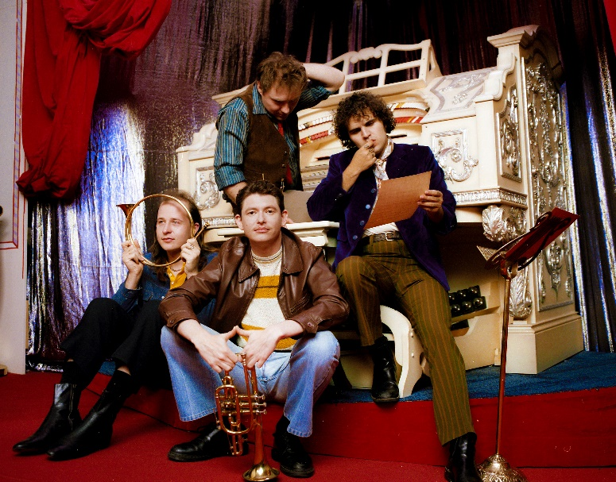

[DOWNLOAD PRESS PHOTOS HERE](https://warnermusicgroup.app.box.com/s/sfvbvl9b1fno7nn1kberfx9bv4uil8fw) (CREDIT: JULIEN SAGE)

CONNECT WITH SURF CURSE

[WEBSITE](https://nam04.safelinks.protection.outlook.com/?url=https%3A%2F%2Fwww.surfcurse.com%2F&data=05%7C01%7CJessica.Nall%40atlanticrecords.com%7C4597ebf60ddd4094906108da65ba8f8c%7C8367939002ec4ba1ad3d69da3fdd637e%7C0%7C0%7C637934150273535318%7CUnknown%7CTWFpbGZsb3d8eyJWIjoiMC4wLjAwMDAiLCJQIjoiV2luMzIiLCJBTiI6Ik1haWwiLCJXVCI6Mn0%3D%7C3000%7C%7C%7C&sdata=9tFY3ue4RxP82f01KrlaQokmldeyo2CFIY9ya1yF4aA%3D&reserved=0) | [FACEBOOK](https://nam04.safelinks.protection.outlook.com/?url=https%3A%2F%2Ffacebook.com%2Fsurfcurseband&data=05%7C01%7CJessica.Nall%40atlanticrecords.com%7C4597ebf60ddd4094906108da65ba8f8c%7C8367939002ec4ba1ad3d69da3fdd637e%7C0%7C0%7C637934150273535318%7CUnknown%7CTWFpbGZsb3d8eyJWIjoiMC4wLjAwMDAiLCJQIjoiV2luMzIiLCJBTiI6Ik1haWwiLCJXVCI6Mn0%3D%7C3000%7C%7C%7C&sdata=JcVGpFsPngNpyvSwxWkZLaWI8%2F2%2FkozFVRvCQpz%2FHFw%3D&reserved=0) | [INSTAGRAM](https://nam04.safelinks.protection.outlook.com/?url=https%3A%2F%2Finstagram.com%2Fsurfcurse&data=05%7C01%7CJessica.Nall%40atlanticrecords.com%7C4597ebf60ddd4094906108da65ba8f8c%7C8367939002ec4ba1ad3d69da3fdd637e%7C0%7C0%7C637934150273535318%7CUnknown%7CTWFpbGZsb3d8eyJWIjoiMC4wLjAwMDAiLCJQIjoiV2luMzIiLCJBTiI6Ik1haWwiLCJXVCI6Mn0%3D%7C3000%7C%7C%7C&sdata=YNw8wfEVU9%2BtrimTvtYaOo%2F17w5eAI3jo4o%2BlQKPqzQ%3D&reserved=0) | [YOUTUBE](https://nam04.safelinks.protection.outlook.com/?url=https%3A%2F%2Fwww.youtube.com%2Fchannel%2FUC17US4Ed0c0yQ-cCkd9ghuQ&data=05%7C01%7CJessica.Nall%40atlanticrecords.com%7C4597ebf60ddd4094906108da65ba8f8c%7C8367939002ec4ba1ad3d69da3fdd637e%7C0%7C0%7C637934150273535318%7CUnknown%7CTWFpbGZsb3d8eyJWIjoiMC4wLjAwMDAiLCJQIjoiV2luMzIiLCJBTiI6Ik1haWwiLCJXVCI6Mn0%3D%7C3000%7C%7C%7C&sdata=qq4hOwtgzB9hdMy1C31SxbchDMdXoS%2BR3117EnXX9WU%3D&reserved=0)

For press inquiries, please contact:  
Jessica Nall // [Jessica.Nall@atlanticrecords.com](mailto:Jessica.Nall@atlanticrecords.com)