FOR IMMEDIATE RELEASE
JULY 27, 2022

RISING R&B ARTIST TRAETWOTHREE
DROPS DEBUT MIXTAPE OUT THE DISTRICT
LISTEN HERE

MIXTAPE FEATURES STAND OUT TRACKS “710 (FEAT. DW FLAME)”, “STUCK IN MY WAYS (FEAT. BLUEFACE)”, “WORTH IT (FEAT. DDG)” AND “DONE DONE”
+
DROPS SEXY NEW VISUAL FOR “KEEP DOING YOU”
WATCH HERE

OUT THE DISTRICT AVAILABLE NOW HERE VIA NCREDIBLE / ART@WAR / ATLANTIC RECORDS

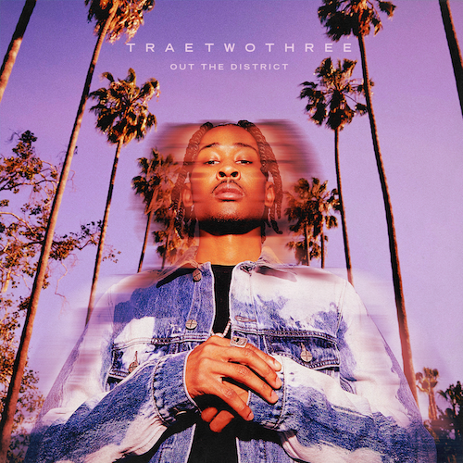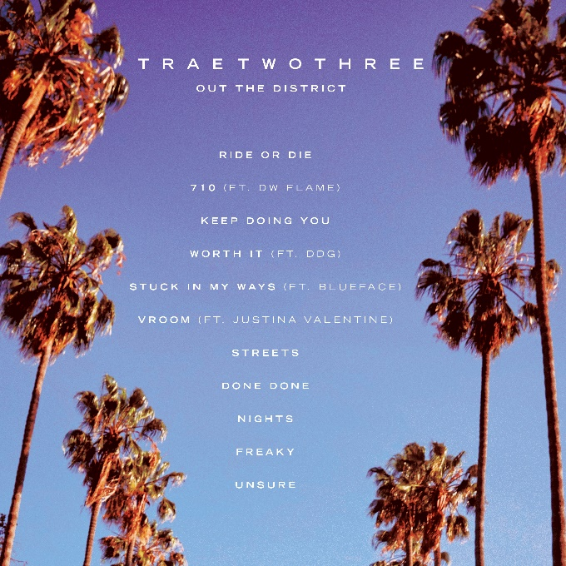
Download High-Res Artwork Here

South Central R&B sensation TRAETWOTHREE has announced today’s release of his eagerly anticipated debut mixtape, OUT THE DISTRICT. The mixtape arrives alongside new single and video, “Keep Doing You,” out now. Watch the visual HERE + stream the project HERE. While flaunting his one-of-a-kind sound that expertly conjures his native South Central after-dark cadence the Okezie Kenneth Nobuisi-directed visual, captures divine femininity and translates it onto a canvas.

“My debut project, OUT THE DISTRICT is an introduction for me,” says TRAETWOTHREE. “It’s important that I let people know that I come from the Crenshaw District. Most artists coming out of South LA are rappers, but I’m an R&B artist who brings a different sound that people never heard before. With Keep Doing You, I wanted to create a song and visual that shows my appreciation for women especially-women of color… encouraging them to be their true authentic selves. Overall, when people listen to OUT THE DISTRICT, I want them to just enjoy the vibes.”

OUT THE DISTRICT includes previously-released tracks, “710 (Feat. DW Flame),” “Stuck In My Ways (Feat. Blueface),” “Done Done,“ and “Worth It (Feat. DDG), stream HERE. TRAETWOTHREE was recently featured on Nick Cannon’s new album, THE EXPLICIT TAPE: RAW & B, and embarked on the “Nick Cannon Presents: Wild 'N Out” North American arena tour – showing a different side of the South Central story in his music.

ABOUT TRAETWOTHREE:
Calm falls over South Central, Los Angeles when the sun goes down. Under the glow of streetlights, the city provides the backdrop for friendship, romance, and growth. It’s a dimension of this neighborhood rarely if ever, depicted in movies, television series, video games, and books, but it’s reality for TRAETWOTHREE. The Crenshaw-raised singer and songwriter invite listeners to sit in the passenger seat as he cruises the place, he proudly calls home and experiences trials, tribulations, and triumphs after dark. As the story goes, he rotated between homes, living with his mom, dad, and grandma. With his parents as Jehovah’s Witnesses, he absorbed faith through his family. He played saxophone throughout middle school and spun records by the likes of Gerald Albright, David Sanborn, Candy Dulfer, Tank, Tyrese, Erykah Badu, and The Isley Brothers. Embracing Drake, J. Cole, and Nipsey Hussle, he wrote and recorded music in his bedroom at the age of sixteen, fashioning a fresh and fiery perspective on R&B. He serendipitously linked up with Ncredible when team members bought sneakers from him during his part-time gig at Dick’s Sporting Goods. Nick Cannon heard his music and signed him. “TRAETWOTHREE is a fresh new voice in R&B. I have the same feeling about him as I did when I found Kehlani.” A series of tracks – Following “4am In The District” and “High Tec,” he put up numbers on “Drownin” [feat. Hitman Holla], collecting 626K Spotify streams and 311K YouTube views. With millions of streams and views under his belt as well as acclaim from The Source and more, he introduces himself and his hometown on his debut mixtape, Out The District.

TRAETWOTHREE
OUT THE DISTRICT

TRACKLIST
Ride or Die
710 (Ft. DW Flame)
Keep Doing You
Worth It (Ft. DDG)
Stuck In My Ways (Ft. Blueface)
Vroom (Ft. Justina Valentine)
Streets
Done Done
Nights
Freaky
Unsure

# # #
CONNECT WITH TRAETWOTHREE
INSTAGRAM | YOUTUBE | TWITTER | FACEBOOK

PRESS CONTACT
FAIRLEY MCCASKILL | FAIRLEY.MCCASKILL@ATLANTICRECORDS.COM

