FOR IMMEDIATE RELEASE
JUNE 10, 2022

MULTI-PLATINUM GLOBAL SUPERSTAR VANCE JOY RETURNS WITH
IN OUR OWN SWEET TIME

NORTH AMERICAN TOUR ANNOUNCED FOR 2023; TICKETS ON SALE TODAY HERE

ENTHRALLING NEW ALBUM HIGHLIGHT, “CATALONIA,” PREMIERES TODAY HERE

IN OUR OWN SWEET TIME AVAILABLE EVERYWHERE NOW VIA ATLANTIC RECORDS HERE

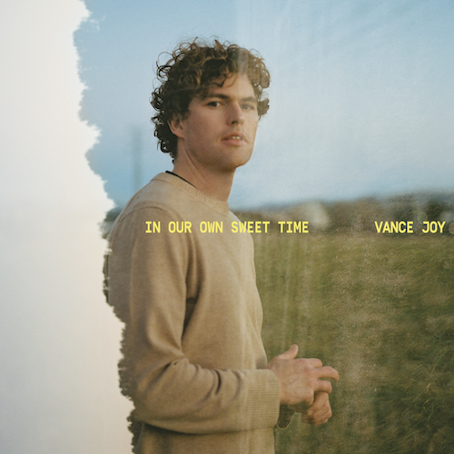
(DOWNLOAD HI-RES ARTWORK)

Multi-platinum singer-songwriter Vance Joy is proud to unveil his highly anticipated third studio album, In Our Own Sweet Time, available everywhere now via Atlantic Records HERE.

Currently boasting over 5 billion worldwide streams and counting, Joy is marking today’s release with the premiere of the enthralling album highlight, “Catalonia,” available at all DSPs and streaming services HERE. An official music video/visualizer premieres today via YouTube HERE.

Joy recently made his return to the live stage with show-stopping festival performances at California’s BeachLife and BottleRock as well as a series of sold-out headline shows in Nashville, New York and Toronto, where he performed at the world-famous Budweiser Stage for more than 17,000 fans and a worldwide livestream audience on his official YouTube channel, which can now be viewed HERE. Now, he has announced that he will travel the globe throughout 2023 on an epic world tour celebrating his new album. The first North American leg of the “In Our Own Sweet Time Tour” gets underway February 7, 2023 at Philadelphia, PA’s The Met and then travels through late March. Tickets for all dates are on sale now. For complete details and ticket information, please visit www.vancejoy.com.

VANCE JOY
IN OUR OWN SWEET TIME TOUR 2023

FEBRUARY
7 – Philadelphia, PA – The Met Philadelphia
8 – Boston, MA – MGM Music Hall at Fenway
10 – Montreal, QC – MTELUS
11 – Montreal, QC – MTELUS
12 – Ottawa, ON – Southam Hall
14 – Kitchener, ON – Centre In The Square
15 – Hamilton, ON – FirstOntario Centre
17 – Columbus, OH – KEMBA Live!
18 – Chicago, IL – The Chicago Theatre
19 – Minneapolis, MN – State Theatre
21 – Winnipeg, MB – Centennial Concert Hall
22 – Saskatoon, SK – TCU Place
23 – Calgary, AB – Jack Singer Concert Hall
24 – Calgary, AB – Jack Singer Concert Hall
27 – Edmonton, AB – Winspear Centre,
28 – Edmonton, AB – Winspear Centre

MARCH
3 – Seattle, WA – Paramount Theatre
6 – Portland, OR – Keller Auditorium
9 – Oakland, CA – Fox Theater
11 – Inglewood, CA – Hollywood Park
16 – San Diego, CA – Soma
20 – Dallas, TX – The Factory in Deep Ellum
21 – Austin, TX – ACL Live at the Moody Theater
23 – Atlanta, GA – Coca–Cola Roxy
24 – Charlotte, NC – The Fillmore
25 – Washington, DC – The Anthem

# # #

Joy’s most creatively inventive and personal project thus far, In Our Own Sweet Time includes such emotionally charged new tracks as “Every Side of You,” available for streaming and download HERE. Hailed by NME as “a wholesome and heartfelt ode to human connection,” the track is joined by an equally poignant official music video, directed by award-winning filmmaker W.A.M. Bleakley (Courtney Barnett, Middle Kids) and streaming HERE.

In Our Own Sweet Time is further highlighted by the rising hit single, “Clarity,” produced and co-written with GRAMMY® Award-winning songwriter Joel Little (Lorde, Taylor Swift) and joined by an official music video streaming HERE. In addition, this week saw Joy pay a visit to NBC’s TODAY for an exclusive live TV performance of “Clarity,” streaming HERE.

“Clarity” is fast proving another landmark success for Joy, currently ascending the top 25 at Alternative radio outlets nationwide after amassing critical acclaim from the likes of Rolling Stone and V Magazine, which raved, “‘Clarity’ is bubbly and bright…Groovy bass, sharp drums, and Joy’s usual guitar blend together with uplifting horn solos to create the perfect summer tune.” “The new track adds a world of depth to the folky indie-pop slant of Joy’s earlier material,” agreed NME, “supplementing his cool and cruisy acoustic strumming with deep bass grooves, crisp and lowkey yet duly impactful drums, and a soaring horn section.”

In Our Own Sweet Time also includes the hit singles, “Missing Piece” and “Don’t Fade,” the latter of which arrived earlier this year and quickly earned more than 10 million worldwide streams alongside praise from Rolling Stone, Entertainment Tonight, and more. Currently certified RIAA gold in the US and 2x platinum in Australia, “Missing Piece” proved a global sensation following its 2021 world premiere on ABC’s Grey’s Anatomy. Reaching #2 at Alternative radio, the single has gone on to earn over 130 million global streams as well as a massive 3 billion TikTok views (with 2.6 million user-created videos). Official music videos for both tracks are streaming now at YouTube HERE.

Recorded largely over the course of lockdown, In Our Own Sweet Time is fueled by old friends, new memories and finding love in a not-so-hopeless place. The eagerly awaited new album includes collaborations with hitmakers such as Little, Dan Wilson (Adele, Leon Bridges), Take a Day Trip (Miley Cyrus, Lil Nas X), and more.

“I’m always drawn to the idea of timelessness or that shared moment that takes you out of the chaos outside,” Joy says. “If the world is crazy, you can retreat somewhere. It’s always hard to think of the right title but I think that sums up the album perfectly.”

(DOWNLOAD HI-RES IMAGE // PHOTO CREDIT: CELINA MARTINS)

# # #

VANCE JOY
IN OUR OWN SWEET TIME
(Atlantic Records)

1. Don't Fade
2. Solid Ground
3. Missing Piece
4. Catalonia
5. Way That I'm Going
6. Every Side Of You
7. Clarity
8. Wavelength
9. Boardwalk
10. Looking at Me Like That
11. This One
12. Daylight

# # #

CONNECT WITH VANCE JOY:
WEBSITE | FACEBOOK | TWITTER | INSTAGRAM | YOUTUBE

For press inquiries, please contact:
Kelly McWilliam // Kelly.McWilliam@atlanticrecords.com
Libby Kober // Libby.Kober@atlanticrecords.com

