FOR IMMEDIATE RELEASE
JUNE 10, 2022

SWEDISH SONGSTRESS WINONA OAK UNVEILS DEBUT ALBUM
ISLAND OF THE SUN

HIGHLIGHTS INCLUDE “JOJO,” “BABY BLUE,” “ISLAND OF THE SUN,”
+ THE ELECTRIFYING NEW SINGLE, “RADIO”

EU/UK TOUR SUPPORTING ALEC BENJAMIN BEGINS LATER THIS MONTH IN PARIS

ISLAND OF THE SUN AVAILABLE EVERYWHERE NOW VIA NEON GOLD/ATLANTIC RECORDS

LISTEN TO “RADIO” | WATCH OFFICIAL “RADIO” MUSIC VIDEO

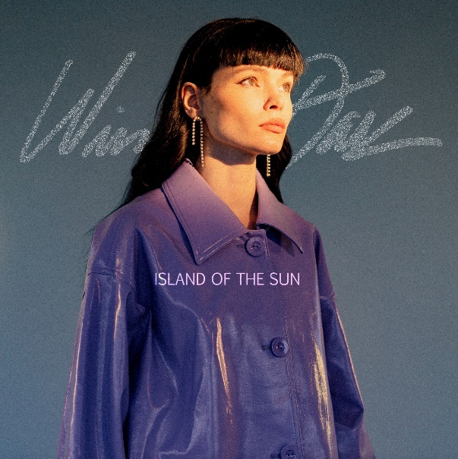
DOWNLOAD HI-RES ARTWORK

“Winona Oak is a name you should know” – PAPER

“Winona Oak’s voice is like honey – rich and oozing with elegance, she never has to do too much to leave an impression.” – CONSEQUENCE

Acclaimed singer-songwriter Winona Oak has announced today’s release of her long-awaited debut album, Island of the Sun, available everywhere now via Neon Gold/Atlantic Records HERE.

Hailed by Uproxx as “one of the best debuts of 2022,” Island of the Sun includes the electrifying new single, “Radio,” available now at all DSPs and streaming services HERE. An official music video premieres today via YouTube HERE.

Island of the Sun further includes such critically acclaimed highlights as “Jojo,” “Baby Blue,” “Break My Broken Heart,” “Piano In The Sky,” and the album’s stunning title track, “Island of the Sun,” all of which are accompanied by equally enthralling companion videos streaming now at the official Winona Oak YouTube channel HERE.

Winona – who just wrapped her first-ever North American concert tour supporting British alt-pop duo Oh Wonder – will continue to celebrate Island of the Sun with an eagerly anticipated EU/UK tour alongside Alec Benjamin. For updates, please visit www.winonaoak.com.

DOWNLOAD PRESS PHOTO HERE

WINONA OAK ON TOUR 2022

JUNE
28 – Paris, FR – Le Trainon
30 – Cologne, DE – Live Music Hall

JULY
1 – Amsterdam, NL – Melkweg
4 – Milan, IT – Fabrique
9 – Barcelona, ES – Razzmatazz Room 2
11 – Munich, DE – TonHalle
12 – Berlin, DE – Columbiahalle
14 – Warsaw, PL – Stodola
15 – Hamburg, DE – Mojo Club
17 – Copenhagen, DK – Vega
18 – Oslo, NO – Sentrum Scene
20 – Stockholm, SW – Arenan Fryshuset
22 – Helsinki, FL – House of Culture
24 – Vienna, AT – WUK
25 – Praha, CZ – Zlute Lazne
26 – Budapest, TR – Akvarium Klub
28 – Utrecht, NE – TivoliVredenburg - Ronda
30 – London, UK – O2 Forum Kentish Town
31 – Manchester, UK – O2 Ritz

AUGUST
2 – Dublin, IE – Academy
3 – Dublin, IE – Academy
5 – Glasgow, UK – SWG 3
6 – London, UK – 02 Forum Kentish Town

# # #

Born and raised in the Nordic forests of Sweden on a small crop of land called Sollerön – known as the Island of the Sun and the inspiration for her extraordinary debut album – Winona Oak is every bit as enchanting as her origin story. With a childhood spent encountering more animals than people, she grew up a trained horse acrobat and pursued creative expression however she could, writing poetry and songs and playing violin and piano from a young age. After moving to Stockholm to pursue her passion for music, Winona honed her craft and landed a deal with Atlantic/Neon Gold Records. Soon after, the budding songstress met Australian electronic maestro What So Not and the two co-wrote his singles “Better,” “Stuck In Orbit“ and “Beautiful,” which highlighted Winona as the track’s featured artist. She then went on to collaborate with The Chainsmokers on their RIAA gold-certified hit single, “Hope” and soon followed with her runaway success debut solo single, ”He Don’t Love Me.” In 2020, Winona released her first EP, Closure, followed quickly by her critically acclaimed sophomore EP, SHE, earning praise from the likes of PAPER, which declared, “Winona Oak is a name you should know.” Winona celebrated SHE with a stirring live performance of the title track as part of CBS’ The Late Show with Stephen Colbert’s #PLAYATHOME series, streaming HERE. 2021 saw Winona collaborate with breakout bedroom pop star ELIO on “Nobody Loves Me.” Now, with the long-anticipated arrival of Island of the Sun, Winona Oak fully affirms her remarkable promise as one of today’s most original and compelling new artists.

# # #

PRAISE FOR WINONA OAK
“(Winona Oak) isn’t afraid to mix the fear, anger, and sadness that she’s experienced as a woman in music with an equally unshakeable sense of self-confidence. ‘We are so powerful,’ she said. ‘We can create an entire life. Women’s bodies are so powerful. We are divine.’ If there is a thesis for Island Of The Sun, it is undoubtedly that.”
– UPROXX

“Magnetizing...a true testament to her unprecedented singing abilities, and it’s a refreshingly authentic look into the multi-faceted vocalist’s emotional psyche”
– V MAGAZINE

“Lyrically, the electro-pop musician pays homage to strong women in every respect, delivering body and sex-positive anthems, and touching on important topics such as mental health and self-love.”
– PAPER

“From the Nordic forests of Sweden, on a small crop of land called Sollerön, known as the ‘Island of the Sun,’ emerges singer-songwriter Winona Oak. Her music, the product of her upbringing, is just as enchanting as its setting, surrounded by nature and wildlife.”
– AMERICAN SONGWRITER

“An impossible to ignore artist. Ethereal, mesmerizing…”
– ONES TO WATCH

“Staggeringly good”
– IDOLATOR

“‘Island of the Sun’ is jarring, exciting, and points to (Winona Oak’s) impressive ability as a producer, songwriter, and arranger.” – CONSEQUENCE

# # #

WINONA OAK
ISLAND OF THE SUN
(Neon Gold/Atlantic Records)

TRACKLIST
1. Island of the Sun
2. Baby Blue
3. He Don't Love Me
4. Break My Broken Heart
5. Radio
6. NDA
7.My Man
8. Yours Tomorrow
9. Nothing To Lose
10. Mother and Daughter
11. Piano in the Sky
12. Happy You're My Ex
13. Jojo

# # #

CONNECT WITH WINONA OAK
WEBSITE | INSTAGRAM | TWITTER |SPOTIFY | APPLE MUSIC | YOUTUBE

For more on Winona Oak, please reach out to:
Kelly McWilliam – Kelly.McWilliam@atlanticrecords.com
Gabby Reese – Gabrielle.Reese@atlanticrecords.com

