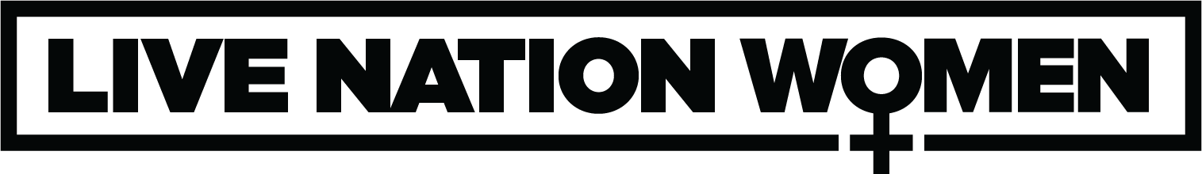

HALESTORM RETURNS TO THE STAGE WITH THEIR SUMMER 2022 TOUR

Featuring An All Female Special Guests Lineup on Select Dates Including
The Pretty Reckless, The Warning, and Lilith Czar

Tickets On Sale Starting Friday, April 1st at 10AM Local on Ticketmaster.com

Halestorm’s Chart-Climbing Single ‘The Steeple” Out Now

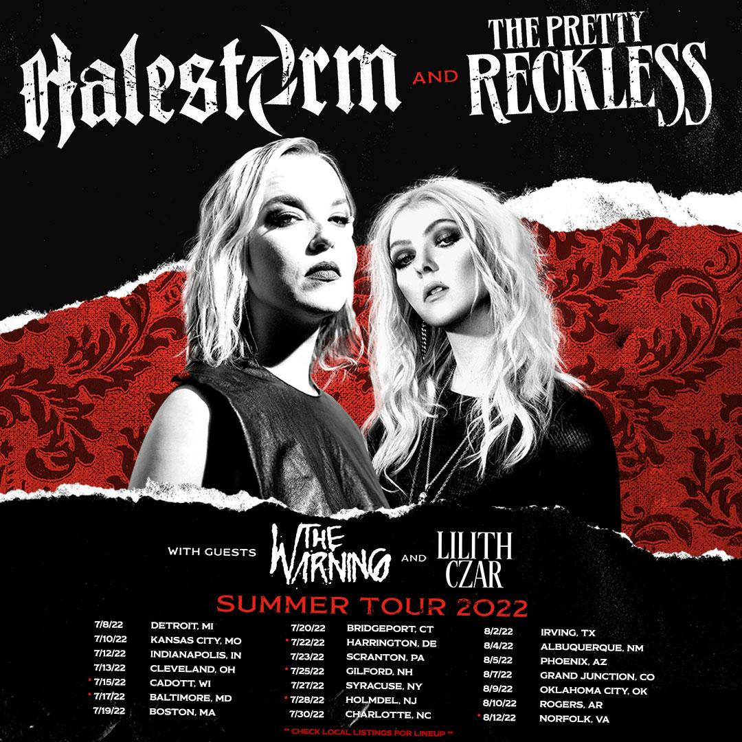

For approved artist images and hi-res tour art, please download HERE.

Today, Grammy-winning hard rock band Halestorm has announced their summer 2022 tour featuring special guests The Pretty Reckless, The Warning, and Lilith Czar on select dates. Produced by Live Nation, the 16-city tour kicks off on July 8th at Michigan Lottery Amphitheatre at Freedom Hill in Detroit making stops across the U.S. in Boston, Charlotte, Phoenix and more before wrapping up in Portsmouth at Atlantic Union Bank Pavilion on August 12th.

Halestorm, founded by siblings Lzzy and Arejay Hale in their teens, has grown into a chart-topping trailblazer in today’s rock music landscape. The band surpassed a billion streams cumulatively and has sold out shows around the globe, with the San Jose Mercury News declaring them “the best hard rock band in the world” after their November 2021 show. On May 6, the band will release their fifth full-length studio album, Back From The Dead. The title track, called “a biting but cathartic howler” by Rolling Stone, marked the band’s sixth #1 at rock radio, and the second single, “The Steeple,” is about to enter the top 10.

TICKETS: Tickets on sale starting Friday, April 1st at 10AM local on Ticketmaster.com

TOUR DATES:
Fri Jul 08 – Detroit, MI – Michigan Lottery Amphitheatre at Freedom Hill
Sun Jul 10 – Kansas City, MO – Starlight Theatre
Tue Jul 12 – Indianapolis, IN – TCU Amphitheater at White River State Park
Wed Jul 13 – Cleveland, OH – Blossom Music Center
Fri Jul 15 – Cadott, WI – RockFest (festival date)
Sun Jul 17 – Baltimore, MD – Pier Six Pavilion+
Tue Jul 19 – Boston, MA – Leader Bank Pavilion
Wed Jul 20 – Bridgeport, CT – Hartford HealthCare Amphitheater
Fri Jul 22 – Harrington, DE – DE State Fair (festival date)
Sat Jul 23 – Scranton, PA – The Pavilion at Montage Mountain
Mon Jul 25 – Gilford, NH – Bank of New Hampshire Pavilion+
Wed Jul 27 – Syracuse, NY – St. Joseph's Health Amphitheater at Lakeview
Thu Jul 28 – Holmdel, NJ – PNC Bank Arts Center+
Sat Jul 30 – Charlotte, NC – Charlotte Metro Credit Union Amphitheatre
Tue Aug 02 – Irving, TX – The Pavilion at Toyota Music Factory
Thu Aug 04 – Albuquerque, NM – Isleta Amphitheater
Fri Aug 05 – Phoenix, AZ – Arizona Federal Theatre
Sun Aug 07 – Grand Junction, CO – Los Colonias Amphitheater*
Tue Aug 09 – Oklahoma City, OK – Zoo Amphitheatre*
Wed Aug 10 – Rogers, AR – Walmart AMP
Fri Aug 12 – Portsmouth, VA – Atlantic Union Bank Pavilion+

*Not A Live Nation Date
+Check local listings for lineup.

ABOUT HALESTORM:
Halestorm has grown from a childhood dream of siblings Lzzy and Arejay Hale into one of the most celebrated rock bands of the last two decades, with their music surpassing a billion streams worldwide. They'll release their fifth studio album, Back From The Dead, on May 6, and the title track marked their sixth #1 at rock radio. Rolling Stone called Vicious, the band’s last album, a “muscular, adventurous, and especially relevant rock record." It earned the band their second Grammy nomination, for Best Hard Rock Performance for the song “Uncomfortable” and led Loudwire to name Halestorm “Rock Artist of the Decade” in 2019. Fronted by the incomparable Lzzy Hale with drummer Arejay Hale, guitarist Joe Hottinger, and bass player Josh Smith, Halestorm has earned a reputation as a powerful live music force, headlining sold-out shows and topping festival bills around the world, and sharing the stage with icons including Heaven & Hell, Alice Cooper, and Joan Jett.

ABOUT THE PRETTY RECKLESS:
The Pretty Reckless formed in New York City during 2008, and the musicians and late producer Kato Khandwala initially made waves with their 2010 debut Light Me Up. After countless gigs, the band returned with Going To Hell in 2014. Not only did the record crash the Top 5 of the Billboard Top 200, but it also ignited three #1 hits — the Platinum-certified "Heaven Knows" (the biggest rock song of 2014), "Fucked Up World," and "Follow Me Down" — a feat that had not been accomplished by a female-fronted group since The Pretenders in 1984. Meanwhile, their third offering, Who You Selling For, saw them return to #1 on the Mainstream Rock Songs Chart with "Take Me Down," which cemented them as "the first band to send its first four singles to #1 on the chart," according to Billboard. Praise followed from Vogue, Nylon, and more, as the quartet lit up television shows such as Letterman and Conan. With over half-a-billion streams, they headlined countless sold out shows and toured with Guns N' Roses, Soundgarden, and many other heavy hitters. Fourth album Death By Rock And Roll was released in February 2021 via Fearless Records. Upon release, the record topped multiple sales charts — including Billboard's Top Albums, Rock, Hard Music, and Digital Charts. The record also yielded several No. 1 singles — "Death By Rock And Roll," "And So It Went" (Feat. Tom Morello), and "Only Love Can Save Me Now" (Feat. Matt Cameron + Kim Thayil) all topped the charts. The Pretty Reckless are also the first female-fronted band to have back-to-back No. 1 singles at the active rock format. They are also the first female-fronted act to have seven No. 1 singles on the Billboard Rock Radio Chart, a feat achieved with "Only Love Can Save Me Now." The album was universally praised by PEOPLE, V, The TODAY Show, The Daily Beast, Hypebae, SPIN, Rolling Stone, Bustle, Women's Wear Daily, Loudwire, and more.

ABOUT THE WARNING:
The Warning infuses rock music with a much-needed shot of adrenaline. The Monterrey, Mexico trio of sisters—Daniela “Dany” (guitar, lead vocals), Paulina “Pau” (drums, vocals, piano), and Alejandra “Ale” Villarreal (bass, piano, backing vocals)—charge forward with head-spinning riffs, unpredictable rhythms, stadium-size beats, and skyscraping vocals. Through a series of independent releases, The Warning garnered the respect of countless fans and musicians from across the globe before signing with LAVA/Republic Records to release their latest MAYDAY EP (2021). The band’s single “CHOKE” surged them to the forefront of hard rock and they amassed over 1.5 million social media followers and 85 million YouTube views. In 2021, the band was given the distinct honor to be featured on Metallica’s Blacklist album, covering “Enter Sandman” with multi-platinum pop superstar Alessia Cara. In January of 2022, Disturbed frontman, David Draiman publicly praised the band on his personal Twitter page stating that The Warning “gives him hope for the genre’s future,” and further described the hard-rock trio as, “Young powerful women playing real instruments and writing songs the entire rock genre can be proud of.” The three-piece powerhouse have already played alongside rock music legends such as The Killers, Alice Cooper, Vince Neil, Tesla, Def Leppard, and Foo Fighters, and will be heading out on their 2022 MAYDAY North American headline tour—kicking off in San Diego on April 18, hitting New York’s Gramercy Theatre on May 6, and two nights at the Troubadour in Los Angeles on May 23 and May 24. Their new single “MONEY” is set for release on March 25, 2022—a song that aims to spotlight the societal and humanitarian burdens directly caused by corruption, power, profit, and greed.

ABOUT LILITH CZAR:
Lilith Czar arrives with the force of an otherworldly thunder, arising in visceral rebirth from an untimely grave of surrender and sacrifice. Her voice is the sound of supernatural determination, summoned with a confessional vulnerability and unapologetic authenticity. The girl who was Juliet Simms - her dreams discouraged and dismissed, her identity confined and controlled - is no more. In her place stands Lilith Czar, a new vessel forged in unbridled willpower and unashamed desire. Created from Filth and Dust, the debut album from Lilith Czar, is an evocative invitation into her bold new world. It's aggressive music with warm accessibility; huge hooks with driving hard rock—the new larger-than-life icon channels the fierce combativeness of Fiona Apple and Stevie Nicks' seductive witchery. Lilith Czar arms herself with sonic power, theatricality, and confidence. It's a sound where the pulse of Nine Inch Nails, Halestorm's songcraft, and the libertine spirit of David Bowie converge, all in service of a ritualistic ache for a more just and equitable world.

About Live Nation Entertainment
Live Nation Entertainment (NYSE: LYV) is the world’s leading live entertainment company comprised of global market leaders: Ticketmaster, Live Nation Concerts, and Live Nation Sponsorship. For additional information, visit www.livenationentertainment.com.

About Live Nation Women
Live Nation Women is a division of Live Nation that centers the advancement of women in every tour, project, and initiative through the advocacy and amplification of women across live music. Live Nation Women strives to drive intersectional gender equity and solve for barriers and challenges women face to equal access and opportunity in the music industry. Connect on instagram @livenationwomen

MEDIA CONTACTS:

Halestorm
Ashley White | ashley@ashleywhitepr.com

The Pretty Reckless
Amy Sciarretto | amy@atomsplitterpr.com

The Warning
Donny Evans | donny@thepresshouse.com

Lilith Czar
Becky Kovach | becky@bigpicturemediaonline.com

Live Nation Concerts
Monique Sowinski | moniquesowinski@livenation.com

To apply for media credentials for show coverage:
livenation.com/pressrequests

