FOR IMMEDIATE RELEASE
MAY 6, 2022

HALESTORM IS BACK FROM THE DEAD;
GRAMMY-WINNING BAND RELEASES FIFTH STUDIO ALBUM TODAY;
TOUR KICKS OFF NEXT WEEK

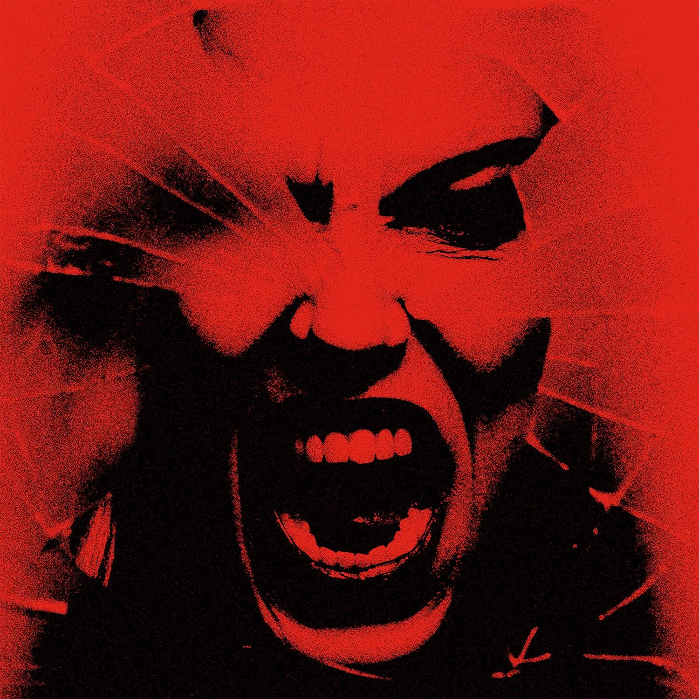

Hi res artwork and press materials available here.

Back From The Dead available here: https://Halestorm.lnk.to/BFTDPR

Watch new lyric video for “Wicked Ways” here: https://halestorm.lnk.to/WickedWaysLyricPR

Grammy-winning hard rock band Halestorm today released Back From The Dead, their fifth studio album and the follow-up to 2018’s Vicious, which earned them their second Grammy nomination.

In an album review released yesterday, Associated Press predicted Back From The Dead “will definitely be in the running for best hard rock/metal album of the year.”

The title track, released last fall and called “a biting, cathartic howler” by Rolling Stone, peaked at #1 on the rock chart, and “The Steeple,” the second single from the album, is currently in the top 10. Guitar World said of the latter track “Lzzy Hale…sings of reclaiming her kingdom, cathedral and castle after going through ‘hell’ against the backdrop of a wall of guitar crunch formidable enough to have an impact in the most distant nosebleed seats." At midnight last night, the band premiered a lyric video for “Wicked Ways” from the album via their YouTube channel. That video is now available here.

At noon Eastern today, the band will hold a listening party for fans via the StationHead app, where they’ll share stories and commentary in real time as they play the album.

Called “a deeply personal effort depicting the band’s personal struggles through the last few years of uncertainty” by Alternative Press, Back From The Dead, produced by Nick Raskulinecz (Foo Fighters, Mastodon, Alice in Chains) with co-production by Scott Stevens (Shinedown, Daughtry, New Years Day), “is a journey of navigating mental health, debauchery, survival, redemption, rediscovery, and still maintaining faith in humanity,” according to frontwoman Lzzy Hale, named by Revolver as “one of the most charismatic, powerful, and captivating vocalists of our time.”

Starting Tuesday, Halestorm is back out on the road, first with Stone Temple Pilots, Black Stone Cherry, and Mammoth WVH, then in July with an all-female special guests lineup of The Pretty Reckless, The Warning, and Lilith Czar. A full itinerary is listed below.

***
Halestorm has grown from a childhood dream of siblings Lzzy and Arejay Hale into one of the most celebrated rock bands of the last two decades. Halestorm’s music has surpassed a billion streams worldwide. Called a “muscular, adventurous, and especially relevant rock record” by Rolling Stone, Vicious earned the band their second Grammy nomination, for Best Hard Rock Performance for the song “Uncomfortable,” the band’s fourth #1 at rock radio, and led Loudwire to name Halestorm “Rock Artist of the Decade” in 2019. Fronted by the incomparable Lzzy Hale with drummer Arejay Hale, guitarist Joe Hottinger, and bass player Josh Smith, Halestorm has earned a reputation as a powerful live music force, headlining sold-out shows and topping festival bills around the world, and sharing the stage with icons including Heaven & Hell, Alice Cooper, and Joan Jett.

HALESTORM
On Tour 2022

May 10-30:
* denotes Stone Temple Pilots supporting
#denotes Mammoth WVH supporting
+denotes Black Stone Cherry supporting

July 7-Aug. 10:
With The Pretty Reckless, The Warning, and Lilith Czar except otherwise noted and festival dates denoted by *

MAY
10 Billings, MT – First Interstate Arena*#+
11 Casper, WY – Ford Wyoming Center*#+
13 Council Bluffs, IA – Stir Cove at Harrah’s#+
14 Wichita, KS – WAVE#
17 Pittsburgh, PA – Stage AE*+
18 Columbus, OH – Kemba Live!*+
21 St. Louis, MO – Pointfest
22 Daytona Beach, FL – Welcome to Rockville
24 Evansville, IN – Ford Center*+
25 Tulsa, OK – Tulsa Theater*+
27 Deadwood, SD – Outlaw Square*+
28 Moorhead, MN – Bluestem Amphitheater*+
30 Missoula, MT – Kettlehouse Amphitheater*+

JULY
7 Milwaukee, WI – Summerfest*
8 Sterling Heights, MI – Michigan Lottery Amphitheatre at Freedom Hill
10 Kansas City, MO – Starlight Theatre
12 Indianapolis, IN – TCU Amphitheater at White River State Park
13 Cuyahoga Falls, OH – Blossom Music Center
15 Cadott, WI – Rock Fest*
17 Baltimore, MD – Pier Six Pavilion
19 Boston, MA – Leader Bank Pavilion
20 Bridgeport, CT – Hartford Health Care Amphitheater
22 Harrington, DE – Delaware State Fairgrounds*
23 Scranton, PA – Pavilion at Montage Mountain
25 Gilford, NH – Bank of New Hampshire Pavilion
27 Syracuse, NY – St. Joseph’s Health Amphitheater at Lakeview
28 Holmdel, NJ – PNC Bank Arts Center
30 Charlotte, NC – Charlotte Metro Credit Union Amphitheatre

AUGUST
2 Irving, TX – The Pavilion at Toyota Music Factory
4 Albuquerque, NM – Isleta Amphitheater
5 Phoenix, AZ – Arizona Federal Theatre
7 Grand Junction, CO – Los Colonias Park Amphitheater
9 Oklahoma City, OK – The Zoo Amphitheatre
10 Rogers, AR – Walmart Arkansas Music Pavilion
12 Portsmouth, VA – Atlantic Union Bank Pavilion (with The Warning)

SEPTEMBER
1 Costa Mesa, CA – OC Fair (with The Struts)
22 Louisville, KY – Louder Than Life Festival*

OCTOBER
8 Sacramento, CA – Monster Energy Aftershock 2022*

For more information on Halestorm, visit and follow:
https://www.halestormrocks.com/
https://www.facebook.com/halestormrocks
https://twitter.com/halestorm
https://www.instagram.com/halestormrocks/
https://www.youtube.com/user/HalestormRocks

# # #

Contact:
Ashley White
Ashley White Public Relations
ashley@ashleywhitepr.com
(512) 436-9260

