FOR IMMEDIATE RELEASE
AUGUST 26, 2022

Anna Clendening DECLARES “I DON’T EVEN LIKE YOU ANYMORE”

RISING SINGER-SONGWRITER SHARES LATEST SINGLE FROM EAGERLY AWAITED NEW EP

NORTH AMERICAN TOUR KICKS OFF SEPTEMBER 7 IN NASHVILLE

UNTITLED X’S ARRIVES VIA ATLANTIC RECORDS ON FRIDAY, SEPTEMBER 9

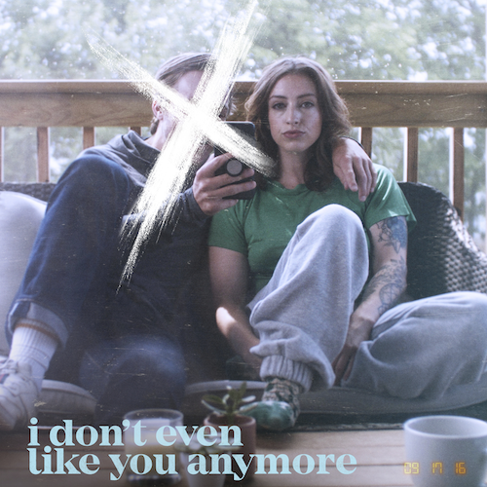
DOWNLOAD HIGH-RES IMAGE

STREAM “I DON’T EVEN LIKE YOU ANYMORE”: LINK

Acclaimed singer-songwriter Anna Clendening has shared “I Don’t Even Like You Anymore,” available now via Atlantic Records at all DSPs and streaming services. An official music video premieres today at YouTube HERE.

Already a fan favorite after a viral series of online teases, “I Don’t Even Like You Anymore” heralds the upcoming arrival of Clendening’s eagerly awaited new EP, UNTITLED X’S, arriving everywhere on Friday, September 9. The five-track collection sees the multi-million streaming artist perfecting her very personal brand of gleefully chaotic pop on such recently released singles as “Sweatshirt“ and “Girls Like You“ (the latter of which marks the spiritual successor to Clendening’s RIAA gold certified 2017 smash, “Boys Like You”). Both songs are joined by official music videos streaming now at YouTube.

UNTITLED X’S follows an 18-month hiatus that found Clendening relocating from Los Angeles to Nashville where she fully embraced herself as an artist and songwriter, a period of deep personal growth which led to an outpouring of introspection and creativity.

“I wanted to write about the past five relationships I’ve had just to get it all out there,” Clendening says. “Being a spiteful human sometimes, I thought it would be cool to name each song after a guy. My manager said it wouldn’t be cool to get sued—he was right. That’s how we came up with ‘UNTITLED X’S.’ Every song is very much about a specific person.”

Clendening will celebrate UNTITLED X’S with a number of upcoming tour dates, beginning September 7 at The Basement in Nashville, TN. Additional North American headline shows will be announced soon. For updates, please visit www.annaclendening.com.

ANNA CLENDENING
SEPTEMBER TOUR 2022

SEPTEMBER
7 – Nashville, TN – The Basement
19 – Brooklyn, NY – Baby’s All Right
21 – Boston, MA – Red Room Café 939
25 – Chicago, IL – Beat Kitchen

OCTOBER
5 – Los Angeles, CA – Hotel Café

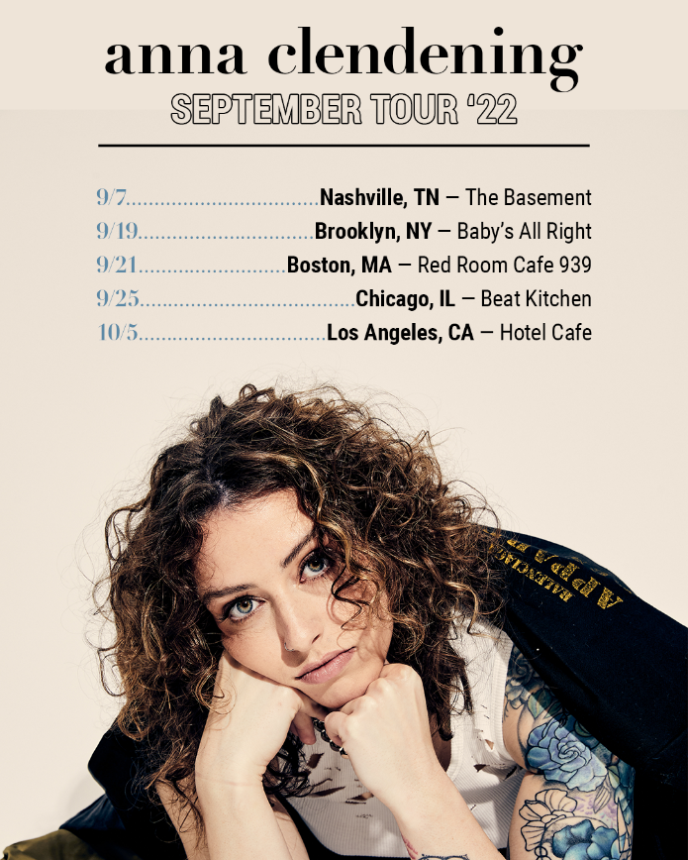

# # #

Clendening has amassed over 500M streams and critical acclaim from the likes of Billboard, Ones To Watch, Refinery29, and more. Her debut EP, 2019’s Waves, generated over 150M streams alone in under six months and led to collaborations with the likes of Illenium, Lost Kings, and Matoma. Clendening made her Atlantic Records debut with 2020’s Evolve EP – featuring the standout single, “Love Song” – arrived to applause from American Songwriter, Flaunt, Idolator, and more. With her honest, authentic songwriting, Clendening has proven a source of universal encouragement and an incredible advocate for mental health awareness. Sharing openly with fans about her own mental health journey managing anxiety, Clendening expertly channels these challenges through the healing power of music.

“We’re all very similar,” Clendening says. “Our experiences, while different, are not isolated. People are going through the same things to not feel alone. When I was first diagnosed with anxiety, I thought I was crazy. I felt like nobody else knew what was going on, and it wasn’t happening to anyone but me. With my music and platform as an artist, I want to be the person I needed when I was 13- or 14-years-old. That’s all I want to do as long as I’m alive.”

DOWNLOAD HI-RES IMAGES

CONNECT:
OFFICIAL | FACEBOOK | TWITTER | INSTAGRAM | YOUTUBE | TIKTOK | PRESS ASSETS

CONTACT:
TED.SULLIVAN@ATLANTICRECORDS.COM

