FOR IMMEDIATE RELEASE
AUGUST 05, 2022
OUT NOW:
BRELAND TEASES DEBUT ALBUM CROSS COUNTRY WITH
“TOLD YOU I COULD DRINK” FEATURING LADY A
LISTEN HERE

UNVEILS TRACK LIST FOR 14-SONG PROJECT RELEASING SEPTEMBER 9 –
PRE-SAVE/PRE-ADD HERE

STANDOUT COLLABS WITH INGRID ANDRESS, MICKEY GUYTON, THOMAS RHETT, KEITH URBAN

ICYMI: BRELAND JOINED LADY A TO PERFORM THEIR HIT “NEED YOU NOW”
ON ABC’S “CMA FEST”

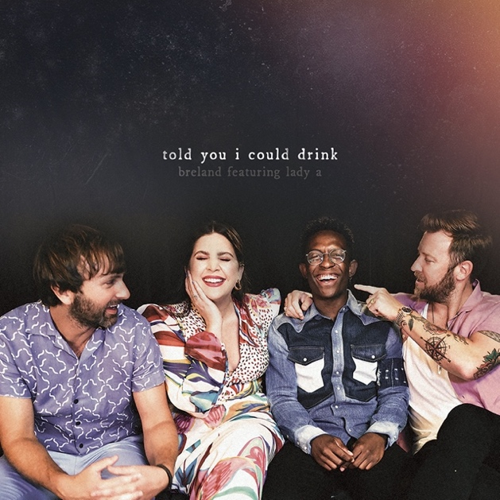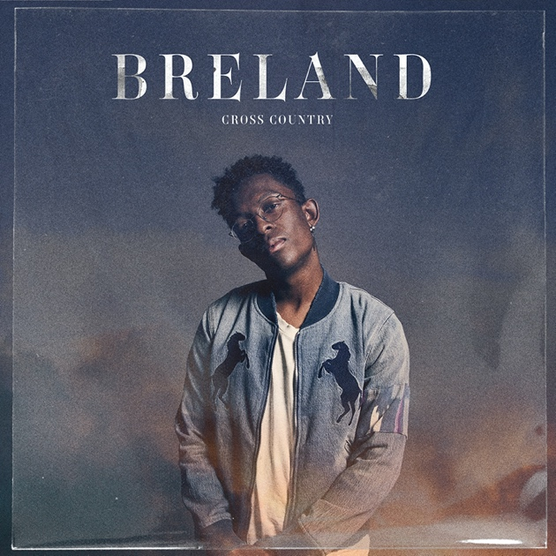
DOWNLOAD SINGLE ART HERE | PHOTO CREDIT: JOHN SHEARER DOWNLOAD ALBUM ART HERE | PHOTO CREDIT: JIMMY FONTAINE
SINGLE ARTWORK CREDIT: NADA TAHA ALBUM ARTWORK CREDIT: NADA TAHA

LOS ANGELES, CA. (AUGUST 05, 2022) – Bad Realm Records/Atlantic Records/Warner Music Nashville multi-talent BRELAND teases his highly anticipated debut album CROSS COUNTRY with today’s drop of the grooving breakup track “Told You I Could Drink” featuring Grammy award-winning trio Lady A. Co-written by BRELAND, Lady A’s Charles Kelley, and Zachary Manno, the must-hear song is available now across all digital and streaming platforms.

"Lady A is one of the groups that introduced me to Country music, so when I finally got in studio with Charles Kelley, I already had a Lady A collab in mind," explains BRELAND. "The two of us performed 'Told You I Could Drink' at BRELAND & Friends at the Ryman in March, and the response we got from the audience was what convinced us to cut the song and put it on my album. I’m so excited for the world to hear what we made."

“Anytime we have a chance to collaborate with BRELAND, you can be sure that we’ll be there,” Lady A’s Hillary Scott said. “When I first heard this song it immediately took me back to high school after a bad breakup, getting lost in an R&B groove.”
(-more-)
Hinting at a collaboration, the Amazon Music Breakthrough Artist joined Lady A as their special guest to perform their 9X PLATINUM “Need You Now” as part of ABC’s primetime special “CMA FEST.” Marking the PLATINUM riser’s debut on the main stage at Nashville’s Nissan Stadium, watch the clip that aired on Wednesday (8/3) here.

Last night, BRELAND first shared the track list for CROSS COUNTRY with fans on his socials. The 14-song project also features standout collaborations with Ingrid Andress, Mickey Guyton, Thomas Rhett and Keith Urban. Living up to his moniker as the “pen point guard,” BRELAND’s pen name is on every song alongside an impressive list of some of the most in-demand songwriters including Ashley Gorley, HARDY, Sam Hunt, ERNEST, Ryan Hurd and more.

Bringing his new music cross country, BRELAND is hitting the road this summer with Fitz & The Tantrums and Andy Grammer on THE WRONG PARTY TOUR. He’ll also stop in his home state of New Jersey for the inaugural TidalWave Festival (8/12) before taking it global with CMC Rocks Qld 2022 (9/23-9/25) in Australia and then jetting to the UK to join Russell Dickerson’s tour throughout October. Check out his full list of tour stops here.

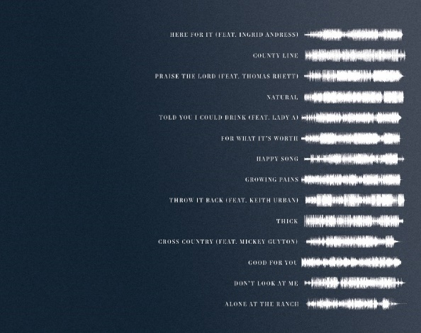

CROSS COUNTRY – TRACKLIST
- “Here For It (feat. Ingrid Andress)”
- “County Line”
- “Praise The Lord (feat. Thomas Rhett)”
- “Natural”
- “Told You I Could Drink (feat. Lady A)”
- “For What It’s Worth”
- “Happy Song”
- “Growing Pains”
- “Throw It Back (feat. Keith Urban)”
- “Thick”
- “Cross Country (feat. Mickey Guyton)”
- “Good For You”
- “Don’t Look At Me”
- “Alone At The Ranch”

See list of writing and production credits here.

(-more-)

ABOUT BRELAND:
With PLATINUM breakout “My Truck,” singer/songwriter/producer BRELAND has emerged as a bold new force on today’s music landscape. The Breakthrough Artist by Amazon Music first popped off when the Hip-Hop and Country hybrid hit #1 on Spotify’s Global Viral 50 in 2019, and a remix featuring Sam Hunt landed on best-of-the-year lists from NPR to The New York Times. Adding to his 600 MILLION+ career streams, BRELAND is previewing his highly anticipated debut CROSS COUNTRY coming September 9 with infectious releases “Told You I Could Drink (feat. Lady A),” “Natural,” “Praise The Lord (feat. Thomas Rhett),” GOLD-certified “Throw It Back (feat. Keith Urban) and title track (feat. Mickey Guyton). Hailed as the “symbol of Country music’s ongoing evolution” (Rolling Stone), the Bad Realm Records/Atlantic Records/Warner Music Nashville artist has scored high profile looks on CMT Crossroads, Good Morning America, Jimmy Kimmel Live!, TODAY, The Kelly Clarkson Show, New Year’s Eve Live: Nashville’s Big Bash, plus performances on the ACM, CMT, and CMA Awards. He’s currently touring with Fitz & The Tantrums and Andy Grammer’s THE WRONG PARTY TOUR this month and then will go global with upcoming shows at CMC Rocks Qld 2022 in Australia (9/23-9/25) before joining Russell Dickerson’s UK run in October.

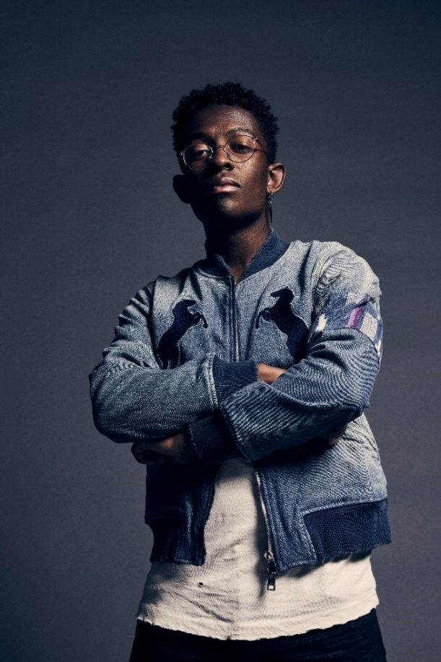
DOWNLOAD HIGH-RES PRESS ASSET(S) HERE

# # #

CONNECT WITH BRELAND
WEBSITE | INSTAGRAM | FACEBOOK | TWITTER | YOUTUBE | SOUNDCLOUD

BRELAND PR CONTACTS
Fairley McCaskill / Fairley.McCaskill@atlanticrecords.com
Jensen Sussman / jensen@sweettalkpr.com
Mary Catherine Rebrovick / MaryCatherine@wmg.com

