ACTORS CHARLIE DAY AND MARY ELIZABETH ELLIS STAR IN NEW MUSIC VIDEO FOR AWARD-WINNING SINGER-SONGWRITER
BEN ABRAHAM’s “IF I DIDN’T LOVE YOU”

DIRECTED BY JILLIAN BELL
(BRITTANY RUNS A MARATHON, GODMOTHERED)

WATCH VIDEO HERE

TRACK ARRIVES OFF ABRAHAM’S SOPHOMORE ALBUM FRIENDLY FIRE
BUY/STREAM HERE

UPCOMING HEADLINE TOUR INCLUDES SHOWS AT LA’s THE MOROCCAN LOUNGE
& SOLD OUT NY SHOW AT JOE’S PUB WITH SECOND NIGHT ADDED BY POPULAR DEMAND – BUY TICKETS HERE

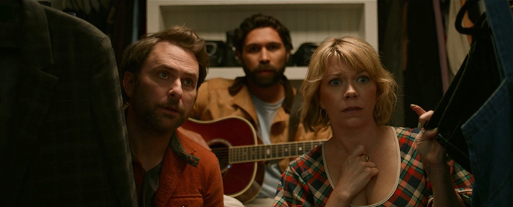

Award-winning singer-songwriter Ben Abraham has today unveiled a brand new music video for his song “If I Didn’t Love You” – starring Charlie Day (It’s Always Sunny In Philadelphia) and his wife, fellow actor Mary Elizabeth Ellis – watch HERE. The video marks the music video debut for both actors and was directed by Jillian Bell (Brittany Runs a Marathon, Godmothered).

The visual serves as a sharp juxtaposition to the romantic nature of the song. What opens as an innocent street performance from Abraham turns into something out of a horror movie when he begins to follow the young couple throughout their day – ultimately even showing up at their home unexpectedly.

Of the video, Abraham shares: “Working with Jillian Bell, Charlie Day and Mary Elizabeth Ellis will go down as one of the best days of my life. Jillian had pitched two possible video ideas for this song, one was warm and romantic, and the other was this video. There was no contest as to which we should make.

Getting to work with three of my comedy heroes was an absolute dream. And I've realised that having funny people like my music is quite possibly the only accolade I need in my career.”

“If I Didn’t Love You” was released earlier this year via Abraham’s stunning sophomore album Friendly Fire – out now via Atlantic Records (buy/stream). A deeply personal body of work, the album marked Abraham’s first for Atlantic; spotlighting the cinematic yet emotionally raw sensibilities previously showcased on his debut album Sirens and while penning songs for artists like The Chicks, Demi Lovato, Wrabel, and Kesha’s double-platinum, Grammy Award-winning smash “Praying.”

Abraham will be embarking on a US and UK headline tour later this month in support of the album. The run will include stops at LA’s The Moroccan Lounge and a sold out NY show at Joe’s Pub, with a second night added by popular demand (full routing below). Tickets and additional information are available here.

Friendly Fire arrived highlighted by the introspective single “Another Falling Star” – long-anticipated by fans having first heard it performed during one of Abraham’s many live shows. A delicate piece of storytelling that slowly unfolds as a glorious epic, the track was joined by an official music video starring the artist (watch here). Abraham made his television debut in April with a performance of “Another Falling Star” on The Kelly Clarkson Show – watch here.

Other tracks released off the album have amassed millions of global streams – including “War In Your Arms,” “Like A Circle,” and most recently “If I Didn’t Love You.”

A selection of songs that speak to the undeniable possibility for rebirth after loss and pain, Friendly Fire details the tumultuous period of Abraham’s life following the release of Sirens – including a serious breakup and ensuing crisis of faith. In a recent interview with Huffington Post, he shared more about this time and his experience navigating new questions surrounding his sexuality and spirituality:

“It felt like a bomb went off, in a sense, and everything I knew about my life crumbled. After that, it was this process of clumsily rediscovering what I believe about God. What do I know of God, of myself, of the world? The album was written during that journey, during that process of chaos. It was weirdly empowering in the making of the record to realize I’m not in control of so many aspects of my life, but what I can do is just explore what I’m going through, through songs and through my songwriting.”

In the thick of all that upheaval, Abraham created Friendly Fire. In bringing the album to life, Abraham worked with producer James Flannigan (Dua Lipa, MARINA, Matt Maeson), engineer/producer Jason Agel (Bjork, John Legend), and mixer Michael Brauer (Coldplay, John Mayer), recording solely at Barefoot Recording Studio (the iconic LA studio where legendary artists including Stevie Wonder and Marvin Gaye recorded in the 1970s).

The child of musicians who performed together in an Indonesian pop group, Abraham self-released his debut album Sirens in 2014 and soon earned widespread critical praise, leading to the album’s 2016 reissue. Featuring appearances by Sara Bareilles and Gotye, Sirens was promptly hailed by the New York Times as “a debut of remarkable depth,” catalyzing his career as an in-demand co-writer. With his earlier live experience including touring with country legend Emmylou Harris, Abraham more recently supported Ben Platt on his 2019 headline tour – a North American run that followed Abraham co-writing several songs on Platt’s debut solo album, Sing to Me Instead.

###

BEN ABRAHAM – LIVE DATES
July 27 – Los Angeles, CA – The Moroccan Lounge
July 29 – San Francisco, CA – Café Du Nord
July 31 – Portland, OR – Mississippi Studios
August 1 – Seattle, WA – Here-After
August 3 – Nashville, TN – Analog at Hutton Hotel
August 6 – New York, NY – Joe’s Pub – SOLD OUT
August 8 – New York, NY – Joe’s Pub
September 1 – Glasgow, UK – Stereo
September 2 – Manchester, UK – Band On The Wall
September 5 – Bristol, UK – Rough Trade Records
September 6 – Brighton, UK – Patterns
September 7 – London, UK – Lafayette

###

BEN ABRAHAM – FRIENDLY FIRE
BUY/STREAM
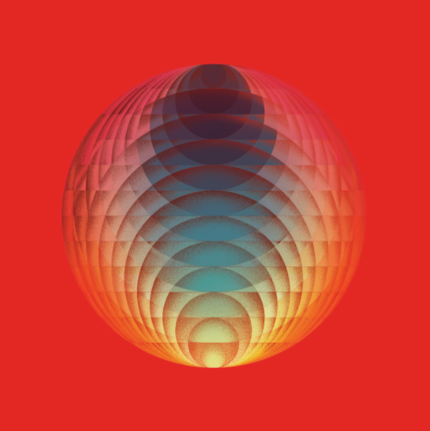
download hi-res album artwork

TRACKLISTING
- Runaway
- War In Your Arms
- Friendly Fire
- Another Falling Star
- If I Didn’t Love You
- I Am Here
- Callie (Interlude)
- Boy In A Bubble
- Requiem
- California Drifting
- Brother Tongue
- Love Myself
- Too Old Too Young
- Like A Circle (Bonus Track)

###

Connect with Ben:
Website | Instagram | TikTok | YouTube | Twitter | Facebook

Press Inquiries:
Libby Kober | libby.kober@atlanticrecords.com

