AUSTRALIAN SINGER-SONGWRITER BEN ABRAHAM COVERS
PETER GABRIEL’S CLASSIC “IN YOUR EYES” –
LIVE FROM THE VASQUEZ ROCKS IN NORTHERN LA COUNTY

WATCH LIVE PERFORMANCE:
https://youtu.be/_DtlUZncHNk

BUY/STREAM:
https://atlantic.lnk.to/InYourEyesM6

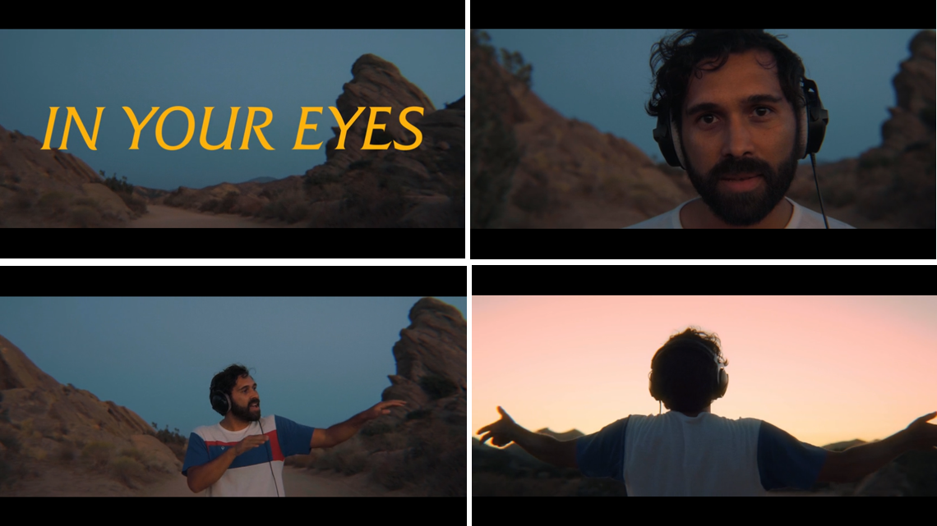

Australian singer-songwriter Ben Abraham has released a stunning live performance of the Peter Gabriel classic “In Your Eyes” – captured during sunset at the Vasquez Rocks Natural Area Park in northern LA County – WATCH HERE.

Ben’s signing to Atlantic was announced exclusively via Billboard last July. Since then, he’s released the songs “Satellite” and “Nobody Wants to Hear Songs Anymore” as he finishes his forthcoming sophomore studio album, the follow-up to 2016’s Sirens.

In addition to his own music, Ben has written for some of the biggest names in the industry – Demi Lovato, Macklemore, Sara Bareilles – as well as co-writing a number of songs on Ben Platt’s debut solo album Sing to Me Instead and, perhaps most notably, the Grammy nominated, 2x RIAA Platinum “Praying,” off Kesha’s 2017 album Rainbow.

Of today’s cover, Ben shares:

“They say don’t meet your heroes so instead I covered mine. I hope this is looked upon favourably by the music gods. It’s my pleasure to share my version of Peter Gabriel’s perfect song In Your Eyes.”

PRESS ASSETS: HERE

