AWARD-WINNING SINGER-SONGWRITER BEN ABRAHAM RELEASES “REQUIEM”

AN ODE TO THE LOSS OF CHILDHOOD INNOCENCE, “REQUIEM” MARKS THE SECOND RELEASE OFF FORTHCOMING SOPHOMORE ALBUM

WATCH OFFICIAL VISUALIZER FOR “REQUIEM” HERE
BUY/STREAM “REQUIEM” HERE

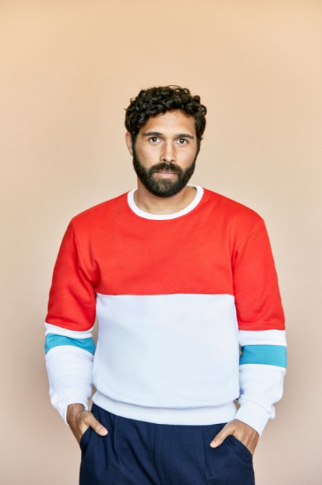
download hi-res press photo

Award-winning Australian-born, LA-based singer/songwriter Ben Abraham has today released “Requiem” – the second track off his forthcoming sophomore album. “Requiem” arrives alongside an official visualizer shot in New York City (watch here), underscoring the introspective themes of the song as an ode to the loss of innocence.

Abraham explains of the song: “I used to be a leader at my church in Melbourne but I made a mess of things in a pretty big way. There came a day I was made to sit in a room full of people and confess my sins. Somehow the experience was both traumatic and euphoric — it became a huge turning point in my life. And that’s when I wrote Requiem.”

download hi-res single artwork here

“Requiem” follows the May release of the forthcoming album’s stunning debut single “War In Your Arms,” produced by James Flannigan (Dua Lipa, MARINA, Matt Maeson) and co-written with fellow Australian singer-songwriter Helen Croome.

Featuring striking piano melodies and massive gospel harmonies set against a gracefully sculpted beat, the song arrived alongside an equally evocative official video starring Abraham (watch here). Upon release, Albumism declared the track: “…mesmeric… the poignant ‘War In Your Arms’ rises from the embers of great heartbreak.”

Of the heavy-hearted lead single, Ben himself shared: “It’s about that point when the relationship is done and you’re trying so hard to hold onto love, it almost becomes like an act of violence. All you’re really doing is hurting yourself and hurting the other person, until you can gather the strength to say, ‘Enough. I’m done.’”

“War In Your Arms” came on the heels of “Like A Circle,” a song released by overwhelming popular demand after Abraham teased a snippet of the then unreleased track to his TikTok (the original clip has since gone on to amass nearly 1 million views).

Last year, Abraham released a striking rendition of Peter Gabriel’s classic “In Your Eyes,” recorded live during sunset at the Vasquez Rocks in California (watch here). This followed previous singles “Satellite” and “Nobody Wants to Hear Songs Anymore,” both released in 2019.

In exclusively announcing his signing to Atlantic and debuting “Satellite,” Billboard declared: “‘Satellite’ is a stunningly cinematic cut, keeping the barebones instrumentation to just piano and strings, letting Abraham’s warm vocal shine.” Idolator continued: “‘Satellite’ is a sublimely-written lullaby… folk-pop poetry.”

His debut LP Sirens was initially self-released in 2014, earning widespread critical praise and leading to a 2016 reissue via indie label Secretly Canadian. Featuring appearances from Sara Bareilles and Gotye, the album was hailed by the New York Times as “a debut of remarkable depth.”

While Sirens catalyzed his career as an in-demand songwriter – co-writing tracks like Kesha’s RIAA-certified double-platinum, Grammy Award-winning smash hit “Praying” – he also experienced the most tumultuous period of his life, including a serious breakup and ensuing crisis of faith. In the thick of all that upheaval, Abraham created his sophomore album – due out later this year via Atlantic Records.

A selection of songs that speak to the undeniable possibility for rebirth after incredible loss and pain, Ben’s forthcoming album reveals the extraordinary gift for songwriting that he’s honed for much of his life and spotlights the cinematic yet emotionally raw sensibilities he’s long showcased while penning songs for artists like Demi Lovato and The Chicks.

With his earlier live experience including touring with country legend Emmylou Harris, Abraham recently supported Grammy, Tony, and Emmy Award-winner Ben Platt on his 2019 headline tour – a North American run that followed Abraham’s co-writing several songs on Platt’s debut solo album, Sing to Me Instead.

###

Connect with Ben:
Website | Instagram | TikTok | YouTube | Twitter | Facebook

Press Assets:
https://press.atlanticrecords.com/ben-abraham/

Press Inquiries:
Libby Kober | libby.kober@atlanticrecords.com

