**AWARD-WINNING SINGER-SONGWRITER BEN ABRAHAM RELEASES STUNNING NEW SINGLE “WAR IN YOUR ARMS”**

**FIRST RELEASE OFF FORTHCOMING SOPHOMORE ALBUM,**

**DUE OUT LATER THIS YEAR**

**WATCH OFFICIAL VIDEO FOR “WAR IN YOUR ARMS”** [**HERE**](https://youtu.be/nMmO_yYFMSw)

**BUY/STREAM “WAR IN YOUR ARMS”** [**HERE**](https://benabraham.lnk.to/WarInYourArmsPR)

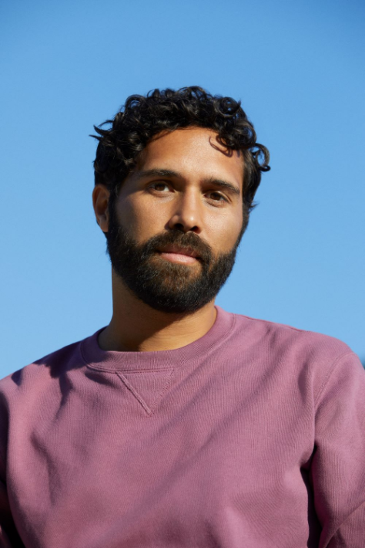

[**download hi-res press photo**](https://press.atlanticrecords.com/wp-content/uploads/2021/03/Ben-Abraham-Press-Image-Credit-Danielle-Levitt-1.jpg)

Award-winning Australian-born, LA-based singer/songwriter **Ben Abraham** has officially unveiled his stunning new single “**War In Your Arms**.” Out today via **Atlantic Records** (buy/stream [here](https://benabraham.lnk.to/WarInYourArmsPR)), the track features striking piano melodies and massive gospel harmonies set against a gracefully sculpted beat. It arrives alongside an equally evocative official video starring Abraham (watch [here](https://youtu.be/nMmO_yYFMSw)).

Produced by **James Flannigan** (Dua Lipa, MARINA, Matt Maeson) and co-written with fellow Australian singer-songwriter Helen Croome, “**War In Your Arms**” marks the first track off Abraham’s forthcoming sophomore album, due out later this year.

**Of the heavy-hearted lead single, Ben shares:** *“It’s about that point when the relationship is done and you’re trying so hard to hold onto love, it almost becomes like an act of violence. All you’re really doing is hurting yourself and hurting the other person, until you can gather the strength to say, ‘Enough. I’m done.’”*

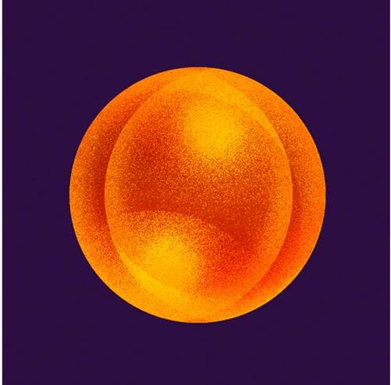

[**download hi-res single artwork here**](https://warnermusicgroup.app.box.com/s/aeptfc6h7n4tvgw5xg671p2f29i69g8e/file/780934718544)

Today’s single comes on the heels of “**Like A Circle**,” released by overwhelming popular demand after Abraham teased a snippet of the then unreleased track to his TikTok last month (the [original clip](https://www.tiktok.com/@benbenabraham/video/6942830107996212481?lang=en&is_copy_url=0&is_from_webapp=v1&sender_device=pc&sender_web_id=6896943064507631109) has now amassed nearly 1 million views in just a few short weeks).

Last year, Abraham released a striking rendition of Peter Gabriel’s classic “**In Your Eyes,**” recorded live during sunset at the Vasquez Rocks in California ([**watch here**](https://youtu.be/_DtlUZncHNk)). This followed previous singles “[**Satellite**](https://www.youtube.com/watch?v=5KQx_pzcY3s&ab_channel=benabrahammusic)” and “[**Nobody Wants to Hear Songs Anymore**](https://www.youtube.com/watch?v=9DBE4klaTD0&ab_channel=benabrahammusic),” both released in 2019.

In exclusively announcing his signing to Atlantic and debuting “**Satellite**,” [**Billboard**](https://www.billboard.com/articles/columns/pop/8520838/ben-abraham-signs-atlantic-records-satellite) declared: *“‘Satellite’ is a stunningly cinematic cut, keeping the barebones instrumentation to just piano and strings, letting Abraham’s warm vocal shine.”* [**Idolator**](https://www.idolator.com/7838397/one-to-watch-ben-abrahams-satellite-is-folk-pop-poetry?adblock=1&chrome=1)continued: *“Ben won rave reviews for his independently-released debut LP, Sirens, but he is perhaps best known for his songwriting prowess which is on full display on his major label debut single. ‘Satellite’ is a sublimely-written lullaby… folk-pop poetry.”*

His debut LP ***Sirens*** was initially self-released in 2014, earning widespread critical praise and leading to a 2016 reissue via indie label Secretly Canadian. Featuring appearances from Sara Bareilles and Gotye, the album was hailed by the [**New York Times**](https://www.nytimes.com/2016/03/07/t-magazine/entertainment/ben-abraham-singer-songwriter.html) as “***a debut of remarkable depth*.**”

While *Sirens* catalyzed his career as an in-demand songwriter – co-writing tracks like **Kesha**’s **RIAA-certified double-platinum**, **Grammy Award-winning** smash hit “**Praying**” – he also experienced the most tumultuous period of his life, including a serious breakup and ensuing crisis of faith. In the thick of all that upheaval, Abraham created his sophomore album – due out later this year via Atlantic Records.

A selection of songs that speak to the undeniable possibility for rebirth after incredible loss and pain, Ben’s forthcoming album reveals the extraordinary gift for songwriting that he’s honed for much of his life and spotlights the cinematic yet emotionally raw sensibilities he’s long showcased while penning songs for artists like **Demi Lovato** and **The Chicks**.

With his earlier live experience including touring with country legend **Emmylou Harris**, Abraham recently supported Grammy, Tony, and Emmy Award-winner **Ben Platt** on his 2019 headline tour – a North American run that followed Abraham’s co-writing several songs on Platt’s debut solo album, ***Sing to Me Instead***.

###

**Connect with Ben:**

[**Website**](https://benabrahammusic.com/) | [**Instagram**](https://www.instagram.com/benbenabraham/?hl=en) | [**TikTok**](https://www.tiktok.com/@benbenabraham?lang=en) | [**YouTube**](https://www.youtube.com/channel/UCuRSncw4PwblvPHfRt9R0dg) | [**Twitter**](https://twitter.com/benabrahammusic) | [**Facebook**](https://www.facebook.com/benabrahammusic/)

**Press Assets:**

[**https://press.atlanticrecords.com/ben-abraham/**](https://press.atlanticrecords.com/ben-abraham/)

**Press Inquiries:**

**Libby Kober |** [**libby.kober@atlanticrecords.com**](mailto:libby.kober@atlanticrecords.com)