**WATCH: BEN PLATT JOINS BEN ABRAHAM FOR A DUET OF “I AM HERE” – LIVE FROM SANTA MONICA**

**SINGER-SONGWRITER ABRAHAM SPEAKS WITH** [**HUFFINGTON POST**](https://www.huffpost.com/entry/ben-abraham-ben-platt-i-am-here-video_n_61f05f8ee4b0061af2570c37) **ABOUT DEEPLY PERSONAL JOURNEY THAT INSPIRED HIS FORTHCOMING ALBUM *FRIENDLY FIRE***

**Watch:** [**https://benabraham.lnk.to/IAmHereWalk-Sing**](https://benabraham.lnk.to/IAmHereWalk-Sing)

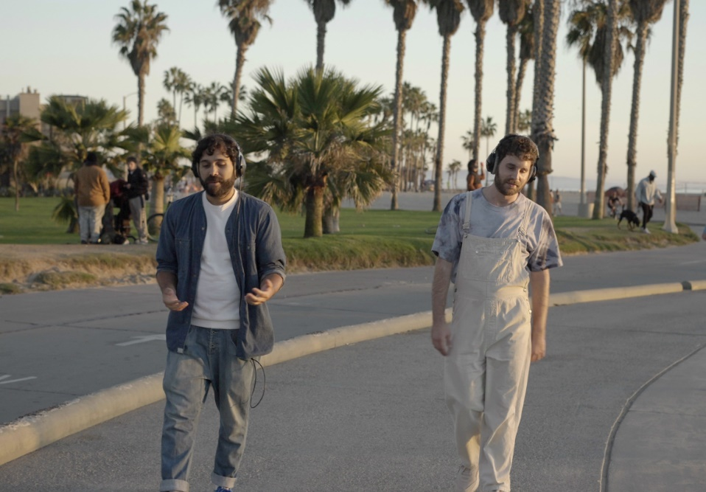

Award-winning singer-songwriter **Ben Abraham** today unveils a live performance of his track “[**I Am Here**](https://open.spotify.com/track/4YiBVTLWDOqJbK7IZRuTFO?si=0a6e3c7c4ab54a17)” – featuring a special cameo from Grammy, Tony, and Emmy winner **Ben Platt** – live from the Santa Monica boardwalk.

The track comes off Abraham’s forthcoming sophomore album ***Friendly Fire*** – set for release on **March 11th**.

The album details an incredibly tumultuous period of Abraham’s life; while engaged to his longtime girlfriend, he became involved briefly with another man – ending the relationship and resulting in a huge crisis of faith for him as a practicing Christian.

In an interview with [**Huffington Post**](https://www.huffpost.com/entry/ben-abraham-ben-platt-i-am-here-video_n_61f05f8ee4b0061af2570c37), he shared more about this time and his experience navigating new questions surrounding his sexuality and spirituality:

*“It felt like a bomb went off, in a sense, and everything I knew about my life crumbled. After that, it was this process of clumsily rediscovering what I believe about God. What do I know of God, of myself, of the world? The album was written during that journey, during that process of chaos. It was weirdly empowering in the making of the record to realize I’m not in control of so many aspects of my life, but what I can do is just explore what I’m going through, through songs and through my songwriting.”*

Abraham’s debut album ***Sirens*** was met with critical acclaim from the **New York Times** who heralded it as *“a debut of remarkable depth.”* The record also catalyzed Ben’s career as an in-demand songwriter for artists like **The Chicks, Gallant** + **Demi Lovato** and led to co-writing massive hits, including **Kesha**’s **double-platinum, Grammy Award-winning smash “Praying.”**

The two artists in today’s video previously collaborated on Platt’s debut solo album, ***Sing to Me Instead***, with Abraham co-writing many of the album’s tracks (incl. “Grow As We Go” + “Bad Habit”). Abraham also opened for Platt on his sold-out 2019 North American headline tour.

***Friendly Fire is out everywhere March 11th***