**AWARD-WINNING SINGER-SONGWRITER BEN ABRAHAM RELEASES SOPHOMORE ALBUM *FRIENDLY FIRE***

**DEEPLY PERSONAL FULL-LENGTH LP OUT NOW VIA ATLANTIC RECORDS**

**LONG-ANTICIPATED FAN FAVORITE “ANOTHER FALLING STAR” ARRIVES WITH OFFICIAL VIDEO**

**BUY/STREAM *FRIENDLY FIRE*** [**HERE**](https://benabraham.lnk.to/FriendlyFirePR)

**WATCH “ANOTHER FALLING STAR”** [**HERE**](https://benabraham.lnk.to/AFS-VideoPR)

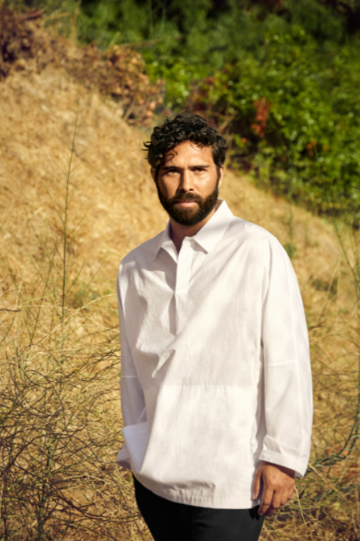

[*DOWNLOAD HI-RES PHOTO*](https://warnermusicgroup.app.box.com/s/nqb0fxb96h2mqzryya4wgwhi284lee1l)*; CREDIT: DANIELLE LEVITT*

Award-winning singer-songwriter **Ben Abraham** has today unveiled his stunning sophomore album ***Friendly Fire*** – out now via Atlantic Records ([buy/stream](https://benabraham.lnk.to/FriendlyFirePR)).

A deeply personal body of work, the album marks Abraham’s first for Atlantic and spotlights the cinematic yet emotionally raw sensibilities previously showcased on his debut album ***Sirens***and while penning songs for artists like **The Chicks, Demi Lovato, Wrabel**, and **Kesha**’s double-platinum, Grammy Award-winning smash “**Praying**.”

***Friendly Fire*** arrives highlighted by the introspective single “**Another Falling Star**” – long-anticipated by fans having first heard it performed during one of Abraham’s many live shows. A delicate piece of storytelling that slowly unfolds as a glorious epic, the track is joined by an official music video starring the artist ([watch here](https://benabraham.lnk.to/AFS-VideoPR)).

*“I wrote ‘Another Falling Star’ with Cara Salimando; we had a free afternoon and decided to sit at the piano and write for no real purpose,”* Abraham recalls, referring to the singer/songwriter who’s worked with Dua Lipa and MØ. *“It came from talking about all the people we know—ourselves included—who moved to Los Angeles to chase their dreams, and how hard that can end up being.”*

Other tracks released off the album thus far have already amassed **millions of global streams** – including “[**War In Your Arms**](https://benabraham.lnk.to/WarInYourArmsPR),” “**Like A Circle**,” and most recently “[**If I Didn’t Love You**](https://benabraham.lnk.to/IfIDidntLoveYou).”

A selection of songs that speak to the undeniable possibility for rebirth after loss and pain, ***Friendly Fire*** details the tumultuous period of Abraham’s life following the release of ***Sirens*** – including a serious breakup and ensuing crisis of faith. In a recent interview with [Huffington Post](https://www.huffpost.com/entry/ben-abraham-ben-platt-i-am-here-video_n_61f05f8ee4b0061af2570c37), he shared more about this time and his experience navigating new questions surrounding his sexuality and spirituality:

*“It felt like a bomb went off, in a sense, and everything I knew about my life crumbled. After that, it was this process of clumsily rediscovering what I believe about God. What do I know of God, of myself, of the world? The album was written during that journey, during that process of chaos. It was weirdly empowering in the making of the record to realize I’m not in control of so many aspects of my life, but what I can do is just explore what I’m going through, through songs and through my songwriting.”*

In the thick of all that upheaval, Abraham created *Friendly Fire*. In bringing the album to life, Abraham worked with producer **James Flannigan** (Dua Lipa, MARINA, Matt Maeson) engineer/producer **Jason Agel** (Bjork, John Legend), and mixer **Michael Brauer** (Coldplay, John Mayer, recording solely at **Barefoot Recording Studio** (the iconic LA studio where legendary artists including Stevie Wonder and Marvin Gaye recorded in the 1970s).

Of the recording process, **Abraham** shares: *“From the start I knew I wanted to make this album the same way that classic records were made—with just one production team, in only one space. It might sound like an obvious thing, but it’s really not how most people make albums these days.”*

The child of musicians who performed together in an Indonesian pop group, Abraham self-released his debut album *Sirens* in 2014 and soon earned widespread critical praise, leading to the album’s 2016 reissue. Featuring appearances by **Sara Bareilles** and **Gotye**, Sirens was promptly hailed by the **New York Times** as *“****a debut of remarkable depth****,”* catalyzing his career as an in-demand co-writer. With his earlier live experience including touring with country legend Emmylou Harris, Abraham more recently supported Ben Platt on his 2019 headline tour – a North American run that followed Abraham co-writing several songs on Platt’s debut solo album, ***Sing to Me Instead***.

###

**BEN ABRAHAM – FRIENDLY FIRE**

[**BUY/STREAM**](https://benabraham.lnk.to/FriendlyFirePR)



[download hi-res album artwork](https://warnermusicgroup.app.box.com/s/urfe7e7cct9qbwv84rk0eot5br988t7q)

**TRACKLISTING**

1. **Runaway**
2. **War In Your Arms**
3. **Friendly Fire**
4. **Another Falling Star**
5. **If I Didn’t Love You**
6. **I Am Here**
7. **Callie (Interlude)**
8. **Boy In A Bubble**
9. **Requiem**
10. **California Drifting**
11. **Brother Tongue**
12. **Love Myself**
13. **Too Old Too Young**
14. **Like A Circle (Bonus Track)**

###

**Connect with Ben:**

[**Website**](https://benabrahammusic.com/) | [**Instagram**](https://www.instagram.com/benbenabraham/?hl=en) | [**TikTok**](https://www.tiktok.com/@benbenabraham?lang=en) | [**YouTube**](https://www.youtube.com/channel/UCuRSncw4PwblvPHfRt9R0dg) | [**Twitter**](https://twitter.com/benabrahammusic) | [**Facebook**](https://www.facebook.com/benabrahammusic/)

**Press Inquiries:**

**Libby Kober |** [**libby.kober@atlanticrecords.com**](mailto:libby.kober@atlanticrecords.com)