FOR IMMEDIATE RELEASE
AUGUST 26, 2022

AFRICA’S BOYFRIEND CKAY IS BACK WITH HIS LATEST SINGLE “YOU”
SINGLE IS A FOLLOW UP TO “WATAWI (FEAT. DAVIDO, FOCALISITIC, AND ABIDOZA)”
CKAY WILL BE HEADLINING HIS FIRST SOLO NORTH AMERICAN TOUR IN OCTOBER KICKING OFF IN OAKLAND, CA
EUROPEAN TOUR TO IMMEDIATELY FOLLOW
Nigerian singer-songwriter and producer CKay returns to give fans a glimpse of what to expect from his upcoming album release with new single ‘You’. His previous offering, ‘WATAWI’ with Davido, Focalisitic and Abidoza, which now sits at over 6.4 million views on YouTube since its drop in June, was a brazen denouncement of affection – a dialogue on the misalignment of two people who are in a relationship with another but have conflicting expectations of their companionship which presages a love lost. ‘You’ is a different temperature altogether. CKay takes the lead in the titillating process of pursuing someone for the first time and becoming so engaged and committed to them that you lose all inhibitions. It is a tender yet patently passionate declaration of love and is delivered in a way only CKay can.
Drawing from R&B, Afrobeat and Amapiano, ‘You’ travels miles along this time-space continuum to deliver a full-fledged work of art that surprises you at every turn. While you think the tune is soft and supple as it begins, brash Amapiano inflections in the form of log drum work and bass convince you otherwise. The single manages to be both vulnerable and bold in its entirety. Producer Christer says the process of composing the song was preoccupied with merging two African cultures together in a way that not only speaks directly to two distinct African expressions of music but brings Africa ever so close to itself. This is no easy feat in a continent that is so rich in tradition and culture but has historically been at odds with itself. While ‘You’ isn’t a political song by any means, it does the work of reimagining an Africa that looks within for inspiration, collaboration and creation.
The instrumentation in the song is also contemplated. As CKay considers a deep-seated concern over the verses, a saxophone helps him sing the chorus. In due time, a string section melody brings the song tighter in the pocket and it grooves. As a precursor to the album, CKay shares that ‘You’ helps him reveal more intimately his own experiences in relationships. The album builds on this and is set to explore the superstar’s journey in the ever complex human experience as well as in music and he hopes to bring fans closer into his world.
The tail end of 2022 will also see CKay headlining his first solo North American tour in October. He is expected to perform in cities around the country, starting with the One Music Festival in Atlanta and moving through cities around the country including New York, Chicago, LA, Houston. On the back of his US tour, CKay will head immediately into his first solo European tour. Full details of dates and cities for the European tour and cities will be announced imminently. Details on the North American tour can be found on www.ckay-music.com.
CKAY’S “SAD ROMANCE TOUR” NORTH AMERICAN DATES
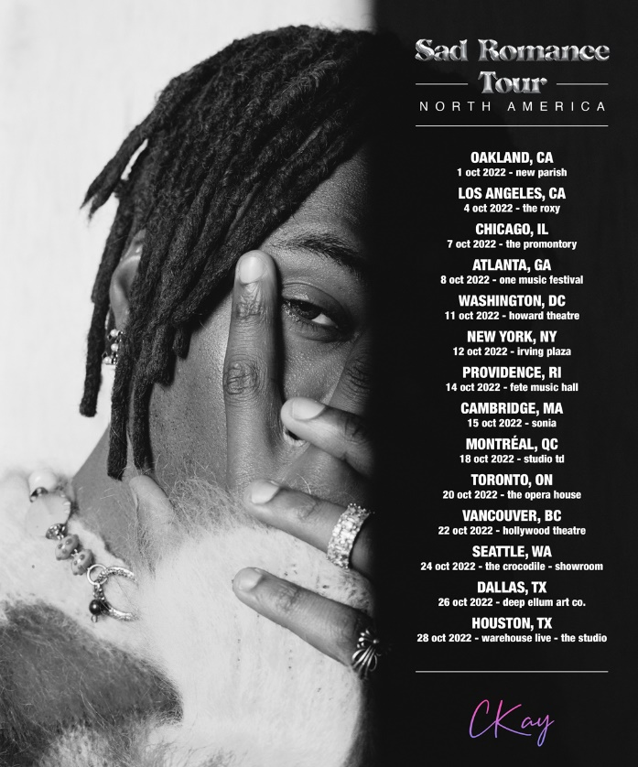
01 – Oakland, CA – New Parish
04 – Los Angeles, CA – The Roxy
07 – Chicago, IL – The Promontory
08 – Atlanta, GA – One Music Festival*
11 – Washington, D.C. – Howard Theatre
12 – New York, NY – Irving Plaza
14 – Providence, RI – Fete Music Hall
15 – Cambridge, MA – Sonia
18 – Montreal, QC – Studio Td
20 – Toronto, ON – The Opera House
22 – Vancouver, BC – Hollywood Theatre
24 – Seattle, WA – The Crocodile – Showroom
26 – Dallas, TX – Deep Ellum Art Co.
28 – Houston, TX – Warehouse Live – The Studio
*festival performance

ABOUT CKAY
Chukwuka Ekweani, known publicly as CKay, is the rising star in the ever-burgeoning Afrobeats scene. A multi-talented artist, whether behind the boards as a producer or in front of the mic performing his self-penned songs, it is CKay’s single-minded vision that shines through. The self-defined Emo-Afrobeat star has and continues to soar up charts across the globe thanks to his first globally recognized single ‘love nwantiti’.
The Nigerian singer, songwriter and producer originally released ‘love nwantiti (ah ah ah)’ back in 2019 as part of his debut EP, CKay The First. In 2021, CKay became the most streamed artist of the year and became the first African artist with two tracks on the Global Spotify Top 30 simultaneously. ‘love nwantiti’ has been certified platinum/multi-platinum in five countries, including the United States and India, The viral hit has also been certified gold in the UK, Australia, South Africa, Italy, and New Zealand. CKay became the first African artist in 50 years to hold a top 5 position on the UK Singles Chart for 4 straight weeks with ‘love nwantiti’.
CKay has continued to create a global presence with accomplishments such as the “most Shazam-ed song in the world”. His most recent globally recognized single, ‘Emiliana’, has followed suit and racked in global chart positions and currently has just under 100 million streams. ‘Emiliana’ peaked at #1 on the UK Afrobeats Chart, #2 on Shazam Top 200 (Afrobeats), and #1 in six countries on Apple Music.
With new music on the way in 2022, CKay is bound to continue creating amazing music that will catch the attention of fans, both old and new, on a global scale.
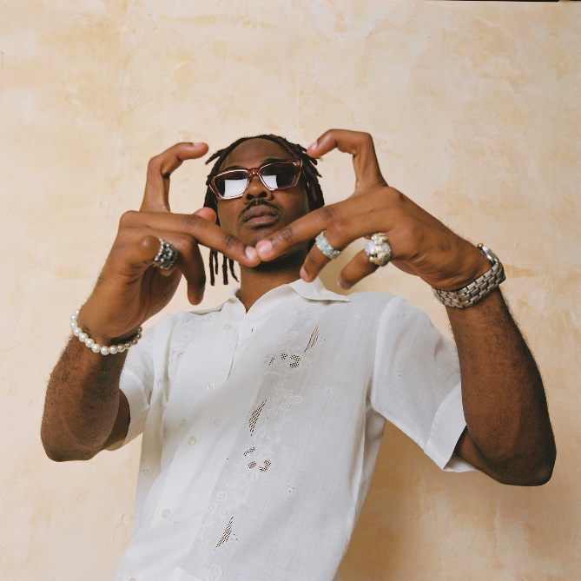
CONNECT WITH CKAY:
TWITTER | FACEBOOK | INSTAGRAM

PRESS CONTACT:
ARIANA.WHITE@ATLANTICRECORDS.COM

