FOR IMMEDIATE RELEASE

AUGUST 25, 2022

CROOKED COLOURS HEAT UP THE SUMMER WITH “HOLIDAY”
+ FORTHCOMING ALBUM TOMORROWS AVAILABLE NOW FOR PRE-ORDER

AUSTRALIAN INDIE-ELECTRONIC TRIO HERALD EAGERLY AWAITED LABEL DEBUT ALBUM
WITH SULTRY NEW SINGLE AND OFFICIAL VISUALIZER

NORTH AMERICAN HEADLINE TOUR BEGINS SEPTEMBER 22 IN AUSTIN, TX

TOMORROWS ARRIVES VIA ATLANTIC RECORDS ON SEPTEMBER 23

LISTEN TO “HOLIDAY” HERE | PRE-ORDER/PRE-SAVE TOMORROWS

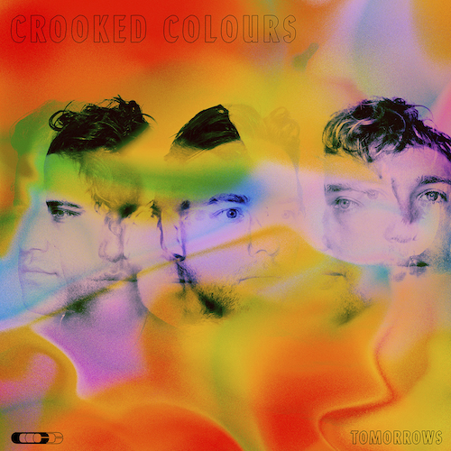
DOWNLOAD ARTWORK HERE

Acclaimed Australian indie-dance trio Crooked Colours are keeping the summer hot with their new single, “Holiday,” available now at all DSPs and streaming services HERE. The dancefloor ready track is joined by an official visualizer – filmed during the band’s recent trip to the island of Bali – WATCH HERE.

Written and produced by Crooked Colours – Phil Slabber (vocals, guitar, production), Leon Debaughn (keys, production), and Liam Merrett-Park (drums) – “Holiday” is but one of the many highlights found on the Fremantle, Western Australia-based trio’s eagerly anticipated Atlantic Records debut album, TOMORROWS, arriving at last on September 23rd. Pre-orders/pre-saves are available now HERE. TOMORROWS further showcases a spectacular array of recent released singles, including “Feel It,” “Light Year (Feat. Masked Wolf & Jasiah),” “No Sleep,” “Falling,” and “Love Language,” all of which are available now for streaming and download everywhere.

“This was an album created during very testing times for us as a group. We started the writing process coming off the back of really great momentum following the success of our sophomore record Langata. With solid progress overseas after a run of international tours and festivals, we inked a deal with Atlantic Records and had everything mapped out when the rug was pulled from underneath us as the reality of the pandemic hit. We have always generated so much inspiration from performing live to our fans so we worried how this record may translate without having that energy to draw from. We bunkered down in our studio in Fremantle and focused on what we could control and that was writing and recording as much music as we could. It became a long process for us as we battled with the reality around us, not knowing what lay ahead while maintaining a creative output.

The title track 'Tomorrows' and the songs we ended up collating for this record is a reflection of us as a group coming to terms with how much the landscape had changed. We realised how hard we had been pushing ourselves in pursuit of tomorrow's success without taking a moment to appreciate how far we had come. We also didn't want to dwell on the hand we had been dealt and try to include a message of hope into these songs. As much as Tomorrows is a statement on what had been driving us in the past it is also us saying that we are looking forward to what is coming in the future and moving past this difficult period in our lives. From a personal level we have grown a lot while writing this record and we couldn't be prouder of what we have created. Musicians, creatives and everyone have been through a lot over the past three years. This album is to let all of our fans, friends and family who have helped us know that we are still here, we are fighting and we are really looking forward to what's coming tomorrow.”
– CROOKED COLOURS

Crooked Colours will celebrate TOMORROWS with an epic world tour. North American headline dates get underway September 22 at Austin, TX’s Scoot Inn and then continue through October. For complete details and ticket information, please visit www.crookedcoloursmusic.com.

CROOKED COLOURS
NORTH AMERICAN TOUR 2022

SEPTEMBER
22 – Austin, TX – Scoot Inn
23 – New Orleans, LA – Toulouse Theatre
24 – Atlanta, GA – Terminal West
28 – Washington, DC – Hi-Lawn
29 – Brooklyn, NY – Music Hall of Williamsburg
30 – Philadelphia, PA – The Foundry

OCTOBER
1 – Cambridge, MA – The Sinclair
4 – Montreal, QC – Le Studio Td
5 – Toronto, ON – Axis Club
7 – Chicago, IL – The Vic Theatre
14 – Denver, CO – Ogden Theatre
22 – San Francisco, CA – The Regency Ballroom
26 – Portland, OR – Wonder Ballroom
27 – Seattle, WA – Showbox at the Market
28 – Vancouver, BC – Commodore Ballroom

# # #

Hailed by EDM.com for their “harmonious blend of indie, house, and pop,” Crooked Colours have quickly proven one of the world’s hottest electronic acts, fusing delicate acoustic instrumentation, evocative vocals, upbeat lyricism, and dancefloor-ready synth transmissions to create a dynamic, shape-shifting sound all their own. Such popular singles as their 2017 breakthrough smash, “Flow,” have already racked up over 300M worldwide streams while earning worldwide critical applause and an ever-growing fan following. An equally unstoppable live act, Crooked Colours have sold out countless shows on multiple continents while lighting up festivals around the world including an unforgettable set at 2019’s Bonnaroo Music & Arts Festival.
# # #

PRAISE FOR CROOKED COLOURS

“Crooked Colours can do no wrong…the perfect balance of instrumentation and electronic elements.”
– THIS SONG IS SICK

“Having established themselves as one of Australia’s hottest emerging electronic acts, Crooked Colours certainly are on their way to the top.”
– CULTR

“Uplifting and emotive...suited for both a sunset dance party or the afterhours’ dancefloor.”
– DANCING ASTRONAUT

“Crooked Colours (have) quickly made a name for themselves carving their own unique yet perfect blend of indie pop and electronic music.”
– FLAUNT

“Dipping into the synth world of electronic, the bright guitars of pop, and the sultry, mysterious lyrics usually associated with indie rock, Crooked Colours shows abilities across the board.”
– POPDUST

“Crooked Colours (have) acquired a reputation for that precise festival-friendly sound that makes you want to get outside and frolic in maximum sunlight.”
– SF WEEKLY

# # #

CROOKED COLOURS
TOMOROWS
(Atlantic Records)

TRACKLIST
Love Language
Holiday
Feel It
Homecoming
No Sleep
Don’t Give Up On Me
Falling
Circles
Moving On
Tomorrows
Light Year (Feat. Masked Wolf & Jasiah)
Still Here
Fight Night

# # #

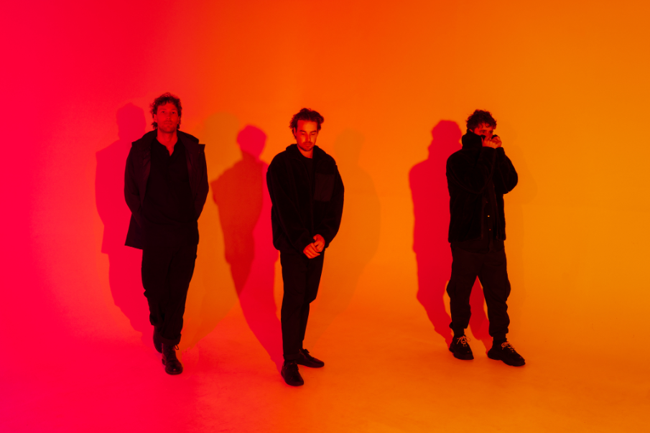
DOWNLOAD PRESS PHOTO HERE // CREDIT: MATSU

CONNECT WITH CROOKED COLOURS
OFFICIAL | FACEBOOK | INSTAGRAM | TWITTER | YOUTUBE

# # #

FOR PRESS INQUIRIES, PLEASE CONTACT:
Jessica Nall // Jessica.Nall@atlanticrecords.com

