COLDPLAY MARK TWENTIETH ANNIVERSARY OF THEIR SECOND ALBUM A RUSH OF BLOOD TO THE HEAD WITH RELEASE OF 4K UPGRADE OF THE SCIENTIST VIDEO

Today, 26 August, marks exactly twenty years since Coldplay released their second album, A Rush Of Blood To The Head. The multi Grammy-winning number one album has since sold over 17 million copies worldwide.

To mark the anniversary, the band have released an upgraded 4K version of the iconic Jamie Thraves-directed video for The Scientist, which has been restored and re-graded from the original 35mm film rushes.

The 4K version is available to watch now on The Scientist’s original YouTube link - where the video has already accumulated more than 1 billion views - at youtu.be/RB-RcX5DS5A.

The entire album - which featured the singles In My Place, The Scientist, Clocks and God Put A Smile Upon Your Face - has also been newly mixed for Dolby Atmos. The Dolby Atmos version is available to listen now on Apple Music, Amazon and TIDAL.

Coldplay have also contributed memories about the album and its recording to Spotify, which can be viewed over on the band’s This Is Coldplay playlist.

On its release, A Rush Of Blood To The Head was described by NME as “an album of outstanding natural beauty”, with Rolling Stone calling it “first rate” and Q presciently hailing it as “a collection of vastly moving songs that will render stadiums as intimate as bedrooms” (as has proven to the the case when the band play songs from the album on their current Music Of The Spheres World Tour).

A Rush Of Blood To The Head can be streamed / downloaded here. Its tracklisting is as follows:

Politik
In My Place
God Put a Smile Upon Your Face
The Scientist
Clocks
Daylight
Green Eyes
Warning Sign
A Whisper
A Rush of Blood To The Head
Amsterdam

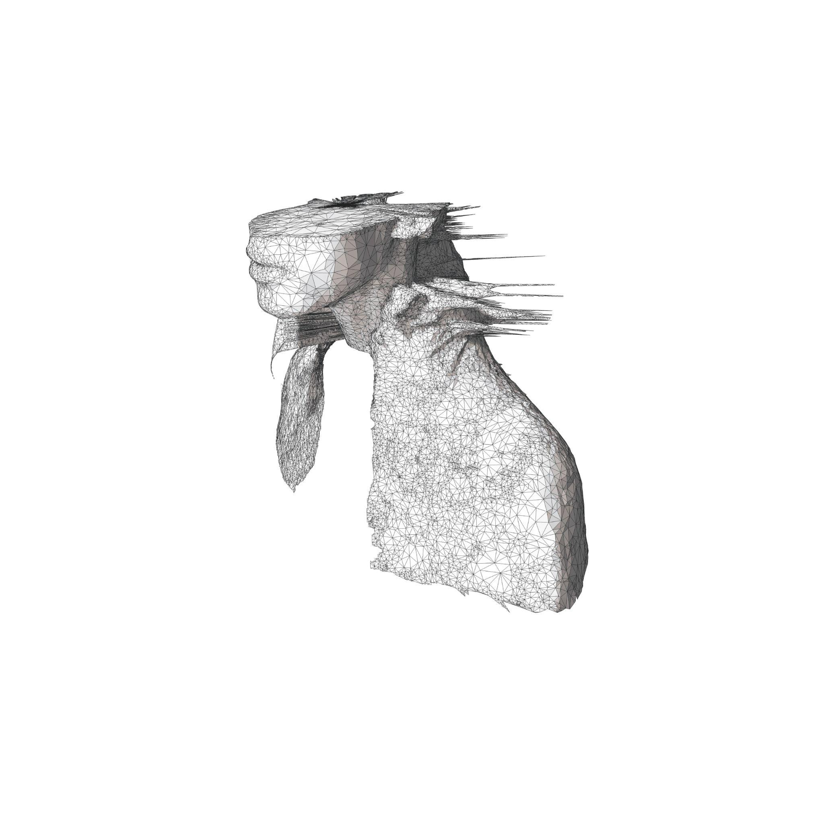
For more information please visit Coldplay.com or contact:
Sheila Richman | sheila.richman@atlanticrecords.com
Ted Sullivan | ted.sullivan@atlanticrecords.com
Gabrielle Reese (Tour) | gabrielle.reese@atlanticrecords.com

