DCG BROTHERS RETURN WITH “ONE CALL”

NEW TRACK ACCOMPANIED BY OFFICIAL MUSIC VIDEO PRODUCED BY NO MORE HEROES

STREAM/DOWNLOAD

WATCH HERE

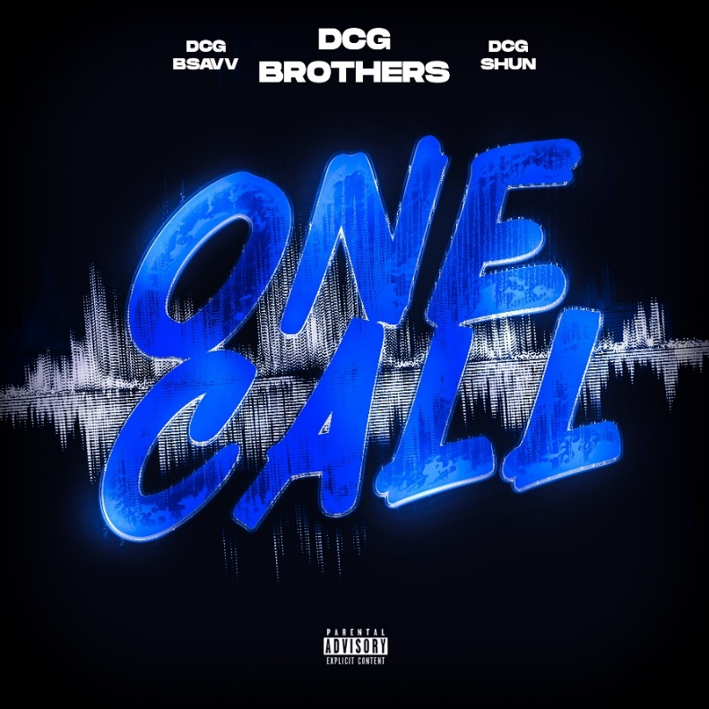
DOWNLOAD HI-RES HERE

New York, NY – March 25, 2022 – Chicago’s blood brother rapper duo DCG Brothers, Shun & BSavv, is back with single “One Call” today. The fresh track is accompanied with an official music video produced by No More Heroes. WATCH HERE.

DCG Brothers’ highly anticipated mixtape is coming this Spring. Known for their punchy rhymes and humorous visuals, DCG Brothers have garnered over 1M+ US streams and over 25M+ views on YouTube to date.

DOWNLOAD HI-RES HERE

ABOUT DCG SHUN & DCG BSAVV:
Chicago’s DCG Brothers, Shun and BSavv, make drill music for everyone. The self-described “Pop Drill” maestros began taking rap music seriously in early 2020, drawing on a healthy diet of Lil Wayne, Lil Durk, G Herbo, Gunna, and more. The blood-brothers actively learned how to rap, write, and punch in, making their music stand out in a sea of artists phoning in verses for a quick viral check. Best known for their hilarious videos, plodding flows, and nasty bars, the DCG Brothers’ spirit can be easily defined by any one of their massive music videos. The video for “Mmhmm,” sitting at over 2 million views, is but one of many (“Dem Faces,” “Paparazzi,” “OK”) visual representations of two kids having a blast while carving out a new lane and making an incredible life for themselves. Spitting over minimalistic trap beats and delivered punchlines that would rival their forefathers’ best material, the DCG Brothers are here to bring drill music worldwide.

CONNECT WITH DCG SHUN:
INSTAGRAM | TWITTER | FACEBOOK | YOUTUBE

CONNECT WITH DCG BSAVV:
INSTAGRAM | TWITTER | FACEBOOK | YOUTUBE

PRESS CONTACT:
JASON DAVIS | JASON.DAVIS@ATLANTICRECORDS.COM
# # #

