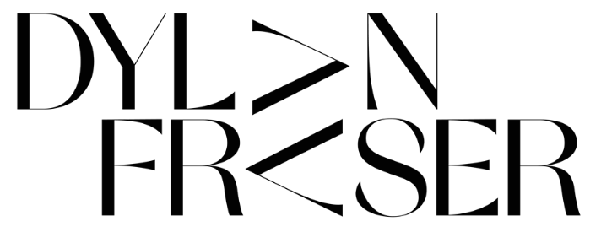

RELEASES NEW EP 2030 REVOLUTION – OUT TODAY ON ASYLUM/ATLANTIC

LISTEN HERE | WATCH “2030 REVOLUTION” VISUALIZER

SCOTTISH DARK-POP MUSICIAN NAMED TO SPOTIFY’S RADAR PROGRAM SHOWCASING EMERGING ARTISTS TO WATCH

“Dylan Fraser’s latest track [‘It Took A Lot To Get To This’] takes a tremendous left turn — after beginning in an indie-folk lane… the song transforms into a pulsing, claustrophobic dance arrangement, with Fraser repeating the titular phrase as a hard-earned mantra. The style swap works thematically and sonically, and Fraser now has his most complete single to date.” – BILLBOARD

Photographer Credit: Ho Hai Tran | DOWNLOAD HERE

“The audacity of this UK newcomer to deliver a sound that's as fully formed and self-assured as this... Get into him now so you can brag to all your friends about knowing him first when he inevitably breaks big.” – E!

“Dylan Fraser’s alternative-streaked interpretation of the genre positions him as one of the few of his ilk actually worth listening to.” – i-D

“There really isn’t a box you could put him in, which is precisely why he’s so compelling…a true original.” – THE SUNDAY TIMES

“Dylan Fraser documents humanity’s downfall on his formidable third EP…” – THE LINE OF BEST FIT

Photographer Credit: Ho Hai Tran | DOWNLOAD HERE

Rising alt/pop Scottish artist Dylan Fraser has unveiled his third EP, 2030 Revolution, out today on Asylum/Atlantic (listen here). The EP includes previously-released standout tracks ‘Vampire’ feat. Alaska Reid, ‘It Took A Lot To Get To This’ and ‘Apartment Complex On The Eastside,’ the latter of which was co-written by Samia.

Today, Dylan also shares the official music video for title track, ‘2030 Revolution’ (watch here).

2030 Revolution was produced by Dylan’s long-time collaborator Jonah Summerfield and Ivor Novello-nominated Rob Milton (Holly Humberstone, Easy Life), and finds the young Scot documenting his all-too-familiar fear of finding purpose, offering a fresh lens on the uncertainties we all face throughout modern life. The EP flows through synth-laden and industrial soundscapes, showcasing Dylan’s knack for bridging genres with ease, a focal point of his work thus far and one of the many reasons he’s brought in a swarm of acclaim since his breakthrough last year.

Over the course of the summer, Dylan – who recently collaborated in the studio with PC Music’s A.G. Cook and Rodaidh McDonald – has been making his name on the live circuit, playing numerous UK festivals, including Barn on the Farm, where Dylan shared the stage with Holly Humberstone, JP Saxe, Maisie Peters, and more for a one-off performance.
In July, Dylan appeared on Jack Saunders’ BBC Radio 1 show, where he reimagined Kate Bush’s ‘Running Up That Hill (A Deal With God)’ and played one of 2030 Revolution’s singles, ‘It Took A Lot To Get To This.’ In October, he’ll play Neighbourhood Festival in Manchester, UK and Live at Leeds.

###

‘2030 REVOLUTION’ EP TRACKLISTING:
- Apartment Complex On The Eastside
- It Took A Lot To Get To This
- Vampire feat. Alaska Reid
- 2030 Revolution

###

ABOUT DYLAN FRASER:

Functioning around introspection, destination and self-validation, Dylan’s early catalogue finds the Scottish-born artist unpacking his journey from his small town of Bathgate to his newfound reality as an artist with the world at his feet, trying to make sense of the people and situations he’s faced along the way.

First picking up a guitar at just 12-years-old (a hand-me-down from his mom, who, subsequently, taught him his first four chords,) Dylan set his sights on a music career from early childhood. Holed away in his bedroom, he would reimagine his favorite songs by his decade-spanning influences - everyone from Radiohead to Lorde to Kanye West - dreaming of city lights whist plotting a path out of his satellite town.

One of the most exciting alt/pop artists on the UK scene, Dylan has accumulated over 16 million streams to date, supported Inhaler and Holly Humberstone on their UK tours, released two well-received EPs, The Storm and The World Isn’t Big When You Know How It Works, and landed early support from music heavyweights Sir Elton John and Sam Smith, press critics, and radio’s Clara Amfo, Jack Saunders and Zane Lowe.

“I’m not a betting man, but it’s not a bet when it’s a sure thing, and this artist is a sure thing.”
– Zane Lowe

